PROJECT

Topic: Property Rental System

Course: Software Modeling and Design

Class: SWE-2A

Members: Kevin Muho Desard Lybeshari
Anisa Domi Haidi Toto
Ledio Tafciu Ornelt Lemellari
Matias Bali

Property Rental System

Requirements Specification Version 3.0
March 8th, 2025

Use this Requirements Specification template to document the requirements for your product or service, including priority and approval. Tailor the specification to suit your project, organizing the applicable sections in a way that works best, and use the checklist to record the decisions about what is applicable and what isn't.
The format of the requirements depends on what works best for your project.
This document contains instructions and examples which are for the benefit of the person writing the document and should be removed before the document is finalized.
To regenerate the TOC, select all (CTL-A) and press F9.

Table of Contents
- Executive Summary 1
  - Project Overview 1
- Product/Service Description 2
  - Product Context 3
  - User Characteristics 5
  - Assumptions 5
  - Constraints Dependencies 6
- Requirements 7
  - Functional Requirements 7
  - Non-Functional Requirements 10
    - Product Requirements 10
      - Usability Requirements 10
      - Performance Requirements 11
      - Availability 11
      - Security 11
    - Organizational Requirements 12
    - External Requirements 12
- User Scenarios/Use Cases 13
- Diagrams 34
- Design Patterns 7
- Appendix. 7
Organizing the Requirements 7

Executive Summary

Project Overview
The Property Rentals System is a software platform designed to simplify and manage the process of renting properties between tenants, property owners, and administrative staff. The system provides a centralized environment where property owners can list rental properties, tenants can search and book accommodations, and administrators can monitor and manage overall system operations.
The platform supports several core services including:
- Property listing and management
- Property search and filtering
- Rental request and booking management
- Online payment processing
- Messaging and notifications
- Complaint and dispute management
- Reporting and administrative monitoring
The intended audience of the system includes:
- Tenants searching for rental accommodations
- Property Owners managing rental properties
- Administrators and Managers supervising operations and disputes
- Financiers handling transactions and refunds
- HR Staff managing complaints and user support
The main goal of the system is to improve efficiency, transparency, accessibility, and communication throughout the property rental process by digitizing rental operations and allowing users to access services online from anywhere.

Product/Service Description
The Property Rentals System is designed as a multi-user rental management platform that connects tenants, property owners, and administrative personnel through a single integrated system. The platform automates major rental activities such as property publishing, booking requests, payment processing, communication, and issue resolution.
The development of this system is motivated by the increasing need for efficient digital rental management solutions that reduce manual paperwork, improve communication, and provide better accessibility for users. Traditional rental management processes often involve delays, fragmented communication, and difficulties in maintaining accurate records. This system addresses those challenges through centralized data management and automated workflows.
Several general factors influence the design and requirements of the system:
- The need for secure authentication and protection of user and payment data
- Support for multiple user roles with different permissions
- Integration with external payment and notification services
- Efficient handling of large numbers of property listings and concurrent users
- Easy-to-use interfaces for both technical and non-technical users
- Real-time communication and booking updates
- Scalable architecture to support future growth and additional services
The system is intended to operate primarily as a web-based application, although the architecture can later support mobile application integration.

Product Context
The Property Rentals System is a web-based rental management platform that operates as a centralized system for managing rental activities between tenants, property owners, administrators, managers, financiers, and HR personnel. The system is primarily designed as a standalone application, but it also interfaces with external services such as payment and notification systems. In the future, the platform can be extended to support mobile application integration in addition to the web-based environment.
The system provides a centralized database that stores and manages all important information related to:
- User accounts and authentication
- Property listings and availability
- Rental requests and bookings
- Payment transactions and refunds
- Messages and notifications
- Complaints, disputes, and issue resolutions
- Reviews, ratings, and reports
The centralized structure ensures that all modules and users work with consistent and updated information across the platform.
The Property Rentals System interacts with several external systems and internal subsystems:

External Systems
- Payment System
  - Processes rental payments, refunds, and transaction confirmations.
  - Used during booking payment operations and financial management.
- Notification System
  - Sends booking confirmations, approval/rejection alerts, reminders, payment updates, and complaint notifications to users.

Internal System Modules
The platform is divided into multiple functional modules that work together:
- Property Management Module
- Booking & Rental Request Module
- Messaging & Communication Module
- Payment Management Module
- Complaint & Issue Management Module
- User & Role Management Module
- Reporting & Monitoring Module
- Notification Management Module
Each module communicates through the centralized system architecture and shares data through the common database.

The platform supports multiple user roles, each with different permissions and responsibilities:
- Tenant
- Property Owner
- Administrator
- Manager
- Financier
- HR Staff
These users interact with the system through role-specific functionalities such as booking management, listing management, payment handling, complaint resolution, and system monitoring.
The overall system context can be represented as follows:
+-------------------------------------------------------+
| Property Rentals System |
|-------------------------------------------------------|
| |
| +------------------+ +----------------------------+ |
| | Property Module | | Booking & Rental Module | |
| +------------------+ +----------------------------+ |
| |
| +------------------+ +----------------------------+ |
| | Messaging Module | | Complaint Management | |
| +------------------+ +----------------------------+ |
| |
| +------------------+ +----------------------------+ |
| | User Management | | Reporting & Monitoring | |
| +------------------+ +----------------------------+ |
| |
| Centralized Database System |
| |
+-------------------------------------------------------+
| |
| |
v v
+--------------------+ +------------------------+
| External Payment | | Notification System |
| Service | | (Alerts & Reminders) |
+--------------------+ +------------------------+
The system architecture also incorporates several software design patterns to improve maintainability and communication between components:
- The Facade Pattern simplifies booking operations by coordinating rental requests, bookings, payments, and notifications through a unified interface.
- The Observer Pattern automatically sends notifications when booking or payment statuses change.
- The Adapter Pattern allows the system to communicate with external payment providers without modifying the internal payment logic.

User Characteristics

The Property Rental System will be used by several categories of users with different responsibilities and technical abilities.The product should therefore be designed with a clear, user-friendly interface, role-based access, secure login, and simple navigation so both technical and non-technical users can use it effectively.
User Type | Category | Experience | Technical Expertise | General Characteristics
Tenant | Other / Customer | May have basic experience using websites or mobile apps | Basic | Needs a simple interface to search properties, view details, send rental requests, make payments, and communicate with owners.
Property Owner | Other / Service Provider | May have experience managing rental properties | Basic to intermediate | Needs tools to add, edit, remove, and manage listings, upload images, respond to requests, and view booking history.
Administrator | Staff | Experienced in managing system operations | Intermediate to advanced | Responsible for managing users, listings, disputes, reports, and platform control.
Manager | Staff | Experienced in supervision and coordination | Intermediate | Oversees rental requests, complaints, reports, discounts, and coordination between users and administrators.
Financier | Staff | Experienced in payment and transaction handling | Intermediate | Handles payment monitoring, refunds, transaction issues, and financial reports.
HR Staff | Staff | Experienced in user support and communication | Basic to intermediate | Manages complaints, reminders, user satisfaction, and issue-resolution records.

Assumptions
The following assumptions affect the requirements of the Property Rentals System:
- Users will have access to a device such as a computer, tablet, or smartphone.
- Users will have a stable internet connection to access the web-based system.
- Users have basic knowledge of using websites or mobile applications.
- Property owners will provide accurate property information, images, prices, and availability.
- Tenants will provide correct personal, booking, and payment information.
- The external payment system will be available to process rental payments and refunds.
- The notification system will be available to send alerts, reminders, and booking updates.
- The system will use a centralized database to store users, properties, bookings, payments, messages, complaints, and reports.
- Administrators, managers, financiers, and HR staff will have the required permissions to perform their tasks.
- Secure authentication and authorization will be used before users access role-specific functions.

Constraints and Dependencies
The following constraints and dependencies affect the system requirements:

Constraints
- The system must protect user information, passwords, booking records, and payment data.
- Access must be controlled using role-based permissions.
- Only authorized users should access sensitive features such as user management, reports, refunds, and dispute handling.
- The system should maintain logs or records for important actions such as payments, refunds, complaints, booking approvals, and account changes.
- The system must support multiple users at the same time without major performance issues.
- The interface must remain simple enough for users with basic technical skills.
- Payment processing must be secure and reliable.
- The application depends on accurate and updated property availability information.
- The system must prevent invalid actions, such as deleting listings with active bookings or submitting reviews without completed rentals.

Dependencies
- The booking module depends on the property search and property listing modules.
- The payment module depends on approved bookings before payments can be processed.
- The refund process depends on payment and booking cancellation records.
- The notification module depends on booking, payment, complaint, and request status changes.
- The complaint management module depends on user accounts, property records, and issue-resolution records.
- The reporting module depends on stored data from users, bookings, payments, complaints, and listings.
- The system depends on the external payment service for transaction processing.
- The system depends on the notification service for sending alerts and reminders.
- User role management must be completed before role-specific modules can be fully implemented.

Requirements

Functional Requirements
Req# | Requirement | Comments | Priority | Date Rvwd | Done By
FR01 | The tenant shall be able to update personal information because profile information must remain accurate and updated. | Business Process = User Profile Management | 2 | 18/03/2026 | Anisa Domi
FR02 | The tenant shall be able to search properties because tenants need to find suitable rental accommodations. | Business Process = Property Search | 2 | 18/03/2026 | Anisa Domi
FR03 | The tenant shall be able to filter properties because search results need to be narrowed based on preferences. | Business Process = Property Filtering | 2 | 18/03/2026 | Anisa Domi
FR04 | The tenant shall be able to view property details and booking history because tenants need complete rental information and history records. | Business Process = Property Viewing & Booking History | 2 | 18/03/2026 | Anisa Domi
FR05 | The tenant shall be able to send rental requests and messages to property owners because communication and booking requests are required for rentals. | Business Process = Rental Request Management | 1 | 18/03/2026 | Anisa Domi
FR06 | The tenant shall be able to cancel rental requests because tenants may change booking decisions before approval. | Business Process = Rental Request Cancellation | 2 | 18/03/2026 | Anisa Domi
FR07 | The tenant shall be able to receive messages from property owners because communication between users must be supported. | Business Process = Messaging System | 2 | 18/03/2026 | Haidi Toto
FR08 | The tenant shall be able to submit rental payments because approved bookings require payment processing. | Business Process = Payment Processing | 1 | 18/03/2026 | Haidi Toto
FR09 | The tenant shall be able to save favorite properties because users may want to review properties later. | Business Process = Favorites Management | 3 | 18/03/2026 | Haidi Toto
FR10 | The tenant shall be able to review and rate properties because feedback improves transparency and user trust. | Business Process = Review & Rating System | 3 | 18/03/2026 | Haidi Toto
FR11 | The property owner shall be able to update profile information and property availability because listing information must remain accurate. | Business Process = Property Owner Profile Management | 2 | 18/03/2026 | Haidi Toto
FR12 | The property owner shall be able to add property listings because rental properties need to be published in the system. | Business Process = Property Listing Management | 1 | 18/03/2026 | Haidi Toto
FR13 | The property owner shall be able to upload property images because tenants need visual information about properties. | Business Process = Property Media Management | 2 | 18/03/2026 | Ledio Tafciu
FR14 | The property owner shall be able to edit property listings because property details may change over time. | Business Process = Property Listing Management | 2 | 18/03/2026 | Ledio Tafciu
FR15 | The property owner shall be able to delete property listings because unavailable or invalid listings must be removed. | Business Process = Property Listing Management | 2 | 18/03/2026 | Ledio Tafciu
FR16 | The property owner shall be able to view rental requests because owners need to manage booking requests. | Business Process = Rental Request Monitoring | 1 | 18/03/2026 | Ledio Tafciu
FR17 | The property owner shall be able to accept or reject rental requests because booking approvals are required before rentals proceed. | Business Process = Rental Approval Workflow | 1 | 18/03/2026 | Ledio Tafciu
FR18 | The property owner shall be able to send messages to tenants because communication between both parties must be supported. | Business Process = Messaging System | 2 | 18/03/2026 | Ledio Tafciu
FR19 | The property owner shall be able to view booking history because owners need access to previous rental records. | Business Process = Booking History Management | 2 | 18/03/2026 | Desard Lybeshari
FR20 | The property owner shall be able to mark properties as unavailable or rented because listing availability must remain accurate. | Business Process = Property Availability Management | 1 | 18/03/2026 | Desard Lybeshari
FR21 | The administrator shall be able to edit user accounts because user information and permissions may require updates. | Business Process = User Account Administration | 1 | 18/03/2026 | Desard Lybeshari
FR22 | The administrator shall be able to delete user accounts because invalid or inappropriate accounts must be removed. | Business Process = User Account Administration | 1 | 18/03/2026 | Desard Lybeshari
FR23 | The administrator shall be able to monitor rental transactions because financial and booking activities require supervision. | Business Process = Transaction Monitoring | 1 | 18/03/2026 | Desard Lybeshari
FR24 | The administrator shall be able to view system reports and property listings because system operations must be monitored. | Business Process = Reporting & Monitoring | 2 | 18/03/2026 | Desard Lybeshari
FR25 | The administrator shall be able to remove inappropriate listings because platform content must comply with system policies. | Business Process = Content Moderation | 1 | 18/03/2026 | Matias Bali
FR26 | The administrator shall be able to manage disputes and system settings because system stability and issue resolution must be maintained. | Business Process = System Administration | 1 | 18/03/2026 | Matias Bali
FR27 | The administrator shall be able to restore user accounts because suspended or deleted accounts may require recovery. | Business Process = User Account Recovery | 2 | 18/03/2026 | Matias Bali
FR28 | The administrator shall be able to suspend user accounts because policy violations may require temporary restrictions. | Business Process = User Account Control | 1 | 18/03/2026 | Matias Bali
FR29 | The administrator shall be able to verify and approve property listings because listings must be validated before publication. | Business Process = Listing Verification | 1 | 18/03/2026 | Matias Bali
FR30 | The manager shall be able to monitor rental requests because booking operations require supervision. | Business Process = Rental Monitoring | 2 | 18/03/2026 | Matias Bali
FR31 | The manager shall be able to generate management reports because operational performance must be evaluated. | Business Process = Management Reporting | 2 | 18/03/2026 | Ornelt Lemellari
FR32 | The manager shall be able to approve large discounts and promotions because special pricing actions require authorization. | Business Process = Promotion Approval | 3 | 18/03/2026 | Ornelt Lemellari
FR33 | The manager shall be able to review complaints and forward unresolved issues because escalated problems require supervision. | Business Process = Complaint Management | 1 | 18/03/2026 | Ornelt Lemellari
FR34 | The financier shall be able to view transaction history because financial records must be monitored and verified. | Business Process = Financial Monitoring | 1 | 18/03/2026 | Ornelt Lemellari
FR35 | The financier shall be able to monitor payment processing and security because secure transactions are required. | Business Process = Payment Security Management | 1 | 18/03/2026 | Ornelt Lemellari
FR36 | The financier shall be able to communicate payment issues with tenants and owners because payment problems require resolution. | Business Process = Payment Issue Resolution | 2 | 18/03/2026 | Ornelt Lemellari
FR37 | The financier shall be able to approve refunds for cancelled rental transactions because financial adjustments may be required. | Business Process = Refund Management | 1 | 18/03/2026 | Kevin Muho
FR38 | HR staff shall be able to manage complaints because user issues and disputes must be handled properly. | Business Process = Complaint Handling | 1 | 18/03/2026 | Kevin Muho
FR39 | HR staff shall be able to send notifications and reminders because users must receive important updates and alerts. | Business Process = Notification Management | 2 | 18/03/2026 | Kevin Muho
FR40 | HR staff shall be able to maintain records of user issues and resolutions because complaint history must be documented. | Business Process = Issue Resolution Tracking | 2 | 18/03/2026 | Kevin Muho
FR41 | Users shall be able to register accounts because authenticated access is required to use the system. | Business Process = User Registration | 1 | 18/03/2026 | Kevin Muho
FR42 | Users shall be able to log into the system because secure account access is required. | Business Process = User Authentication | 1 | 18/03/2026 | Kevin Muho
FR43 | Users shall be able to log out of the system because secure session termination is required. | Business Process = Session Management | 1 | 18/03/2026 | Kevin Muho

Non-Functional Requirements

Product Requirements

Product requirements specify how the Property Rentals System must behave in terms of usability, performance, availability, reliability, and security. These requirements ensure that the system operates efficiently, securely, and consistently for all users.

3.2.1.1 Usability Requirements
The system must be easy to learn and simple to use for tenants, property owners, administrators, managers, financiers, and HR staff.
Req# | Requirement | Priority | Date Rvwd | Done By
NFR-UR-01 | The system shall provide a user-friendly interface for all users. | 2 | 18/03/2025 | Kevin Muho
NFR-UR-02 | The system shall provide clear and understandable error messages when errors occur. | 2 | 18/03/2025 | Kevin Muho
NFR-UR-03 | The system shall support responsive design for desktops, tablets, and mobile devices. | 2 | 18/03/2025 | Kevin Muho
NFR-UR-04 | The system shall be easy to learn for users with basic technical knowledge. | 2 | 18/03/2025 | Kevin Muho
NFR-UR-05 | The system shall provide complete user documentation and help support for major system functions. | 3 | 18/03/2025 | Kevin Muho

3.2.1.2 Performance Requirements
The system must maintain fast response times and stable performance under both normal and peak workloads.
Req# | Requirement | Priority | Date Rvwd | Done By
NFR-PR-01 | The system shall load pages within 3 seconds under normal network conditions. | 1 | 18/03/2025 | Anisa Domi
NFR-PR-02 | The system shall support at least 500 simultaneous users. | 1 | 18/03/2025 | Anisa Domi
NFR-PR-03 | The system shall process property search queries within 2 seconds for most requests. | 1 | 18/03/2025 | Anisa Domi
NFR-PR-04 | The system shall process payment transactions within 5 seconds under normal conditions. | 1 | 18/03/2025 | Anisa Domi
NFR-PR-05 | The system shall maintain stable performance during peak usage periods. | 1 | 18/03/2025 | Anisa Domi
NFR-PR-06 | At least 95% of user transactions shall complete successfully without performance degradation. | 2 | 18/03/2025 | Haidi Toto

3.2.1.3 Availability
The system must remain available and reliable for users with minimal service interruptions.
Req# | Requirement | Priority | Date Rvwd | Done By
NFR-AV-01 | The system shall be available 99.5% of the time under normal operating conditions. | 1 | 18/03/2025 | Haidi Toto
NFR-AV-02 | The system shall support geographically distributed user access. | 2 | 18/03/2025 | Haidi Toto
NFR-AV-03 | The system shall notify users in advance of scheduled maintenance periods. | 2 | 18/03/2025 | Haidi Toto
NFR-AV-04 | The system shall recover from failures automatically or with minimal administrative intervention. | 1 | 18/03/2025 | Haidi Toto
NFR-AV-05 | Unscheduled downtime shall not exceed 4 hours per month. | 2 | 18/03/2025 | Haidi Toto
NFR-AV-06 | The system shall maintain reliable operation during peak usage periods. | 1 | 18/03/2025 | Ledio Tafciu

3.2.1.4 Security
Req# | Requirement | Priority | Date Rvwd | Done By
NFR-SE-01 | The system shall require secure authentication before users access their accounts. | 1 | 18/03/2025 | Ledio Tafciu
NFR-SE-02 | The system shall encrypt user passwords before storing them in the database. | 1 | 18/03/2025 | Ledio Tafciu
NFR-SE-03 | The system shall protect payment information during processing and storage. | 1 | 18/03/2025 | Ledio Tafciu
NFR-SE-04 | The system shall restrict access based on user roles and permissions. | 1 | 18/03/2025 | Ledio Tafciu
NFR-SE-05 | The system shall maintain activity logs for payments, refunds, complaints, and account changes. | 2 | 18/03/2025 | Desard Lybeshari
NFR-SE-06 | The system shall validate user inputs to maintain data integrity and prevent invalid transactions. | 1 | 18/03/2025 | Desard Lybeshari
NFR-SE-07 | The system shall ensure that communication between system modules is secure and protected from unauthorized access. | 2 | 18/03/2025 | Desard Lybeshari
The system must protect user data, payment information, and system operations from unauthorized access, misuse, or data loss.

3.2.2 Organizational Requirements
Organizational requirements are based on maintenance policies, scalability goals, and system management procedures.
Req# | Requirement | Priority | Date Rvwd | Done By
NFR-OR-01 | The system architecture shall support future expansion without requiring major redesign. | 2 | 18/03/2025 | Desard Lybeshari
NFR-OR-02 | The system shall allow new modules and features to be added with minimal impact on existing functionality. | 2 | 18/03/2025 | Desard Lybeshari
NFR-OR-03 | The system shall support database expansion for increasing users, properties, and transactions. | 2 | 18/03/2025 | Matias Bali
NFR-OR-04 | The system shall allow updates and bug fixes without affecting core system operations. | 2 | 18/03/2025 | Matias Bali
NFR-OR-05 | The system shall provide technical documentation for developers and system administrators. | 3 | 18/03/2025 | Matias Bali
NFR-OR-06 | The system shall maintain data consistency during updates and unexpected shutdowns. | 1 | 18/03/2025 | Matias Bali

3.2.3 External Requirements
External requirements arise from legal regulations, interoperability needs, and integration with external services.
Req# | Requirement | Priority | Date Rvwd | Done By
NFR-ER-01 | The system shall comply with GDPR and applicable data protection regulations. | 1 | 18/03/2025 | Matias Bali
NFR-ER-02 | The system shall comply with secure online payment standards and financial regulations. | 1 | 18/03/2025 | Ornelt Lemellari
NFR-ER-03 | The system shall comply with local real estate and rental laws. | 1 | 18/03/2025 | Ornelt Lemellari
NFR-ER-04 | The system shall ensure personal data is accessible only to authorized users. | 1 | 18/03/2025 | Ornelt Lemellari
NFR-ER-05 | The system shall generate payment receipts and financial records according to tax and financial regulations. | 2 | 18/03/2025 | Ornelt Lemellari
NFR-ER-06 | The system shall integrate with external payment and notification services. | 1 | 18/03/2025 | Ornelt Lemellari

User Scenarios/Use Cases

Use Case Tables
FR1 - Update Personal Information (Done by:Anisa Domi)

Use Case Name | FR1 ➔ Update Personal Information
Actors | Primary: Tenant
Goal | Edit personal profile data such as name, phone number, or contact details.
Preconditions | The actor is authenticated when the function requires account access, and the relevant page or module is available to the actor.
Main Success Flow | - The tenant logs in.  - The tenant opens the profile settings page.  - The tenant edits the required personal information.  - The tenant saves the changes.  - The tenant profile is updated and he reads the success message on screen.
Alternative / Exception Flow | - If data is invalid, tenant reads error message on screen.
Postconditions | The tenant profile is updated.

FR2 - Search Properties (Done by:Anisa Domi)

Use Case Name | FR2 ➔ Search Properties
Actors | Primary: Tenant
Goal | Search for rental properties that match general preferences.
Preconditions | The actor is authenticated when the function requires account access, and the relevant page or module is available to the actor.
Main Success Flow | - The tenant opens the property search page.  - The tenant enters search keywords or basic preferences.  - The tenant starts the search.  - The system retrieves matching properties.  - The system displays the search results.
Alternative / Exception Flow | - If no properties match the search, the system shows an empty-results message.
Postconditions | Matching properties are displayed or the tenant is informed that no results were found.

FR3 - Filter Properties (Done by:Anisa Domi)

Use Case Name | FR3 ➔ Filter Properties
Actors | Primary: Tenant
Goal | Filter available properties by location, price, and property type to narrow search results.
Preconditions | The tenant is logged into the system and the property search page is accessible.
Main Success Flow | - The tenant opens the property search page.  - The tenant selects filter options such as location, price range, or property type.  - The tenant applies the selected filters.  - The system processes the selected criteria.  - The system displays properties that match the selected filters.
Alternative / Exception Flow | - If no properties match the selected filters, the system displays a message indicating that no results were found.
Postconditions | Filtered property results are displayed to the tenant or the tenant is informed that no matching properties were found.

FR4 - View Property Details and Booking History (Done by:Anisa Domi)

Use Case Name | FR4 ➔ View Property Details and Booking History
Actors | Primary: Tenant
Goal | View detailed information about a property and the tenant’s booking history.
Preconditions | The tenant is logged into the system and has access to property listings or booking history.
Main Success Flow | - The tenant selects a property from the search results.  - The Tenant sees property details  - The tenant navigates to their booking history section.  - If history exists, tenant reads the booking history
Alternative / Exception Flow | - If the tenant has no booking history, he will read the no history message on screen
Postconditions | The tenant views property details and/or booking history successfully.

FR5 - Send Rental Request and Message to Property Owner (Done by:Anisa Domi)

Use Case Name | FR5 ➔ Send Rental Request and Message to Property Owner
Actors | Primary: Tenant  Secondary: Property Owner
Goal | Allow the tenant to send a rental request or message to a property owner regarding a property listing.
Preconditions | The tenant is logged into the system and viewing the details of a property listing.
Main Success Flow | - The tenant selects a property listing.  - The tenant chooses the option to send a rental request or message the property owner.  - The tenant enters the request or message details.  - The tenant submits the request or message.  - If valid, tenant sends request to owner and then stores the request.
Alternative / Exception Flow | - Tenant reads the error on screen.  - If the message field is empty or invalid, the system prompts the tenant to correct the input before sending.
Postconditions | The rental request or message is successfully sent to the property owner and recorded in the system.

FR6 - Cancel Rental Request (Done by:Anisa Domi)

Use Case Name | FR6 ➔ Cancel Rental Request
Actors | Primary: Tenant
Goal | Cancel a previously submitted rental request before it is finalized.
Preconditions | The actor is authenticated when the function requires account access, and the relevant page or module is available to the actor.
Main Success Flow | - The tenant logs into the system.  - The tenant opens the list of submitted rental requests.  - The tenant selects a pending request.  - The tenant chooses the cancel option.  - The system updates the request status and confirms the cancellation.
Alternative / Exception Flow | - If the request has already been approved, rejected, or processed, the system may deny cancellation and show the cant cancel message.
Postconditions | The selected request is canceled when cancellation is allowed.

FR7 - Receive Messages from Property Owner (Done by: Haidi Toto)

Use Case Name | FR7 ➔ Receive Messages from Property Owner
Actors | Primary: Tenant  Secondary: Property Owner
Goal | Read messages sent by property owners.
Preconditions | The actor is authenticated when the function requires account access, and the relevant page or module is available to the actor.
Main Success Flow | - The tenant logs in.  - The tenant opens inbox/notifications.  - The tenant opens a conversation.  - The tenant checks the received message content.
Alternative / Exception Flow | - If there are no new messages, the tenant sees the current conversation history or an empty inbox message.
Postconditions | The tenant can view messages received from property owners.

FR8 - Submit Rental Payment (Done by: Haidi Toto)

Use Case Name | FR8 ➔ Submit Rental Payment
Actors | Primary: Tenant
Goal | Pay for an approved rental booking through the system.
Preconditions | The actor is authenticated when the function requires account access, and the relevant page or module is available to the actor.
Main Success Flow | - The tenant logs into the system.  - The tenant opens an approved booking or payment page.  - The tenant enters payment details or chooses a saved payment method.  - The tenant confirms the payment.  - The system sends the payment request to the payment service.  - The system receives the payment result and displays confirmation.
Alternative / Exception Flow | - If payment fails, the system displays the failure reason and asks the tenant to retry or choose another method.
Postconditions | The payment is recorded if successful, and the booking status is updated.

FR9 - Save favourite properties for later viewing (Done by: Haidi Toto)

Use Case Name | FR9 ➔ Save Favorite Properties for later viewing
Actors | Primary: Tenant
Goal | Allow tenants to save properties they are interested in for later viewing.
Preconditions | The tenant is logged into the system and viewing a property listing.
Main Success Flow | - The tenant browses available property listings.  - The tenant selects a property they want to save.  - The tenant clicks the “Save to Favorites” option.  - The tenant stores the selected property.  - The tenant saves the property.
Alternative / Exception Flow | - If the property is already saved in favorites, the tenant sees that the property is already in the favorites list.
Postconditions | The property is successfully added to the tenant’s favorites list.

FR10 - Review and Rate property (Done by: Haidi Toto)

Use Case Name | FR10 ➔ Review and Rate Property
Actors | Primary: Tenant  Secondary: Property Owner
Goal | Allow tenants to review and rate a property after completing a rental.
Preconditions | The tenant has completed a rental transaction for the property and is logged into the system.
Main Success Flow | - The tenant opens their booking history.  - The tenant selects a completed rental.  - The tenant chooses the option to review the property.  - The tenant enters a rating and optional review comment.  - The tenant submits the review.  - The tenant saves and publishes the review for other users to see.
Alternative / Exception Flow | - If the tenant has not completed a rental for the property, he prevents the review from being submitted.
Postconditions | The property review and rating are stored in the system and visible to other users.

FR11 - Update Profile Information and availability of rental properties (Done by: Haidi Toto)

Use Case Name | FR11 ➔ Update Profile Information and availability of rental properties
Actors | Primary: Property Owner
Goal | Allow property owners to update their personal profile information and manage the availability status of their rental properties.
Preconditions | The property owner is logged into the system and has an existing account and property listings.
Main Success Flow | - The property owner logs into the system.  - The property owner navigates to their profile or property management section.  - The property owner selects the option to edit profile information or property availability.  - The property owner updates the necessary information (contact details, availability status, etc.).  - The property owner saves the changes.  - The system updates and stores the new information.
Alternative / Exception Flow | - If the entered information is incomplete or invalid, the system displays an error message and asks the owner to correct the data.
Postconditions | The property owner’s profile information and/or property availability status are successfully updated in the system.

FR12 - Add Property Listing (Done by: Haidi Toto)

Use Case Name | FR12 ➔ Add Property Listing
Actors | Primary: Property Owner
Goal | Create a new rental property listing.
Preconditions | The actor is authenticated when the function requires account access, and the relevant page or module is available to the actor.
Main Success Flow | - The property owner logs into the system.  - The property owner opens the add-listing page.  - The property owner enters property information such as title, description, price, location, and availability.  - The property owner submits the listing.  - The system validates and stores the listing.
Alternative / Exception Flow | - If required listing information is missing, the system asks the owner to complete it before submission.
Postconditions | A new property listing is stored in the system.

FR13 - Upload Property Images (Done by: Ledio Tafciu)

Use Case Name | FR13 ➔ Upload Property Images
Actors | Primary: Property Owner
Goal | Attach photos to a property listing.
Preconditions | The actor is authenticated when the function requires account access, and the relevant page or module is available to the actor.
Main Success Flow | - The property owner logs in.  - The property owner opens an existing or draft listing.  - The property owner selects image files to upload.  - The property owner uploads and attaches the images to the property listing.
Alternative / Exception Flow | - If a file format is unsupported or upload fails, the system shows an error message.
Postconditions | Property images are linked to the listing.

FR14 - Edit Property Listing (Done by: Ledio Tafciu)

Use Case Name | FR14 ➔ Edit Property Listing
Actors | Primary: Property Owner
Goal | Modify an existing property listing.
Preconditions | The actor is authenticated when the function requires account access, and the relevant page or module is available to the actor.
Main Success Flow | - The property owner logs into the system.  - The property owner opens one of their listings.  - The property owner edits the listing details.  - The property owner saves the changes.  - The system validates and updates the listing.
Alternative / Exception Flow | - If validation fails, the system shows an error and keeps the previous saved version until corrected.
Postconditions | The selected listing is updated.

FR15 - Delete Property Listing (Done by: Ledio Tafciu)

Use Case Name | FR15 ➔ Delete Property Listing
Actors | Primary: Property Owner
Goal | Remove an existing property listing from the platform.
Preconditions | The actor is authenticated when the function requires account access, and the relevant page or module is available to the actor.
Main Success Flow | - The property owner logs into the system.  - The property owner opens one of their listings.  - The property owner chooses the delete option.  - The system asks for confirmation.  - The property owner confirms deletion.  - The system removes or deactivates the listing.
Alternative / Exception Flow | - If the property is linked to an active booking, the system may block deletion and inform the owner.
Postconditions | The listing is removed or marked inactive.

FR16 - View Rental Requests (Done by: Ledio Tafciu)

Use Case Name | FR16 ➔ View Rental Requests
Actors | Primary: Property Owner  Secondary: Tenant
Goal | See rental requests sent by tenants.
Preconditions | The actor is authenticated when the function requires account access, and the relevant page or module is available to the actor.
Main Success Flow | - The property owner logs into the system.  - The property owner opens the rental requests section.  - The property owner views pending request.  - The system displays the request list.
Alternative / Exception Flow | - If no requests exist, the system shows an empty list message.
Postconditions | The owner can view rental requests for their properties.

FR17 - Accept or Reject Rental Request (Done by: Ledio Tafciu)

Use Case Name | FR17 ➔ Accept or Reject Rental Request
Actors | Primary: Property Owner  Secondary:Tenant
Goal | Review a tenant request and decide whether to approve or reject it.
Preconditions | The actor is authenticated when the function requires account access, and the relevant page or module is available to the actor.
Main Success Flow | - The property owner logs into the system.  - The property owner opens a specific rental request.  - The property owner reviews tenant and property request details.  - The property owner chooses Accept or Reject.  - The property owner updates the request status.  - The property owner notifies the tenant about the decision.
Alternative / Exception Flow | - If the property is no longer available, the system may block approval and ask the owner to resolve availability first.
Postconditions | The rental request is approved or rejected and the tenant is informed.

FR18 - Send Message to Tenant (Done by: Ledio Tafciu)

Use Case Name | FR18 ➔ Send Message to Tenant
Actors | Primary: Property Owner  Secondary: Tenant
Goal | Send a message to a tenant through the system.
Preconditions | The actor is authenticated when the function requires account access, and the relevant page or module is available to the actor.
Main Success Flow | - The property owner logs into the system.  - The property owner opens a conversation or request.  - The property owner writes a message.  - The property owner sends the message.  - The property owner stores and delivers the message to the tenant.
Alternative / Exception Flow | - If the message is empty, the system asks for message content before sending.
Postconditions | The message is stored and delivered to the tenant.

FR19 - View Booking History (Done by: Desard Lybeshari)

Use Case Name | FR19 ➔ View Booking History
Actors | Primary: Property Owner  Secondary: Tenant
Goal | Allow property owners to view the booking history of their listed properties.
Preconditions | The property owner is logged into the system and has at least one property listed in the system.
Main Success Flow | - The property owner logs in.  - The property owner opens the property management section.  - The property owner selects one of their listed properties.  - The property owner chooses the option to view booking history.  - Current and past bookings are displayed
Alternative / Exception Flow | - If the selected property has no booking history, a message no bookings found is shown
Postconditions | The booking history of the selected property is displayed to the property owner.

FR20 - Mark Property as Unavailable or Rented (Done by: Desard Lybeshari)

Use Case Name | FR20 ➔ Mark Property as Unavailable or Rented
Actors | Primary: Property Owner
Goal | Allow property owners to update the status of a property as unavailable or rented.
Preconditions | The property owner is logged into the system and has an existing property listing.
Main Success Flow | - The property owner logs in.  - The property owner opens the property management section.  - The property owner selects a listed property.  - The property owner chooses the option to update the property status.  - The property owner marks the property as unavailable or rented.  - Status is saved and reflected in listing
Alternative / Exception Flow | - If status cannot be updated, an error message is displayed and the change is not saved.
Postconditions | The selected property status is updated to unavailable or rented in the system.

FR21 - Edit User Accounts (Done by: Desard Lybeshari)

Use Case Name | FR21 ➔ Edit User Accounts
Actors | Primary: Administrator
Goal | Modify user account information when administrative action is required.
Preconditions | The actor is authenticated when the function requires account access, and the relevant page or module is available to the actor.
Main Success Flow | - The administrator logs in.  - The administrator opens user management.  - The administrator selects a user account.  - The administrator edits the account details or status.  - The administrator saves the changes.  - The system validates entered data.  - If data valid, update user account.
Alternative / Exception Flow | - If data is invalid, the system shows an error and requests account details.
Postconditions | The selected user account is updated.

FR22 - Delete User Accounts (Done by: Desard Lybeshari)

Use Case Name | FR22 ➔ Delete User Accounts
Actors | Primary: Administrator
Goal | Remove a user account from the system.
Preconditions | The actor is authenticated when the function requires account access, and the relevant page or module is available to the actor.
Main Success Flow | - The administrator logs in.  - The administrator opens user management.  - The administrator selects a user account.  - The administrator chooses Delete.  - The system asks for confirmation.  - The administrator confirms the action.  - The system deletes or deactivates the account.
Alternative / Exception Flow | - If the account is linked to unresolved transactions or disputes, the system may block deletion and warn the administrator.
Postconditions | The user account is removed or deactivated.

FR23 - Monitor Rental Transactions (Done by: Desard Lybeshari)

Use Case Name | FR23 ➔ Monitor Rental Transactions
Actors | Primary: Administrator
Goal | Track rental transactions for control and oversight.
Preconditions | The actor is authenticated when the function requires account access, and the relevant page or module is available to the actor.
Main Success Flow | - The administrator logs in.  - The administrator opens the transactions section.  - The system retrieves transaction records.  - Administrator displays transaction details and statuses.
Alternative / Exception Flow | - If no transactions are found for the selected period,an empty-results message is shown.
Postconditions | The administrator can review rental transaction records.

FR24 - View System Reports and Property Listings (Done by: Desard Lybeshari)

Use Case Name | FR24 ➔ View System Reports and property listings
Actors | Primary: Administrator  Secondary: Property Owner
Goal | Allow the administrator to view system reports and monitor property listings available on the platform.
Preconditions | The administrator is logged into the system and has administrative access privileges.
Main Success Flow | - The administrator logs in.  - The administrator navigates to the admin dashboard.  - The administrator selects the option to view system reports or property listings.  - The administrator retrieves the relevant data from the database.  - The administrator displays reports and property listings.
Alternative / Exception Flow | - Error message is displayed.
Postconditions | The administrator successfully views system reports and property listings for monitoring and management purposes.

FR25 - Remove Inappropriate Listings (Done by: Matias Bali)

Use Case Name | FR25 ➔ Remove Inappropriate Listings
Actors | Primary: Administrator  Secondary: Property Owner
Goal | Take down listings that violate rules or platform standards.
Preconditions | The actor is authenticated when the function requires account access, and the relevant page or module is available to the actor.  The administrator is logged into the system and has administrative privileges.
Main Success Flow | - The administrator reviews flagged or reported listings.  - The administrator selects a listing.  - The administrator removes or disables the listing.  - The system records the action.
Alternative / Exception Flow | - If the listing is already inactive, the system informs the administrator.
Postconditions | The inappropriate listing is removed or disabled.

FR26 - Manage Disputes and System Settings (Done by: Matias Bali)

Use Case Name | FR26 ➔ Manage Disputes and System Settings
Actors | Primary: Administrator
Goal | Allow the administrator to manage user disputes and update system settings.
Preconditions | The administrator is logged into the system and has administrative privileges.
Main Success Flow | - The administrator accesses the admin dashboard.  - The administrator selects the dispute management or system settings option.  - The administrator reviews disputes submitted by users or views current system settings.  - The administrator updates dispute status or modifies the required system settings.  - The system saves the changes made by the administrator.
Alternative / Exception Flow | - If the selected dispute or system setting cannot be updated, the system displays an error message and does not save the changes.
Postconditions | The dispute information and/or system settings are updated successfully in the system.

FR27 - Restore User Accounts (Done by: Matias Bali)

Use Case Name | FR27 ➔ Restore User Accounts
Actors | Primary: Administrator
Goal | Reactivate a previously suspended or deactivated user account.
Preconditions | The actor is authenticated when the function requires account access, and the relevant page or module is available to the actor.  The administrator is logged into the system.
Main Success Flow | - The administrator opens user management.  - The administrator selects a suspended or inactive account.  - The administrator chooses Restore.  - The system updates the account status and confirms the action.
Alternative / Exception Flow | - If the account cannot be restored due to policy or unresolved issues, the system notifies the administrator.
Postconditions | The selected account is restored when restoration is allowed.

FR28 - Suspend User Accounts (Done by: Matias Bali)

Use Case Name | FR28 ➔ Suspend User Accounts
Actors | Primary: Administrator
Goal | Temporarily block a user account.
Preconditions | The actor is authenticated when the function requires account access, and the relevant page or module is available to the actor.  The administrator is logged into the system and has administrative privileges.
Main Success Flow | - The administrator opens user management.  - The administrator selects a user account.  - The administrator chooses Suspend.  - The system asks for confirmation or a reason.  - The administrator confirms the suspension.  - The system updates the account status.
Alternative / Exception Flow | - If the user is already suspended, the system informs the administrator.
Postconditions | The selected account is suspended.

FR29 - Verify and Approve property listings (Done by: Matias Bali)

Use Case Name | FR29 ➔ Verify and approve property listings
Actors | Primary: Administrator  Secondary: Property Owner
Goal | Allow the administrator to verify newly submitted property listings and approve them before publication.
Preconditions | The administrator is logged into the system and there are pending property listings awaiting approval.  The administrator is logged into the system and has administrative privileges.
Main Success Flow | - The administrator accesses the admin dashboard.  - The administrator selects the pending property listings section.  - The system displays newly submitted property listings awaiting verification.  - The administrator reviews the property details and uploaded information.  5. The administrator approves the listing.  6. The system publishes the approved property listing.
Alternative / Exception Flow | - 1. If the property listing contains missing, invalid, or inappropriate information, the administrator rejects it and the system keeps it unpublished.
Postconditions | - The property listing is either approved and published or rejected and kept unpublished.

FR30 - Monitor Rental Requests (Done by: Matias Bali)

Use Case Name | FR30 ➔ Monitor Rental Requests
Actors | Primary: Manager  Secondary: Tenant, Property Owner
Goal | Review rental requests and approval activity at an operational level.
Preconditions | The actor is authenticated when the function requires account access, and the relevant page or module is available to the actor.
Main Success Flow | - The manager logs into the system.  - The manager views the rental requests.  - The manager reviews requests.  - The manager approves or rejects the request
Alternative / Exception Flow | - If there are no requests pending, the manager waits for new requests.
Postconditions | The manager can monitor rental requests and approvals.

FR31 - Generate Management Reports (Done by:Ornelt Lemellari)

Use Case Name | FR31 ➔ Generate Management Reports
Actors | Primary: Manager
Goal | Produce reports for operational oversight.
Preconditions | The actor is authenticated when the function requires account access, and the relevant page or module is available to the actor.
Main Success Flow | - The manager logs in.  - The manager opens the reports section.  - The manager selects report criteria or period.  - The manager generates the report.  - The manager displays the report.
Alternative / Exception Flow | - If no data exists for the selected criteria, a no data message is shown.
Postconditions | A management report is generated and displayed.

FR32 - Approve Large Discounts and Promotions (Done by:Ornelt Lemellari)

Use Case Name | FR32 ➔ Approve Large Discounts and Promotions
Actors | Primary: Manager  Secondary: Property Owner
Goal | Authorize high-impact discounts or promotions.
Preconditions | The actor is authenticated when the function requires account access, and the relevant page or module is available to the actor.
Main Success Flow | - The manager logs in.  - The manager opens the pending discounts or promotions list.  - The manager reviews the proposal details.  - The manager approves or rejects the request and records his answer.
Alternative / Exception Flow | - If required information is missing, the manager may return the proposal without approval.
Postconditions | The discount or promotion request is approved or rejected.

FR33 - Review Complaints and Forward Unresolved Issues (Done by:Ornelt Lemellari)

Use Case Name | FR33 ➔ Review Complaints and Forward Unresolved Issues
Actors | Primary: Manager  Secondary: Administrator
Goal | Allow the manager to review user complaints and forward unresolved issues to the administrator.
Preconditions | The manager is logged into the system and there are complaints submitted by users in the system.
Main Success Flow | - The manager logs in.  - The manager navigates to the complaints management section.  - The manager views submitted complaints.  - The manager reviews the details of a complaint.  - The manager attempts to resolve the issue.  - If the issue cannot be resolved, the manager forwards the complaint to the administrator.
Alternative / Exception Flow | - If the complaint can be resolved by the manager, the manager updates the complaint status as resolved and no escalation is needed.
Postconditions | The complaint is either resolved by the manager or forwarded to the administrator for further action.

FR34 - View Transaction History (Done by:Ornelt Lemellari)

Use Case Name | FR34 ➔ View Transaction History
Actors | Primary: Financier  Secondary: Tenant, Property Owner
Goal | Review past payment and transaction records.
Preconditions | The actor is authenticated when the function requires account access, and the relevant page or module is available to the actor.
Main Success Flow | - The financier logs in.  - The financier opens transaction history.  - The system retrieves transaction records.  - The system displays the transaction history.
Alternative / Exception Flow | - If no transactions are found, the system shows an empty-history message.
Postconditions | The financier can review transaction history.

FR35 - Monitor Payment Process and Security (Done by:Ornelt Lemellari)

Use Case Name | FR35 ➔ Monitor Payment Process and Security
Actors | Primary: Financier
Goal | Track payment processing activity and payment-related security status.
Preconditions | The actor is authenticated when the function requires account access, and the relevant page or module is available to the actor.
Main Success Flow | - The financier logs in.  - The financier opens payment monitoring tools or records.  - The system displays payment statuses, failures, or suspicious events.  - The system reviews normal payment processing information.
Alternative / Exception Flow | - If a payment issue or security alert is detected, the system highlights it for follow-up.
Postconditions | The financier has reviewed payment processing and security information.

FR36 - Communicate Payment Issues with Tenants and Owners (Done by:Ornelt Lemellari)

Use Case Name | FR36 ➔ Communicate Payment Issues with Tenants and Owners
Actors | Primary: Financier  Secondary: Tenant, Property Owner
Goal | Contact users about payment-related problems.
Preconditions | The actor is authenticated when the function requires account access, and the relevant page or module is available to the actor.
Main Success Flow | - The financier logs in.  - The financier identifies a payment issue.  - The financier opens the communication interface.  - The financier writes a message to the relevant tenant or owner.  - The financier sends the message.  - The financier stores and delivers the communication.
Alternative / Exception Flow | - If the message is empty, content is asked before sending.
Postconditions | Users are informed about the payment issue and the communication is stored.

FR37 - Approve Refunds for cancelled Rental Transactions (Done by:Kevin Muho)

Use Case Name | FR37 ➔ Approve Refunds for cancelled Rental Transactions
Actors | Primary: Financier
Goal | Allow the financier to approve refunds for cancelled rental transactions.
Preconditions | The financier is logged into the system and there is at least one cancelled rental transaction with a pending refund request.
Main Success Flow | - The financier logs in.  - The financier accesses the transaction management section.  - The system displays cancelled rental transactions with pending refund requests.  - The financier selects a refund request for review.  - The financier reviews the transaction details and cancellation information.  - The financier approves the refund request.  - The system updates the refund status and records the approval.
Alternative / Exception Flow | - If the refund request does not meet the refund conditions, the request is rejected and the system records the rejection.
Postconditions | The refund request is either approved and recorded in the system or rejected and marked accordingly.

FR38 - Manage Complaints (Done by:Kevin Muho)

Use Case Name | FR38 ➔ Manage Complaints
Actors | Primary: HR
Goal | Review and process user complaints.
Preconditions | The actor is authenticated when the function requires account access, and the relevant page or module is available to the actor.
Main Success Flow | - The HR user logs in.  - The HR user opens the complaints section.  - The system retrieves submitted complaints.  - The HR user reviews a complaint and records a handling action or update.  - The system saves the complaint status update.
Alternative / Exception Flow | 1. If required complaint details are missing, the system requests more information before progressing the case.
Postconditions | The complaint record is updated.

FR39 - Send Notifications and Reminders (Done by:Kevin Muho)

Use Case Name | FR39 ➔ Send Notifications and Reminders
Actors | Primary: HR
Goal | Notify users about deadlines, updates, or follow-up actions.
Preconditions | The actor is authenticated when the function requires account access, and the relevant page or module is available to the actor.
Main Success Flow | - The HR user logs in.  - The HR user opens the notifications interface.  - The HR user selects recipients and writes the message.  - The HR user sends the notification or reminder.  - The HR delivers and records the notification.
Alternative / Exception Flow | - If recipient or message data is missing, HR asks for completion before sending.
Postconditions | The notification or reminder is sent and recorded.

FR40 - Maintain Records of User Issues and Resolutions (Done by:Kevin Muho)

Use Case Name | FR40 ➔ Maintain Records of User Issues and Resolutions
Actors | Primary: HR
Goal | Keep a record of issues reported by users and how they were resolved.
Preconditions | The actor is authenticated when the function requires account access, and the relevant page or module is available to the actor.
Main Success Flow | - The HR user logs in.  - The HR user opens the issues and resolutions records area.  - The HR user creates or updates a record with issue details and status.  - The HR user saves the record.  - The HR stores the issue and resolution data.
Alternative / Exception Flow | - If required information is missing, HR asks for correction before saving.
Postconditions | The user issue record is created or updated.

FR41 - Register Account (Done by:Kevin Muho)

Use Case Name | FR41 ➔ Register Account
Actors | Primary: User
Goal | Allow a user to create a new account in the system.
Preconditions | The user does not already have an account and has access to the registration page.
Main Success Flow | - The user opens the registration page.  - The user enters the required personal and account information.  - The user submits the registration form.  - The user validates the entered information.  - If information is valid, if account doesn’t exist already, then new account is created
Alternative / Exception Flow | - If required fields are missing or invalid, user sees error message.  - If an account with the same email or username already exists, user is informed
Postconditions | A new user account is created and stored in the system.

FR42 - Log In (Done by:Kevin Muho)

Use Case Name | FR42 ➔ Log In
Actors | Primary: User
Goal | Allow a user to log into the system using valid credentials.
Preconditions | The user already has a registered account in the system.
Main Success Flow | - The user opens the login page.  - The user enters username or email and password.  - The user submits the login request.  - The system validates the entered credentials.  - The system grants access to the user.
Alternative / Exception Flow | - If the entered credentials are incorrect, the system displays an error message.
Postconditions | The user is logged into the system successfully.

FR43 – Log Out (Done by:Kevin Muho)

Use Case Name | FR43 ➔ Log Out
Actors | Primary: User
Goal | Allow a user to securely log out of the system and terminate their active session.
Preconditions | The user is logged into the system. The system session is active.
Main Success Flow | - The user selects the “Log Out” option from the system interface.  - The system processes the logout request.  - The system terminates the user session.  - The system clears any session-related data.  - The system redirects the user to the login page or home page.
Alternative / Exception Flow | - If the session has already expired, the system redirects the user to the login page automatically.  - If a system error occurs during logout, the system shows an error message but ensures the session is terminated.
Postconditions | The user is logged out successfully.  The session is terminated and no longer accessible without re-authentication.

Diagrams
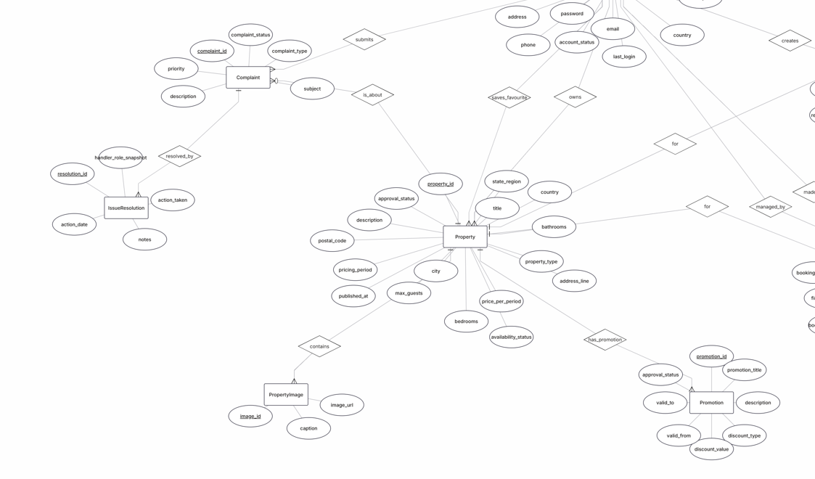
  - ER Diagram (continues on the other page)

Continues on the other page
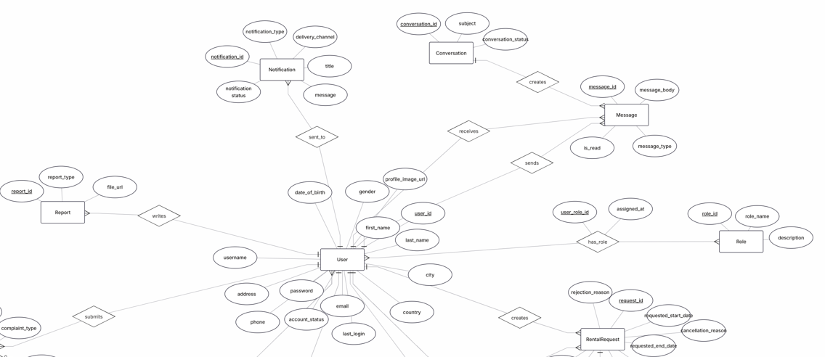

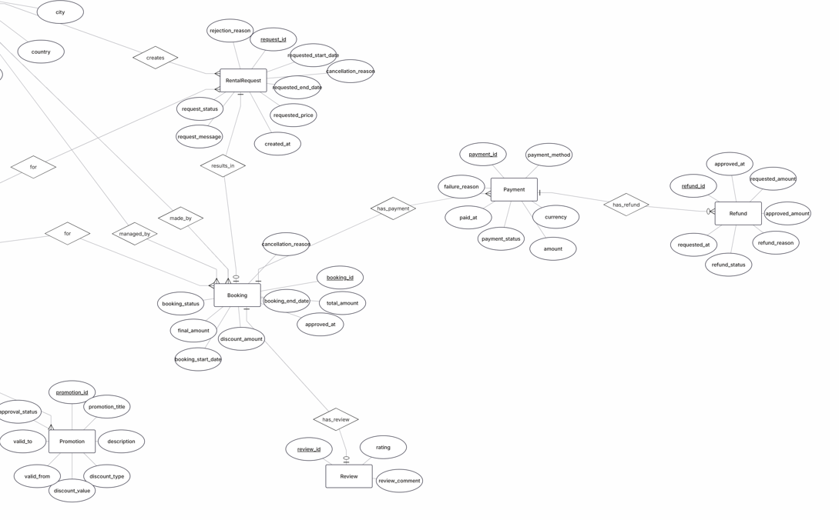

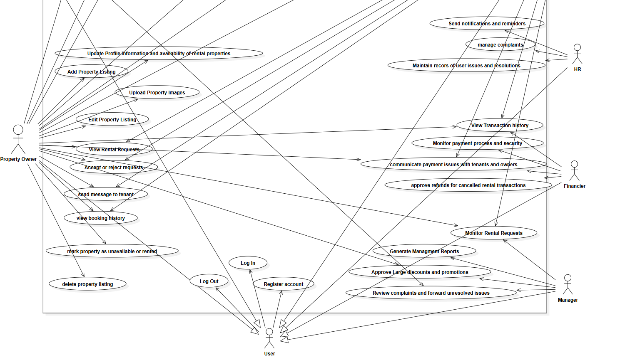
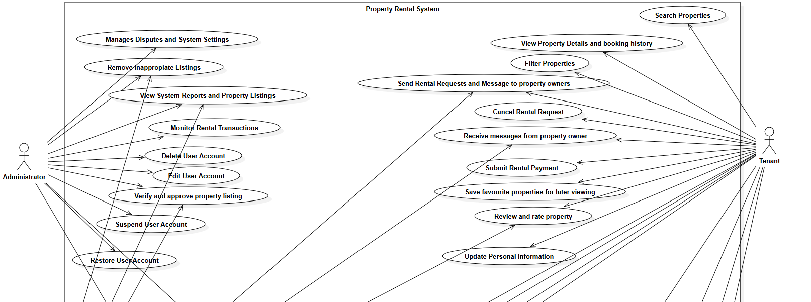
  - Use Case Diagram (general)

  - Activity Diagram

Activity and State Diagrams
FR1- Update personal information (Done by: Anisa Domi)
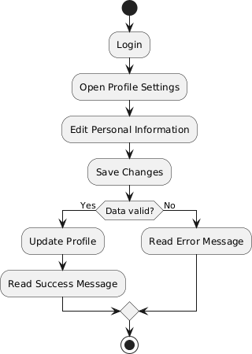

FR2 - Search properties (Done by: Anisa Domi)
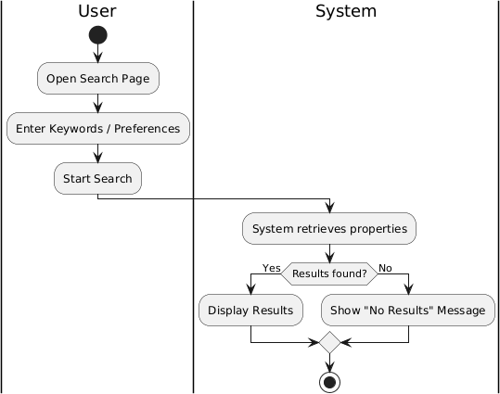

FR3 - Filter properties (Done by: Anisa Domi)

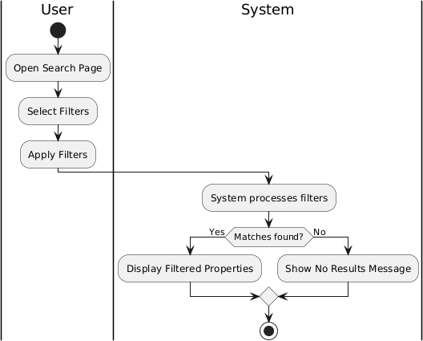

FR4 - View property details and booking history. (Done by: Anisa Domi)

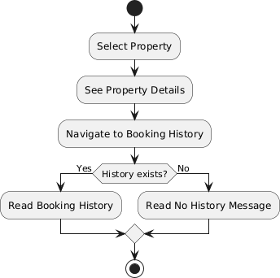

FR5 - Send rental requests and message to property owners. (Done by: Anisa Domi)

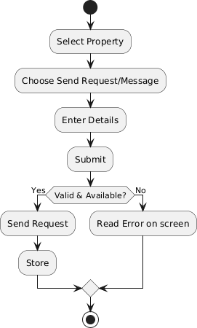

FR6 - Cancel rental request (Done by: Anisa Domi)

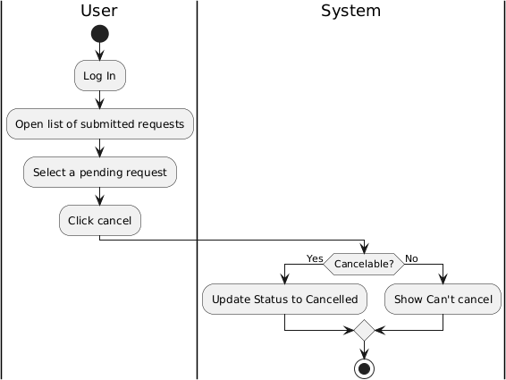

FR7 - Receive messages from property owners. (Done by: Haidi Toto)

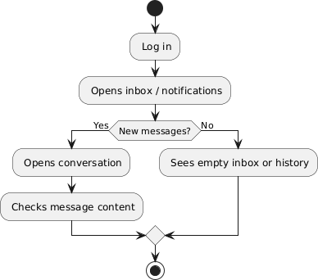

FR8 – Submit rental payments. (Done by: Haidi Toto)
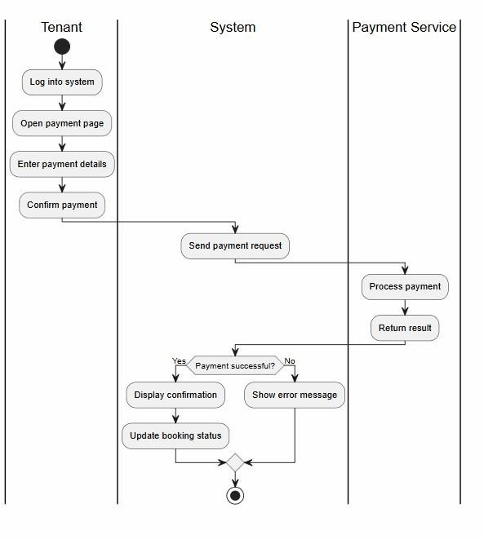

FR9 - Save favourite properties for later viewing. (Done by: Haidi Toto)

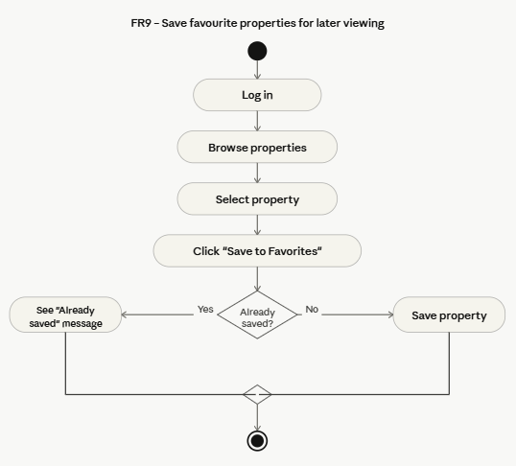

FR10 – Review and Rate property (Done by: Haidi Toto)

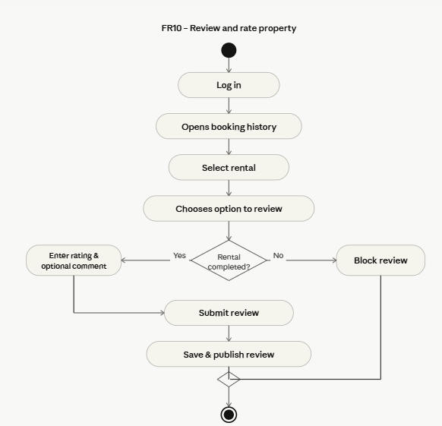

FR11 - Update Profile Information and availability of rental properties (Done by: Haidi Toto)
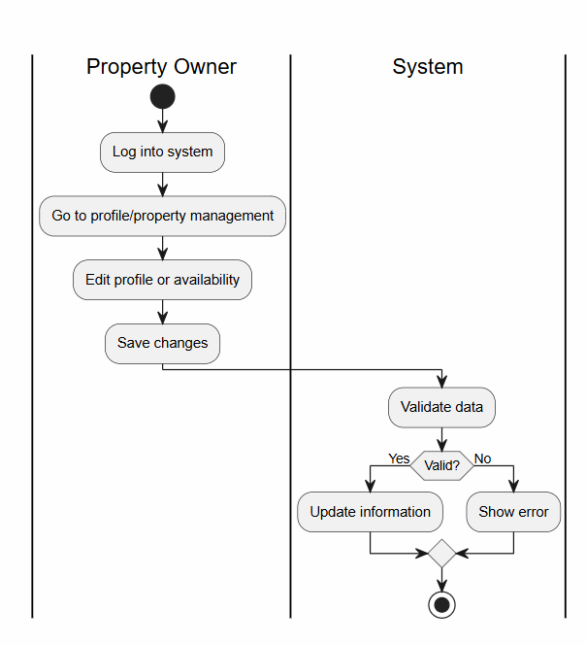

FR12 - Add Property Listing (Done by: Haidi Toto)
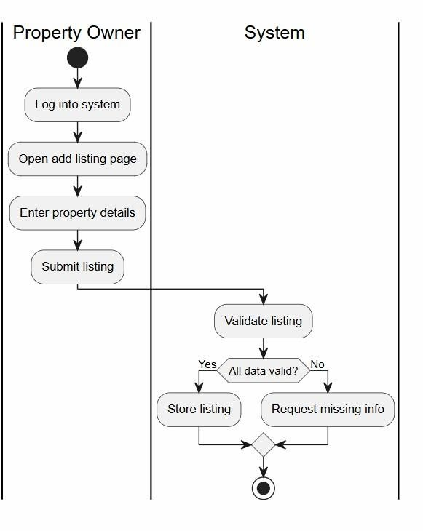

FR13 - Upload Property Images (Done by: Ledio Tafciu)
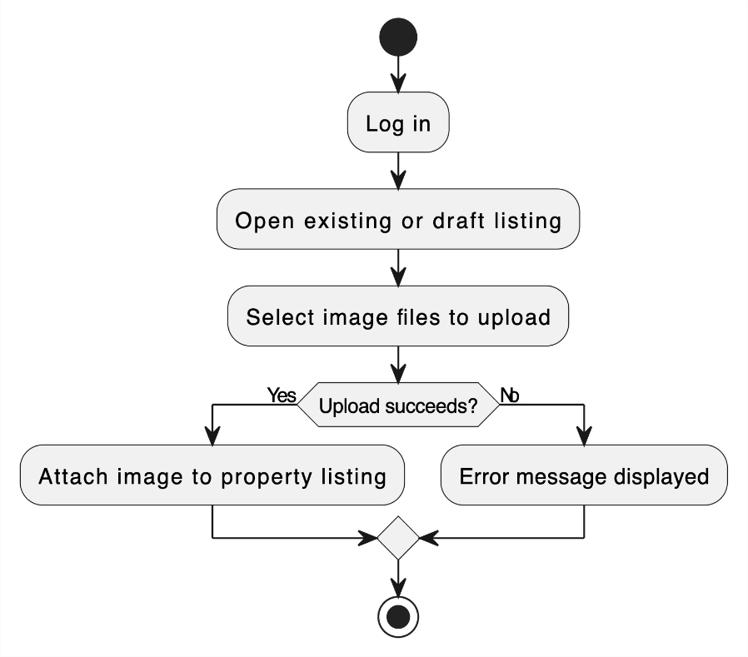

FR14 - Edit Property Listing (Done by: Ledio Tafciu)

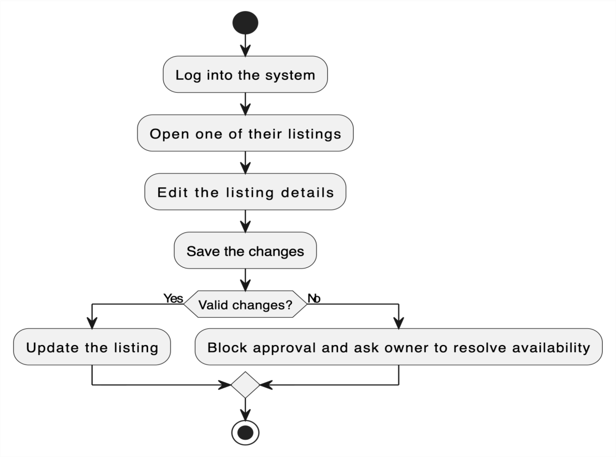

FR15 - Delete Property Listing (Done by: Ledio Tafciu)
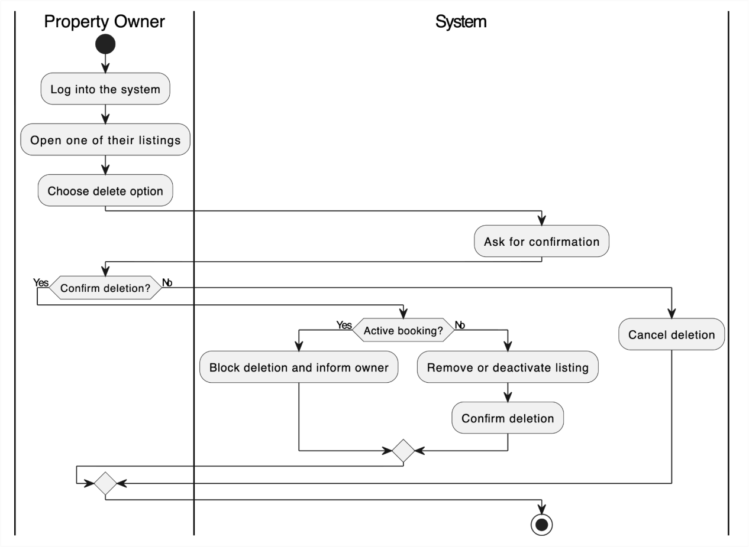

FR16 - View Rental Requests (Done by: Ledio Tafciu)
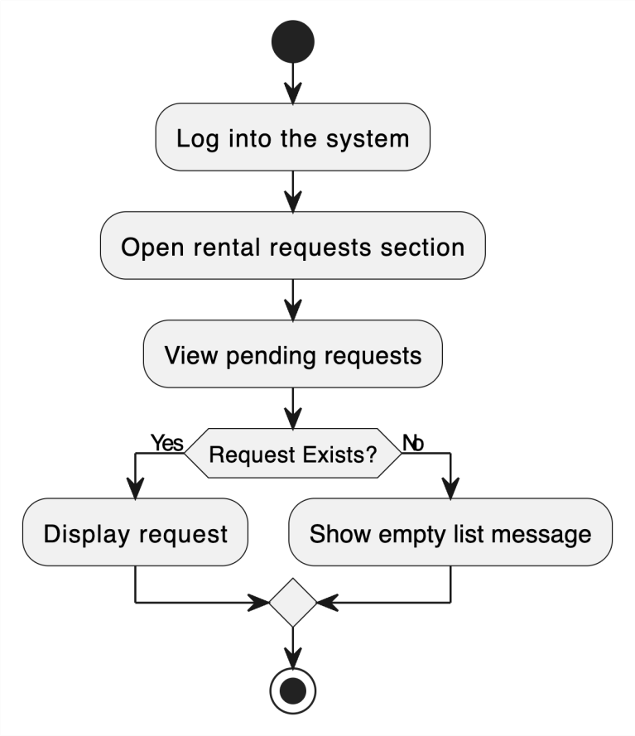

FR17 - Accept or Reject Rental Request (Done by: Ledio Tafciu)
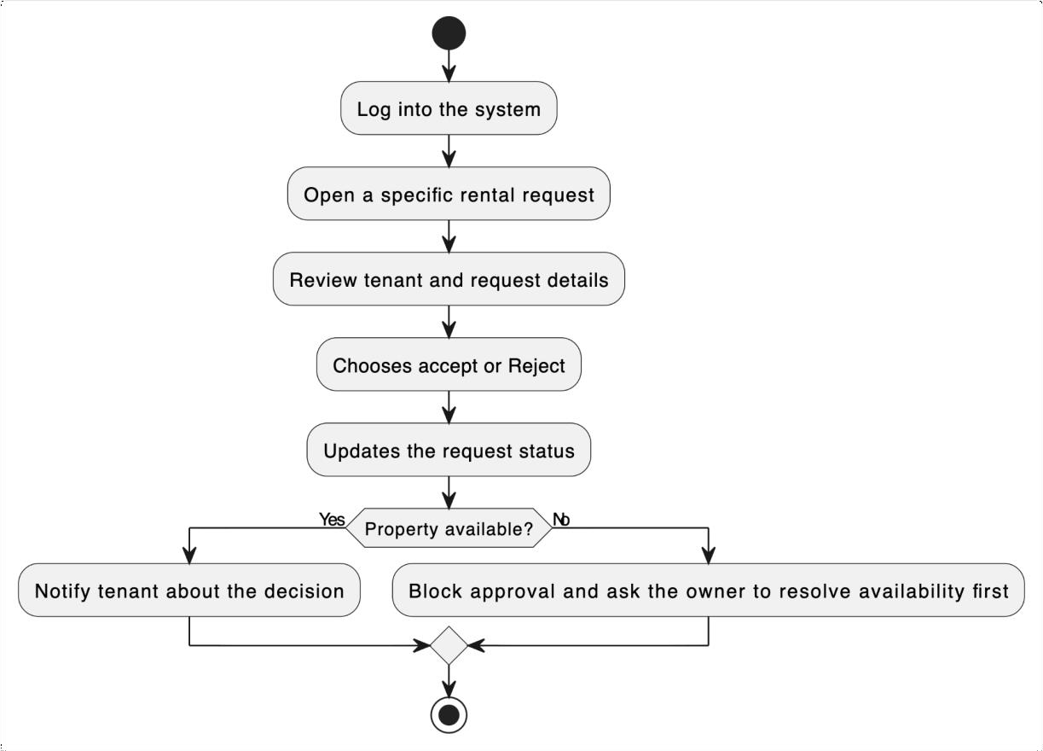

FR18 - Send Message to Tenant (Done by: Ledio Tafciu)
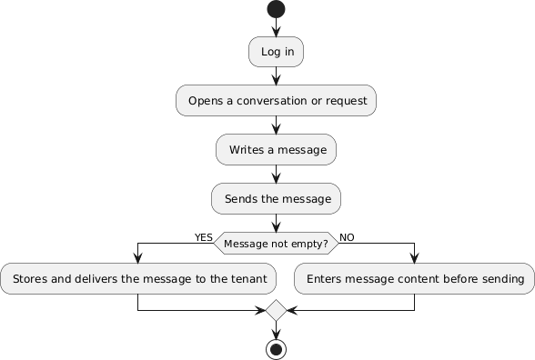

FR19 - View Booking History (Done by: Desard Lybeshari)

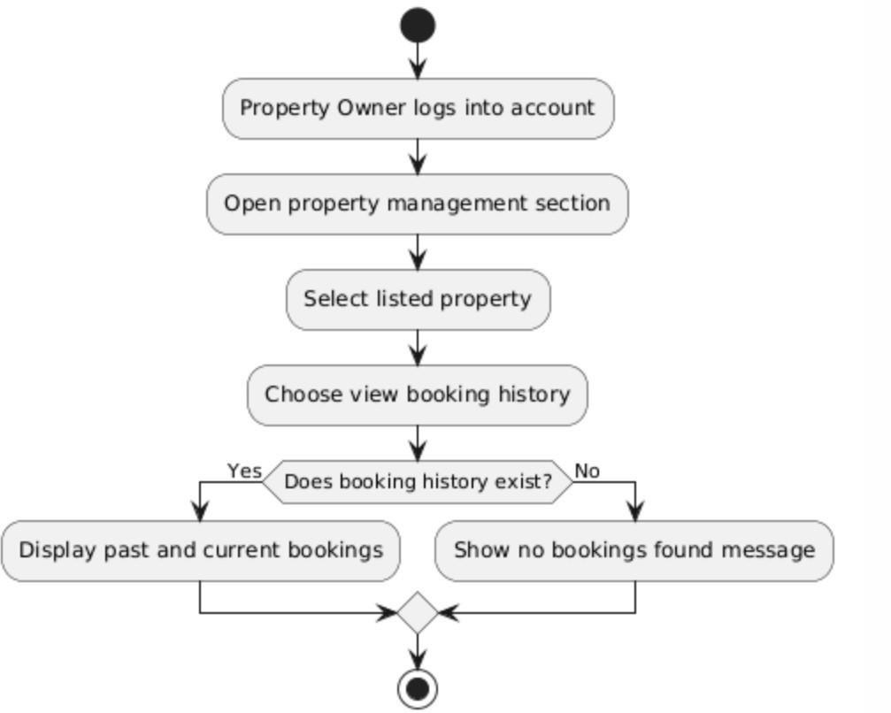

FR20 - Mark Property as Unavailable or Rented (Done by: Desard Lybeshari)

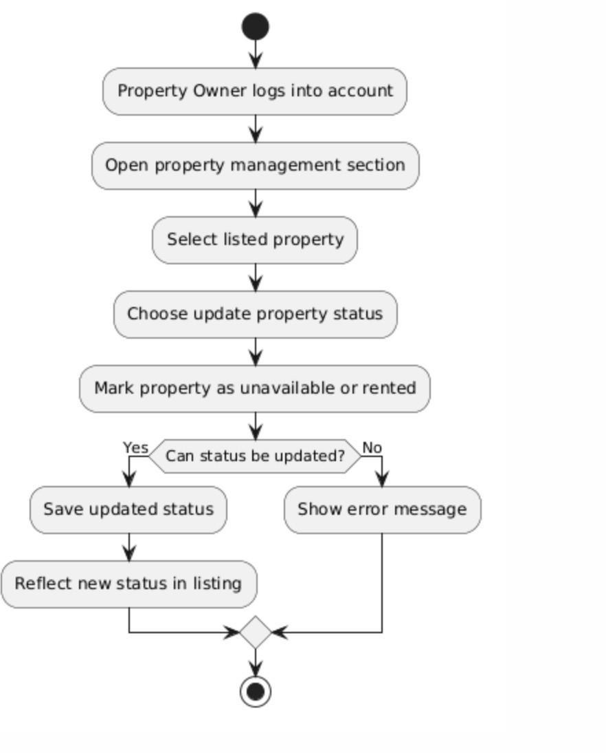

FR21 - Edit User Accounts (Done by: Desard Lybeshari)
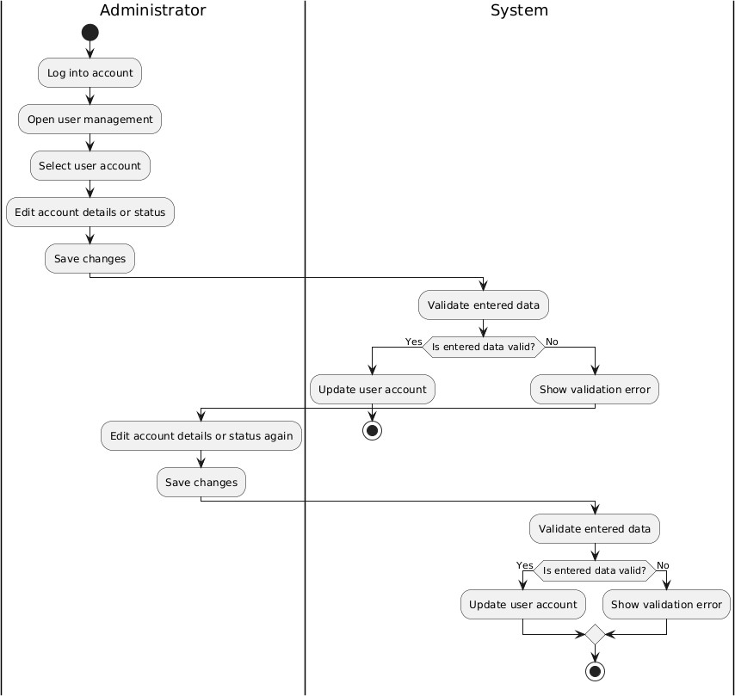
FR22 - Delete User Accounts (Done by: Desard Lybeshari)

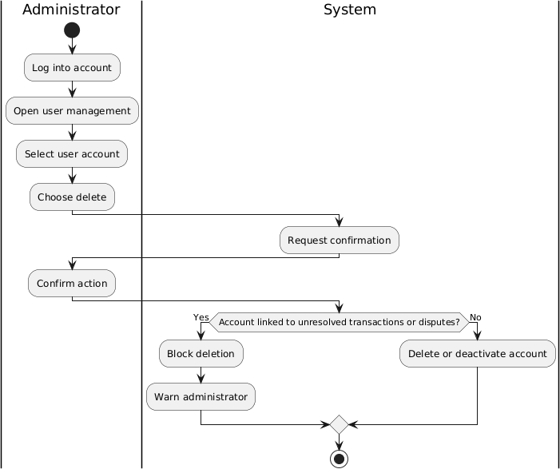

FR23 - Monitor Rental Transactions (Done by: Desard Lybeshari)

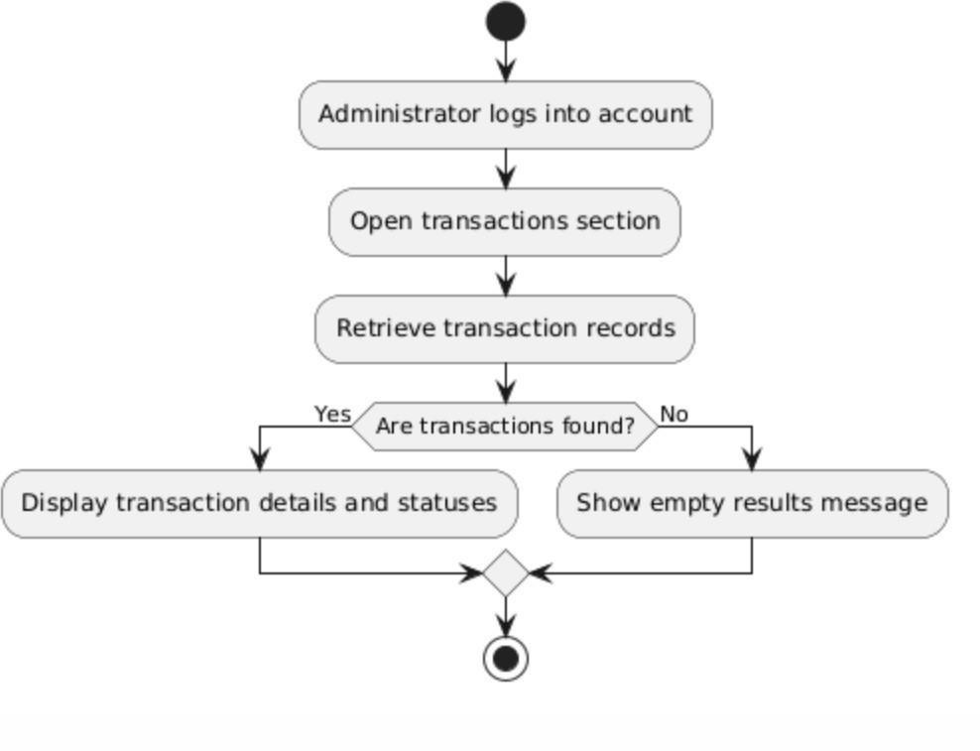

FR24 - View System Reports and Property Listings (Done by: Desard Lybeshari)

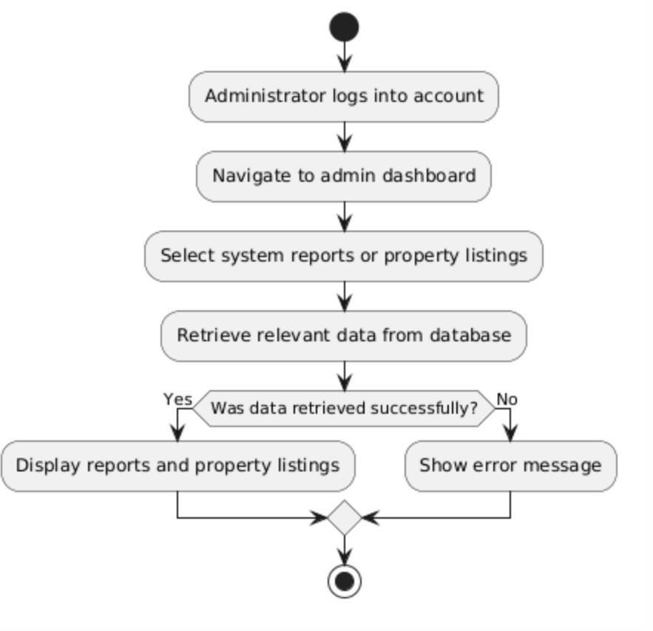

FR25 - Remove Inappropriate Listings (Done by: Matias Bali)

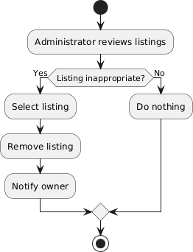

FR26 - Manage Disputes and System Settings (Done by: Matias Bali)
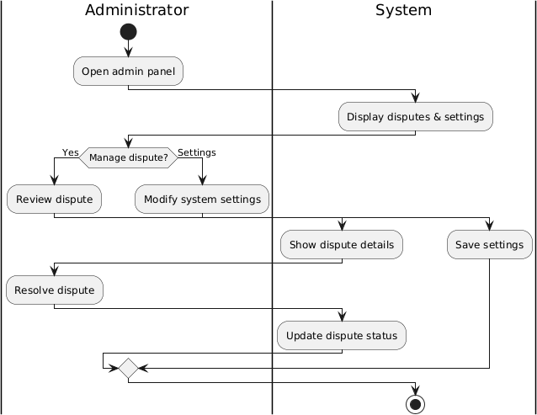

FR27 - Restore User Accounts (Done by: Matias Bali)
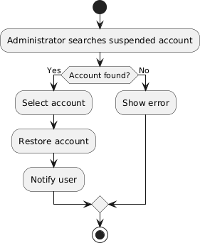

FR28 - Suspend User Accounts (Done by: Matias Bali)
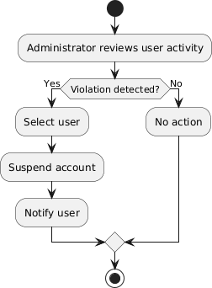

FR29 - Verify and Approve property listings (Done by: Matias Bali)
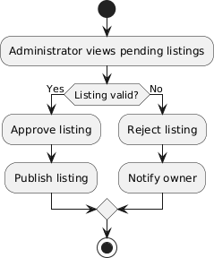

FR30 - Monitor Rental Requests (Done by: Matias Bali)

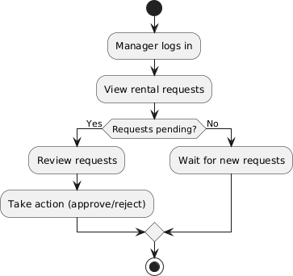

FR31 - Generate Management Reports (Done by: Ornelt Lemellari)

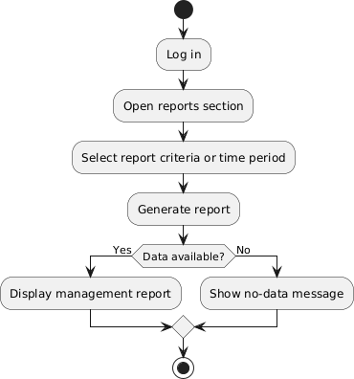

FR32 - Approve Large Discounts and Promotions (Done by: Ornelt Lemellari)

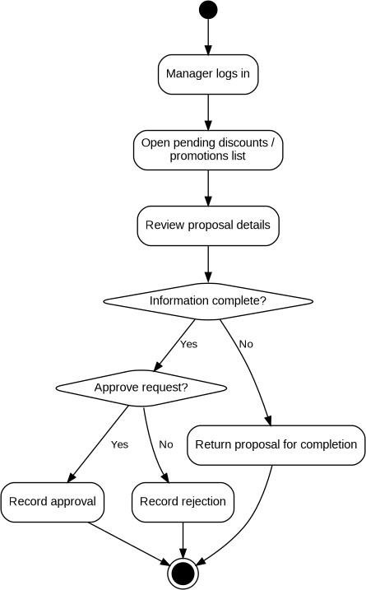

FR33 - Review Complaints and Forward Unresolved Issues (Done by: Ornelt Lemellari)

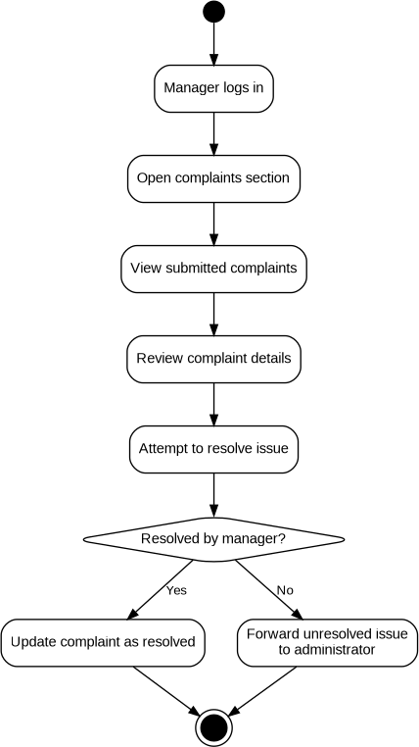

FR34 - View Transaction History (Done by: Ornelt Lemellari)

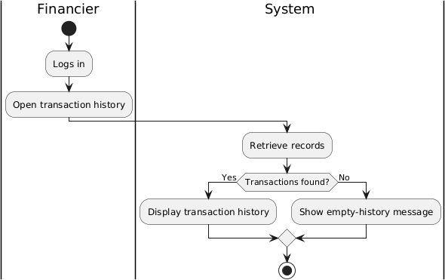

FR35 - Monitor Payment Process and Security (Done by: Ornelt Lemellari)
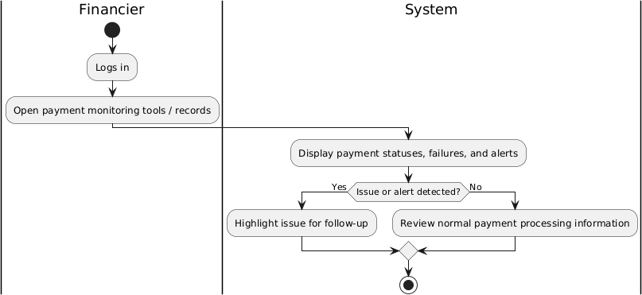

FR36 - Communicate Payment Issues with Tenants and Owners (Done by: Ornelt Lemellari)

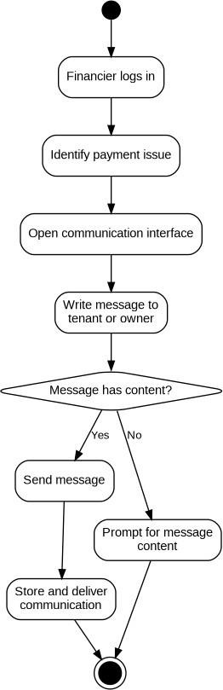

FR37 - Approve Refunds for cancelled Rental Transactions (Done by: Kevin Muho)

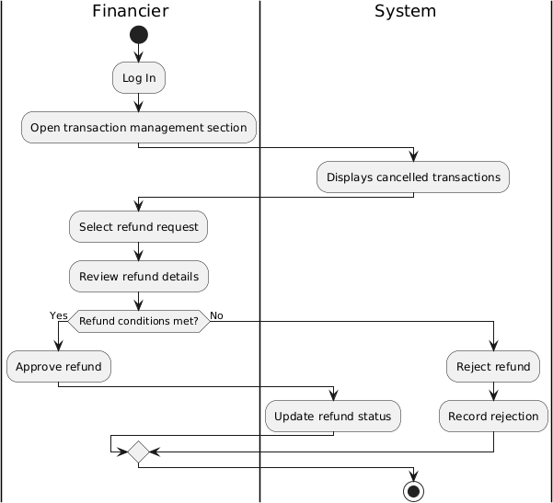

FR38 - Manage Complaints (Done by: Kevin Muho)

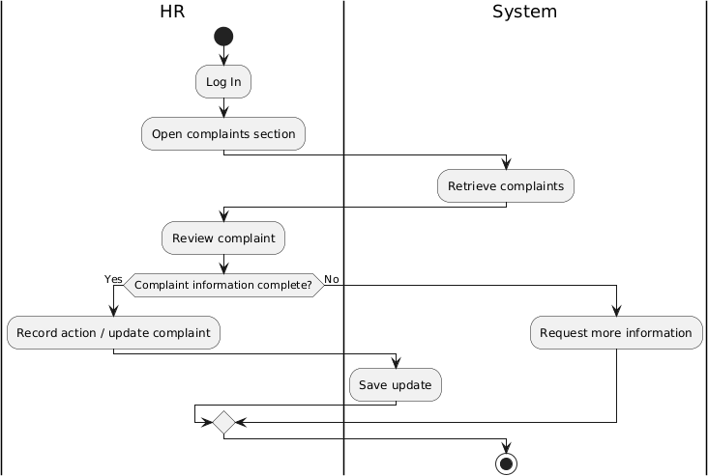
FR39 - Send Notifications and Reminders (Done by: Kevin Muho)

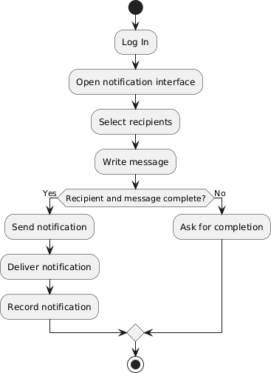

FR40 - Maintain Records of User Issues and Resolutions (Done by: Kevin Muho)

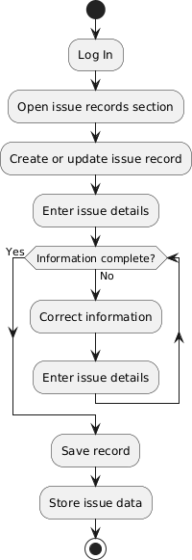

FR41 - Register Account (Done by: Kevin Muho)

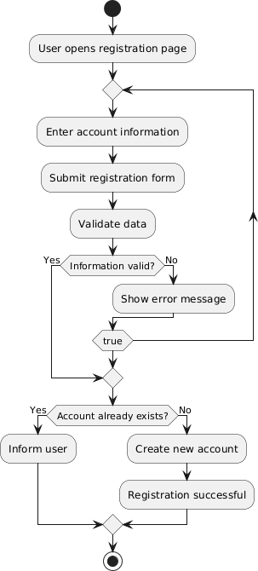

FR42 - Log In (Done by: Kevin Muho)

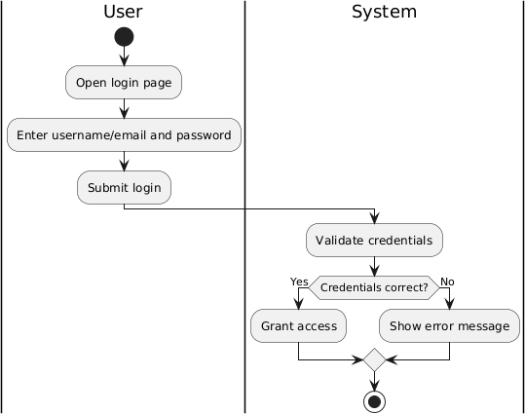

FR43 – Log Out (Done by: Kevin Muho)

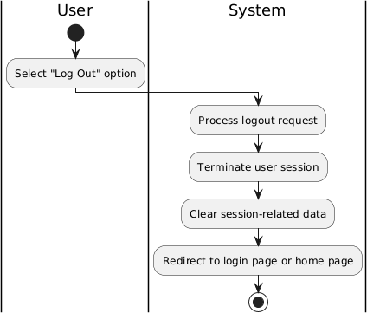

5.4. Class diagram.(continues on other page)
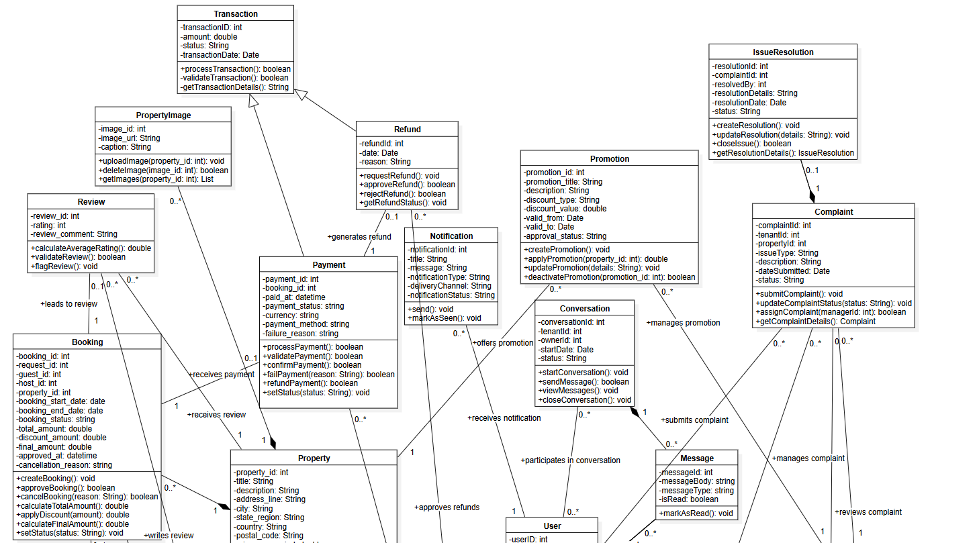

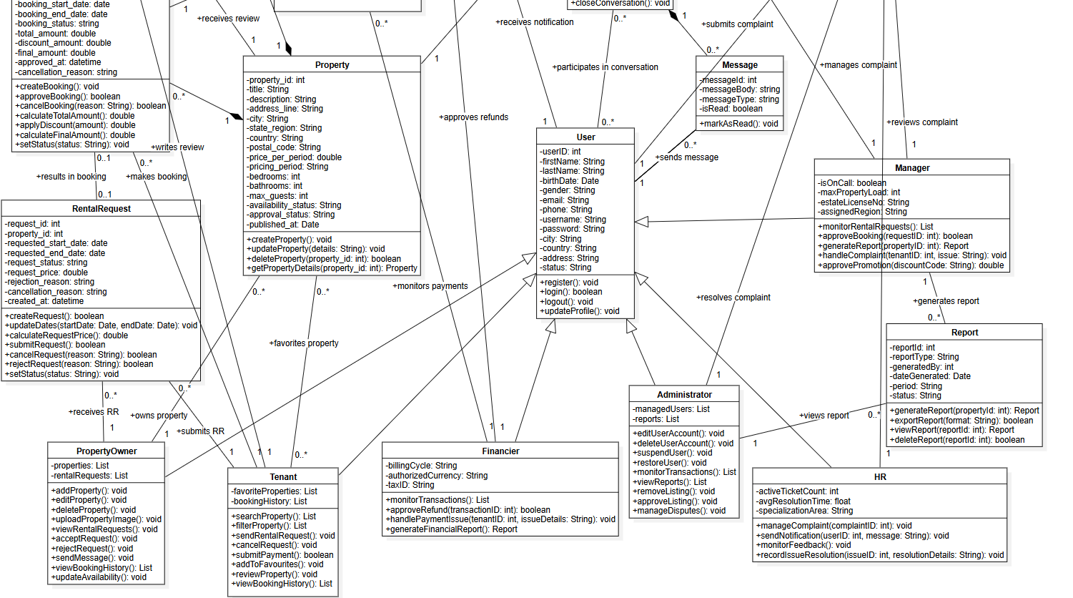

  - State diagram

State Diagrams
- Tenant
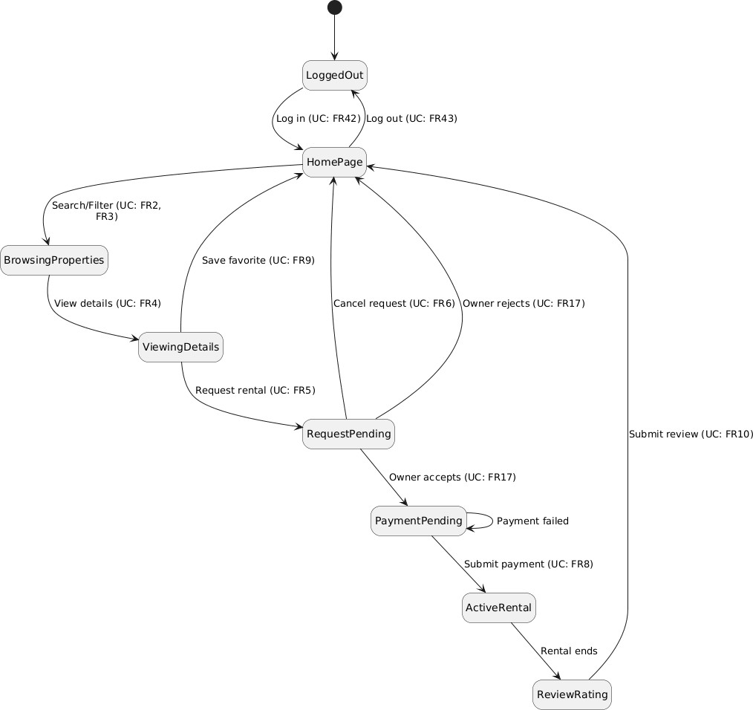

- Property owners

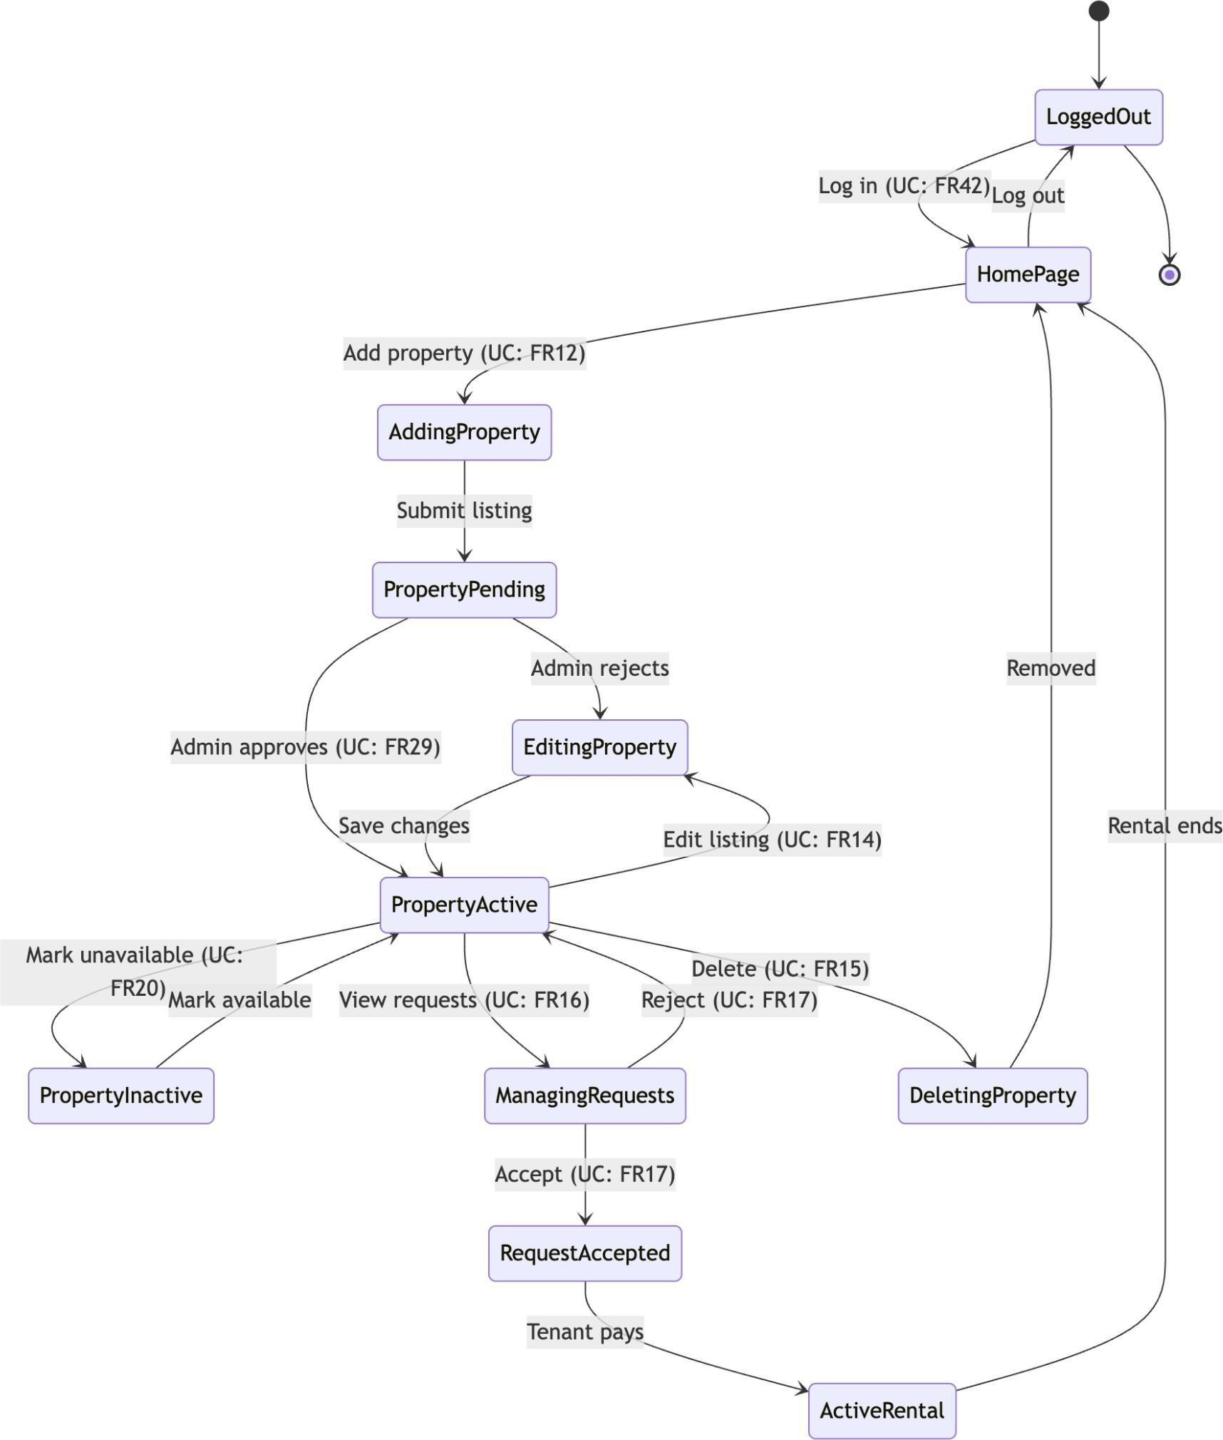

- Administrator

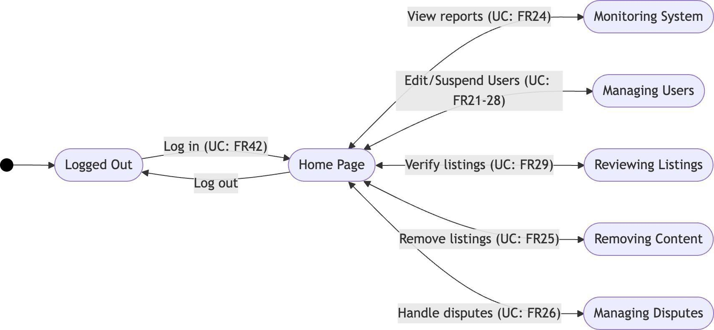

- Manager
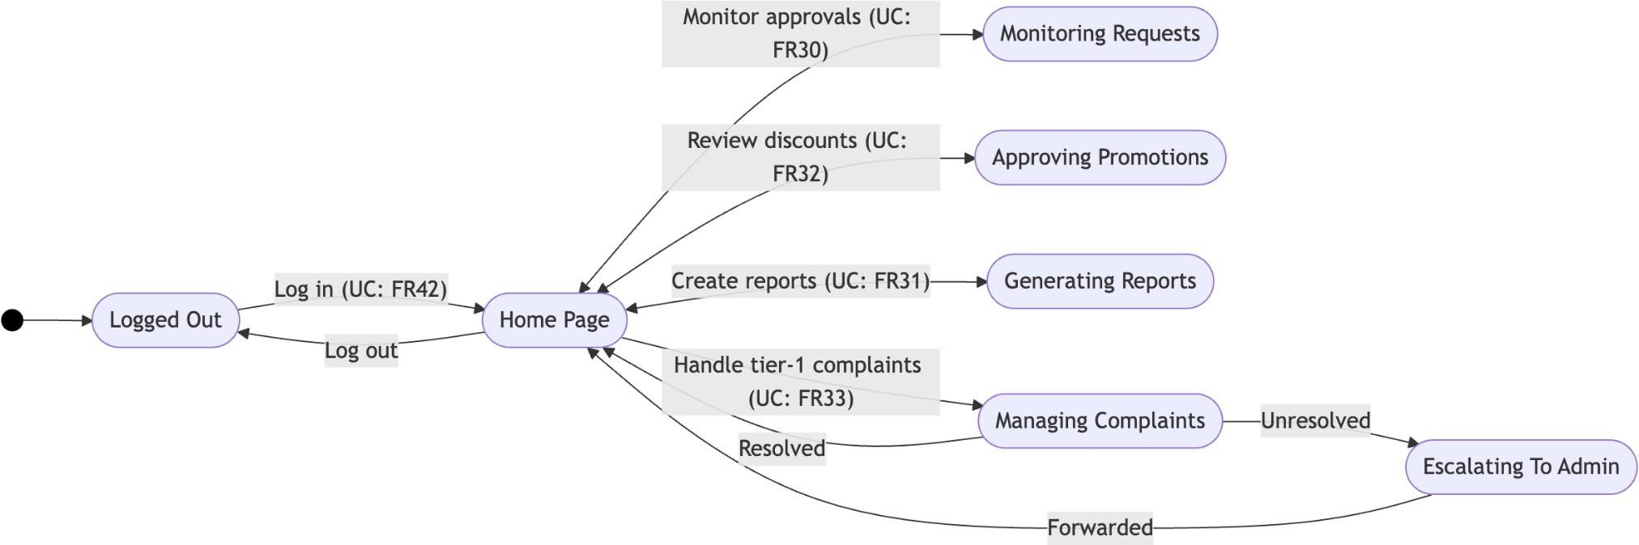

- Finanicer
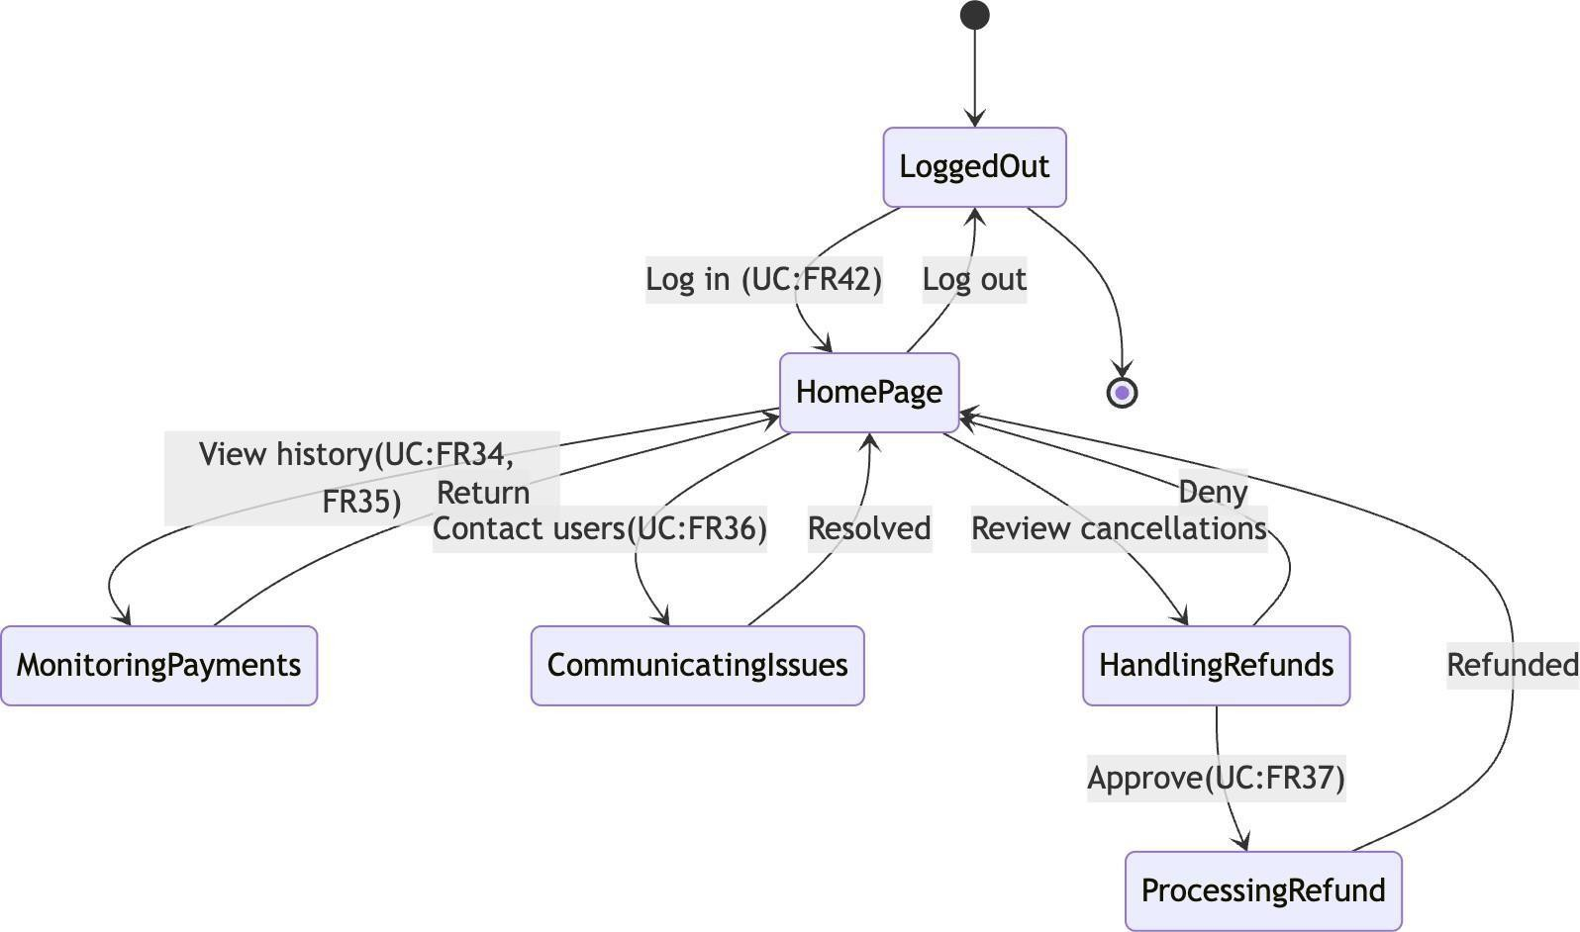

- HR
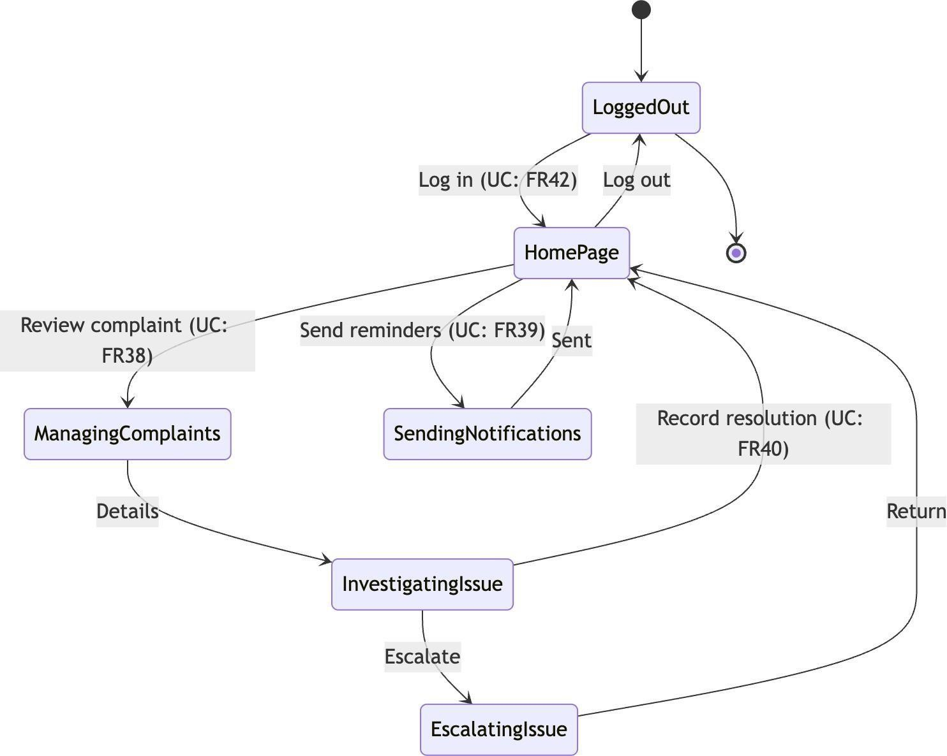

  - Sequence diagram.

Sequence Diagrams
FR01 - Update personal information (Done by: Anisa Domi)

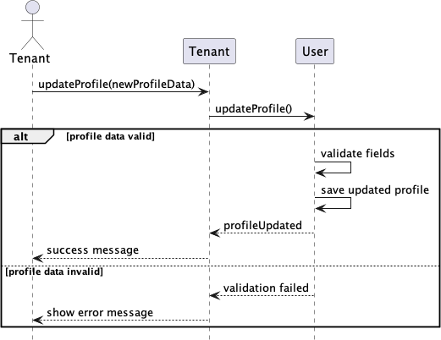

FR02 - Search properties (Done by: Anisa Domi)

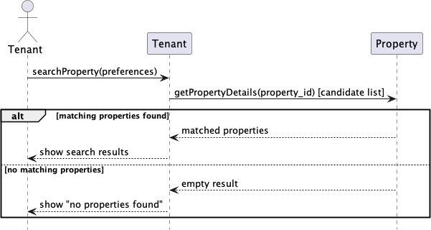

FR03 - Filter properties (Done by: Anisa Domi)
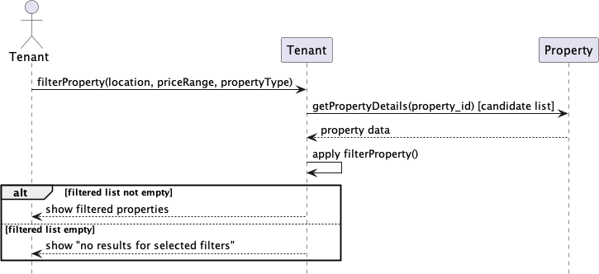

FR04 - View property details and booking history (Done by: Anisa Domi)

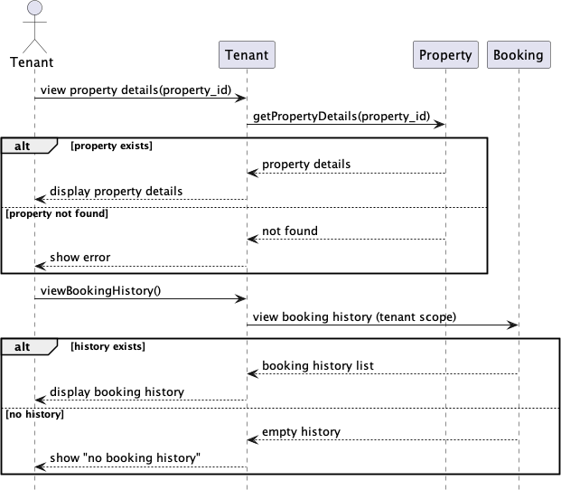

FR05 - Send rental requests and message to property owners (Done by: Anisa Domi)
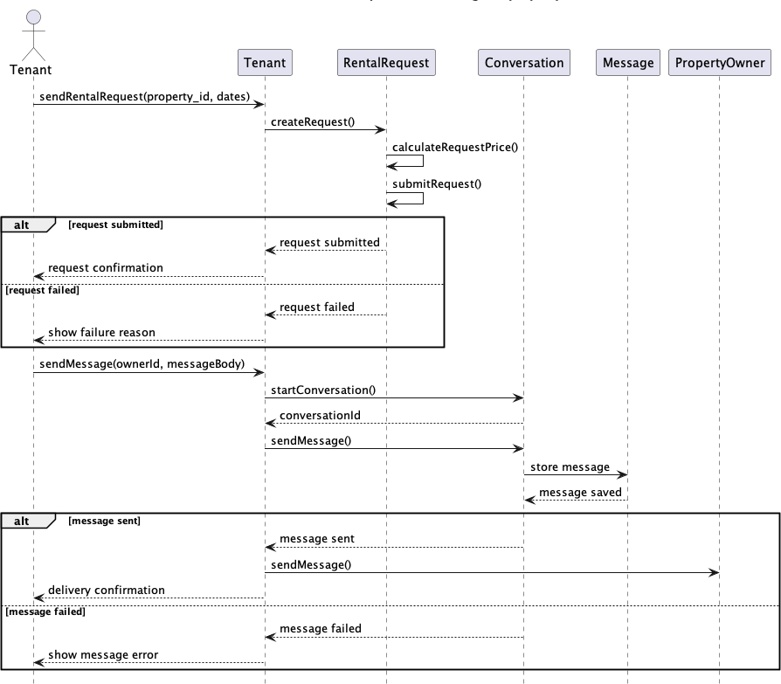

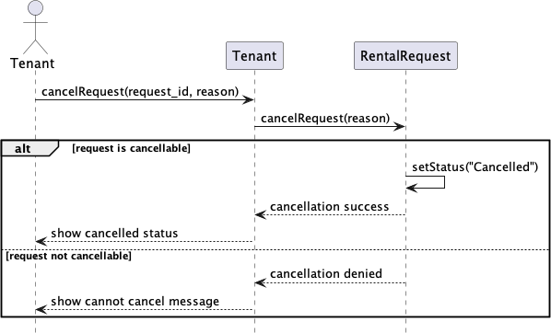

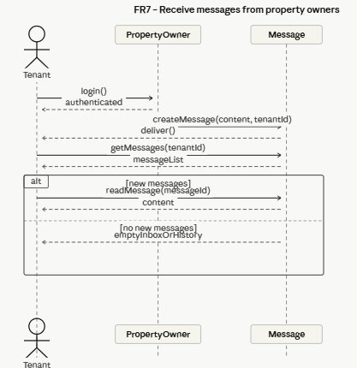
FR8 - Submit Rental Payments (Done by: Haidi Toto)
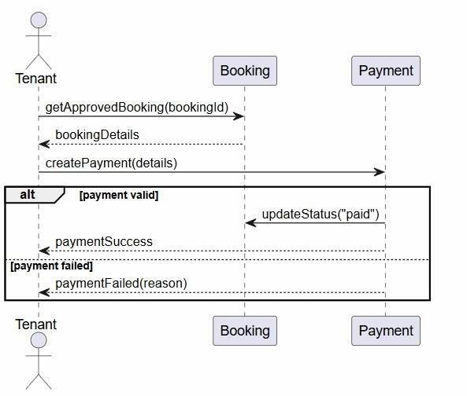

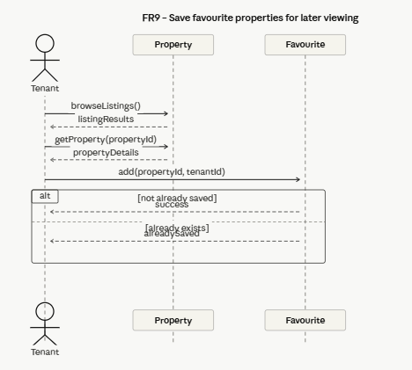
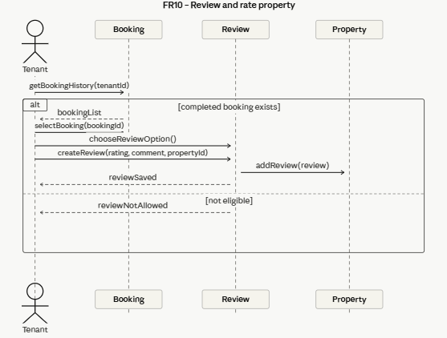
FR10 - Review and Rate Property (Done by: Haidi Toto)

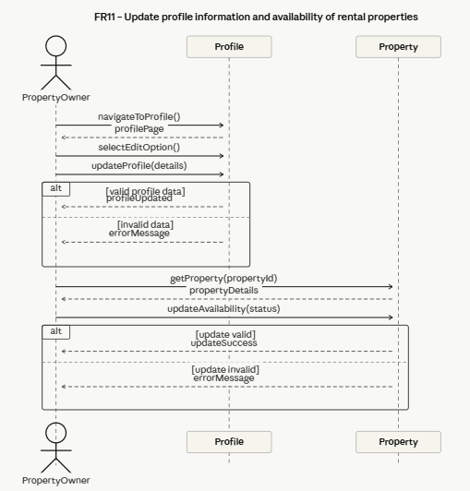
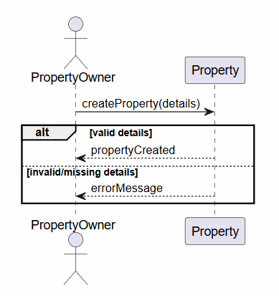
FR12 - Add Property Listing (Done by: Haidi Toto)

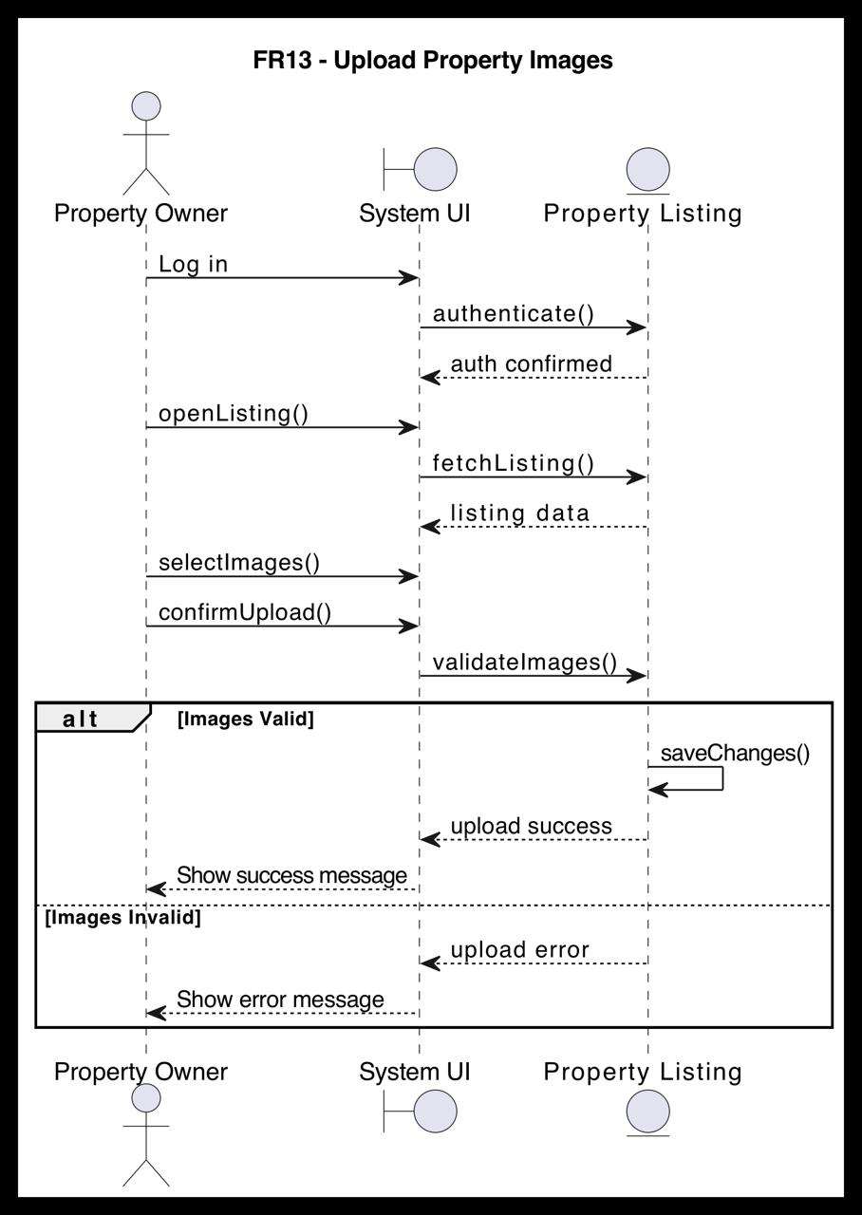

FR14 - Edit Property Listing (Done by: Ledio Tafciu)

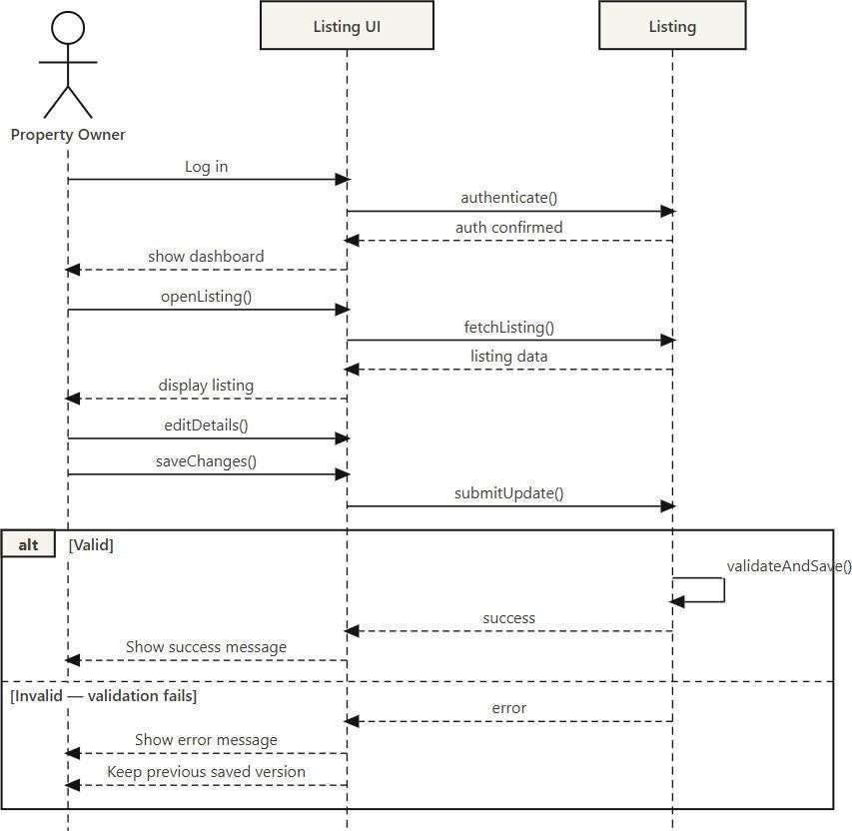

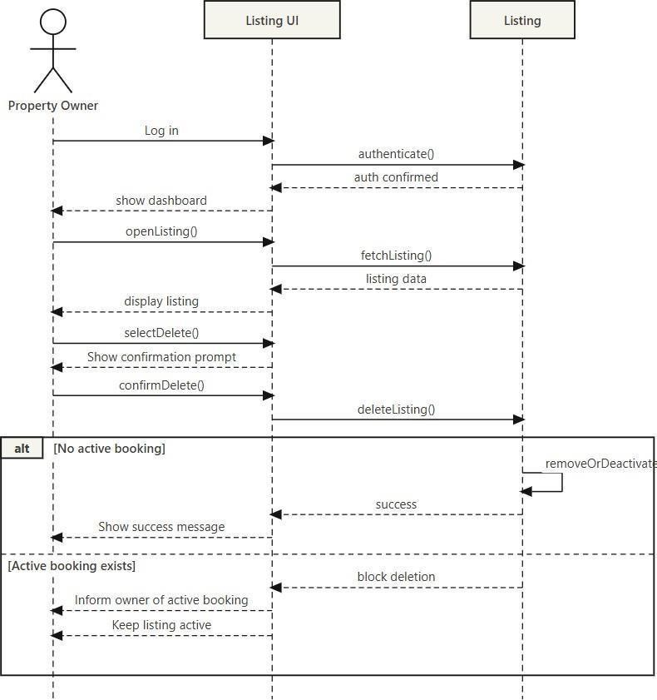

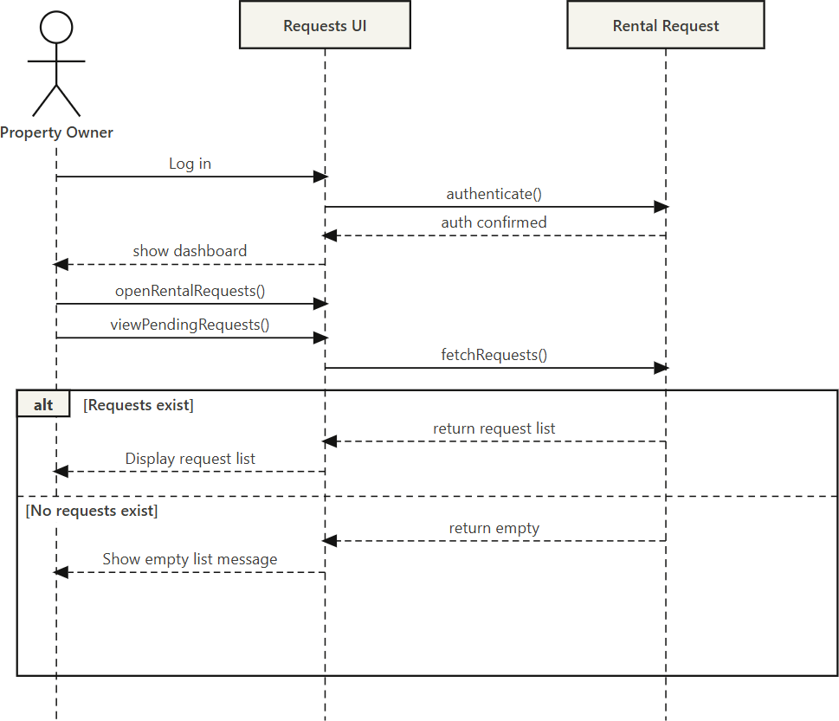

FR17 - Accept or Reject Rental Request (Done by:Ledio Tafciu)

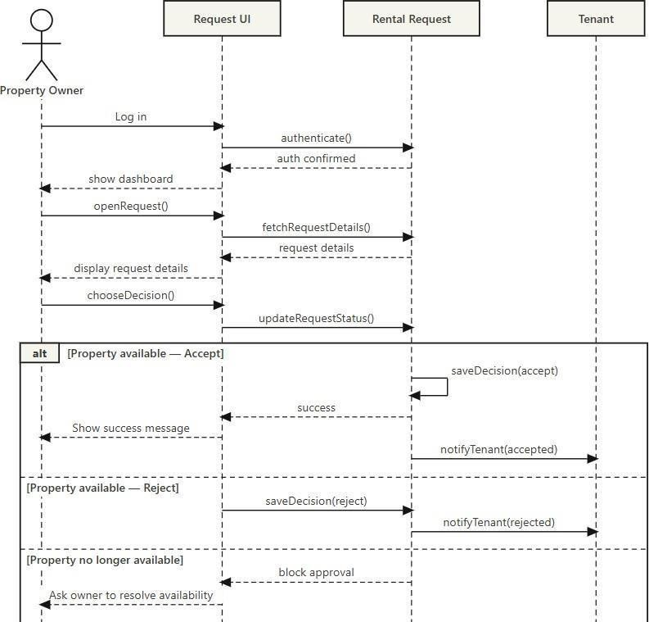

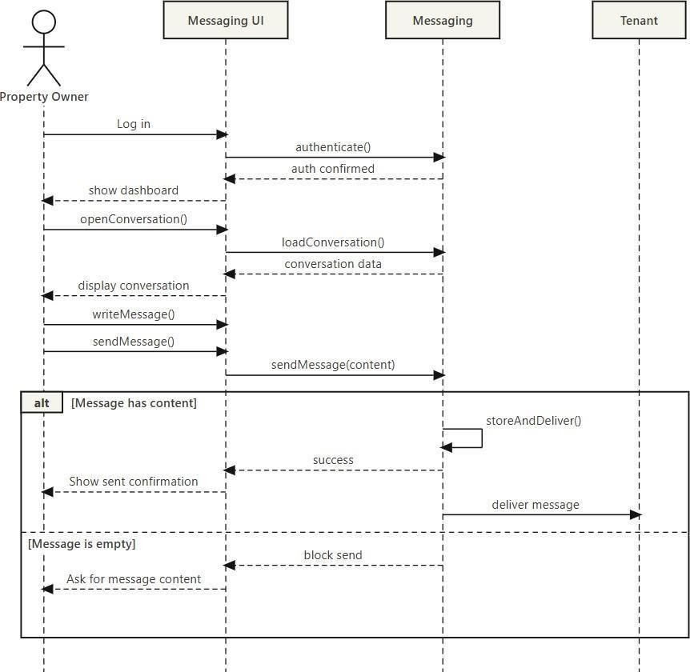

FR19 - View Booking History (Done by: Desard Lybeshari)

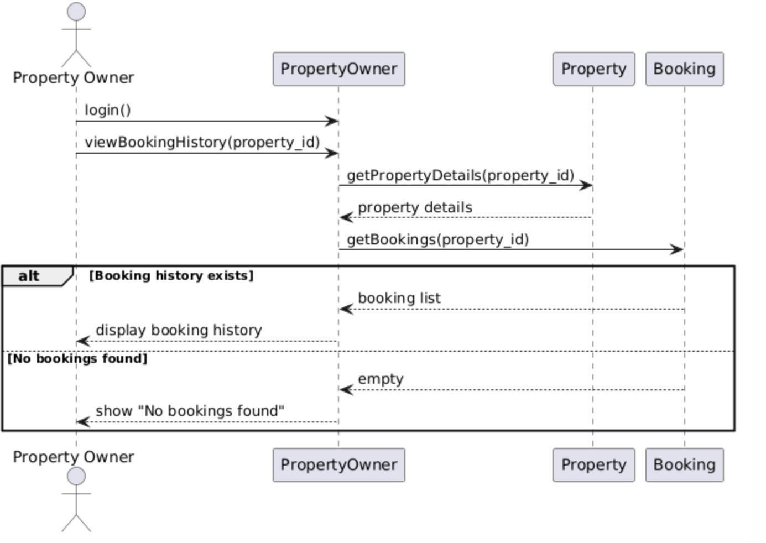

FR20 - Mark Property as Unavailable or Rented (Done by: Desard Lybeshari)

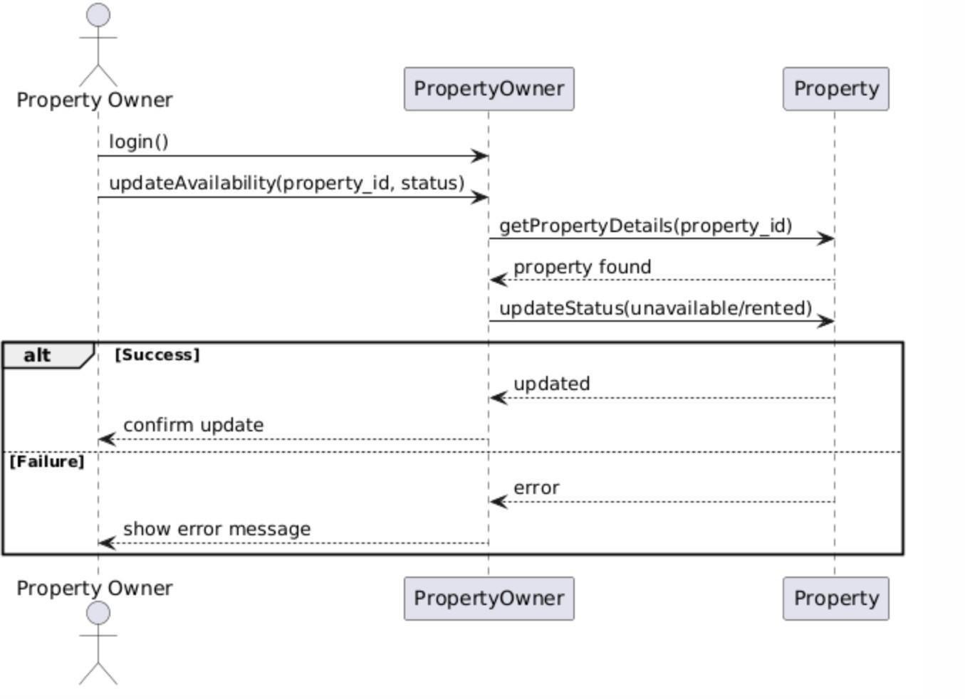

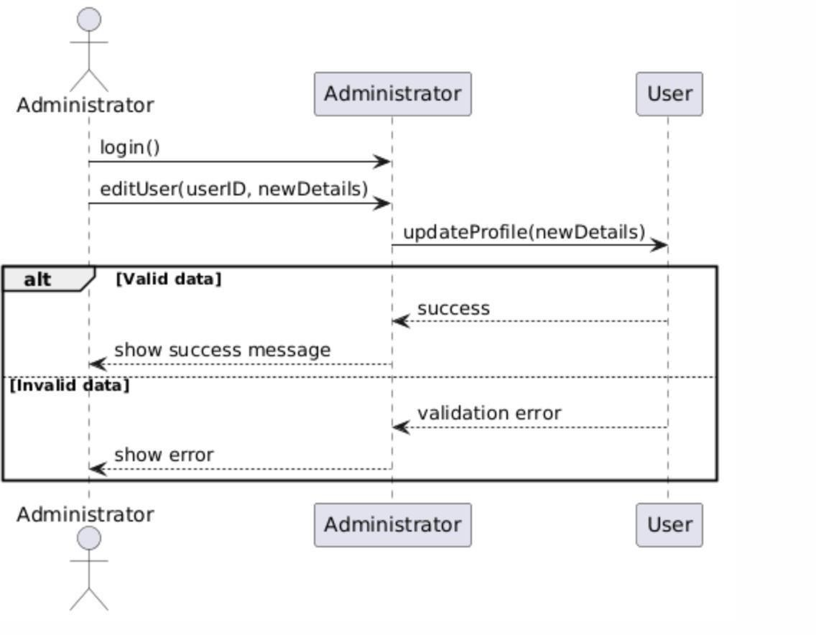

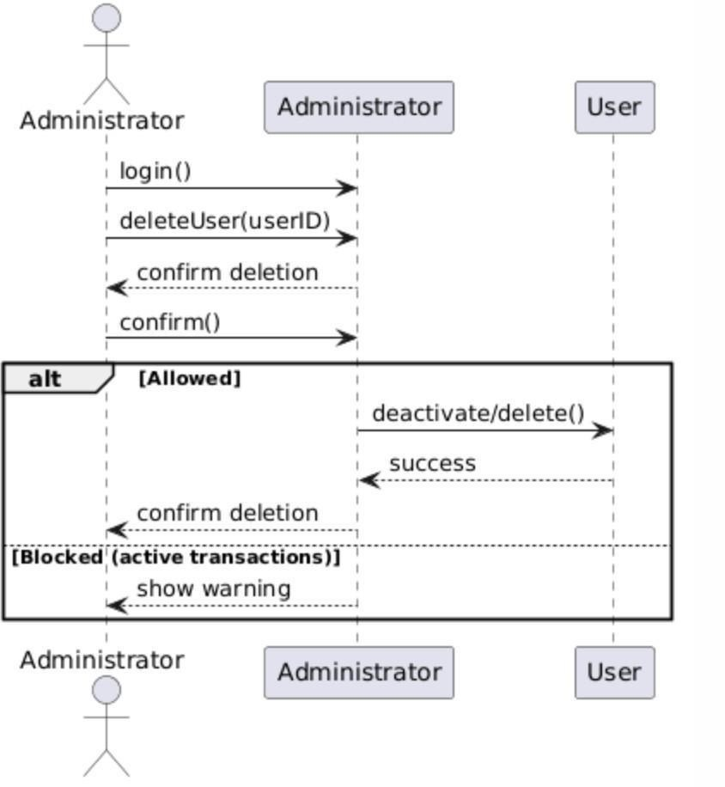

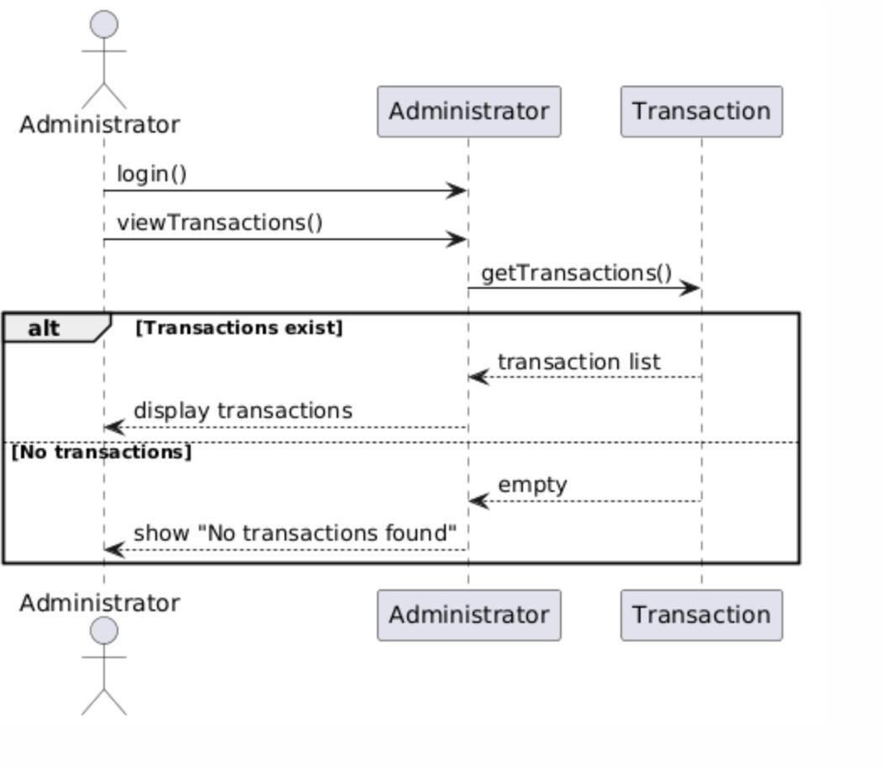

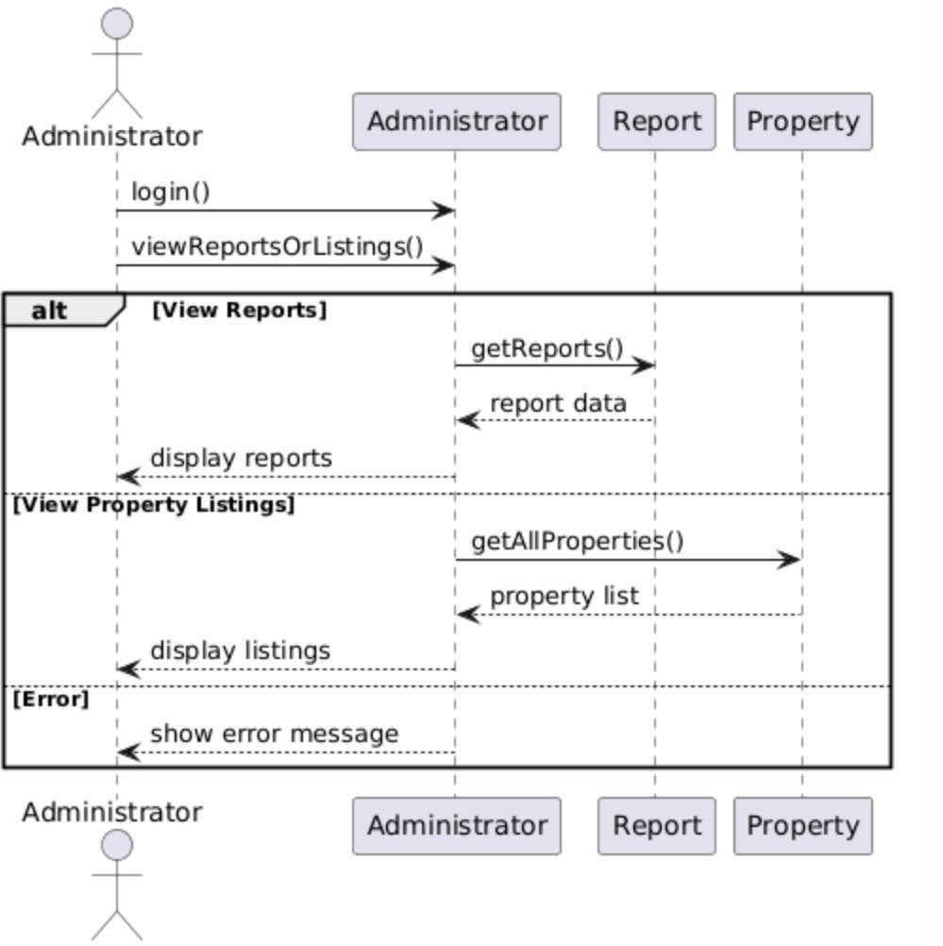

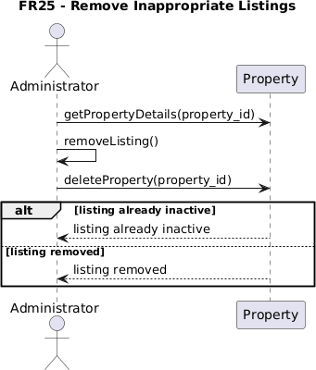

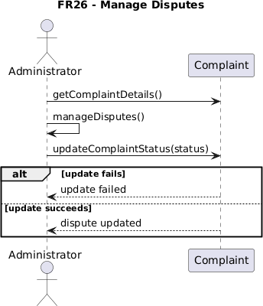

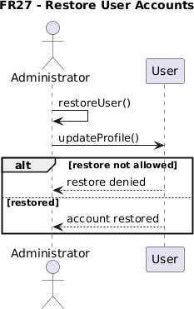

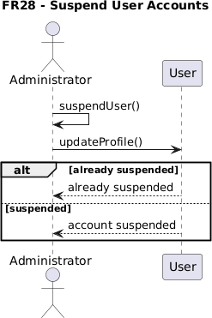

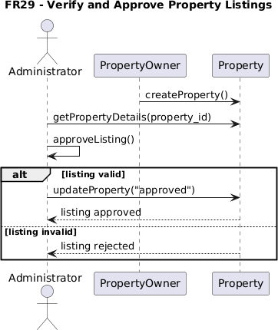

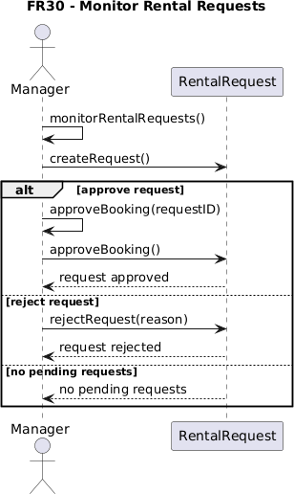

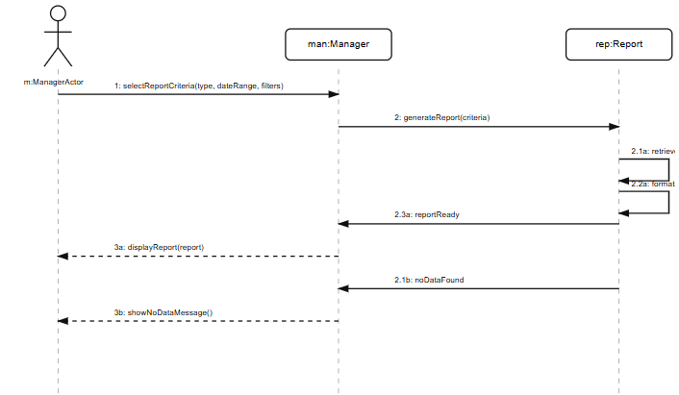

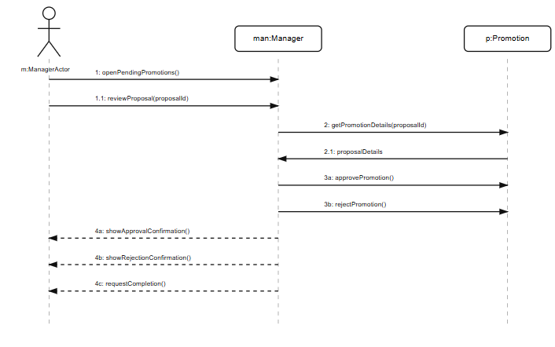

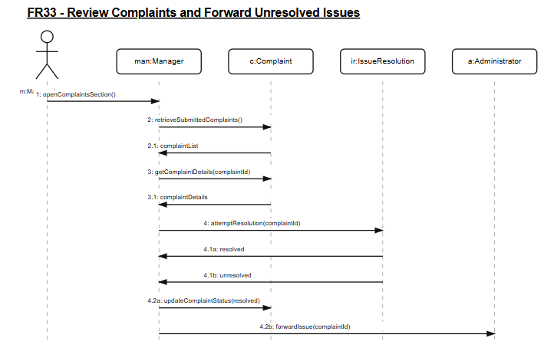

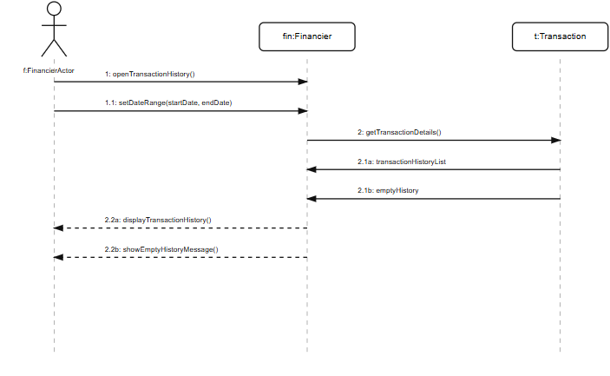

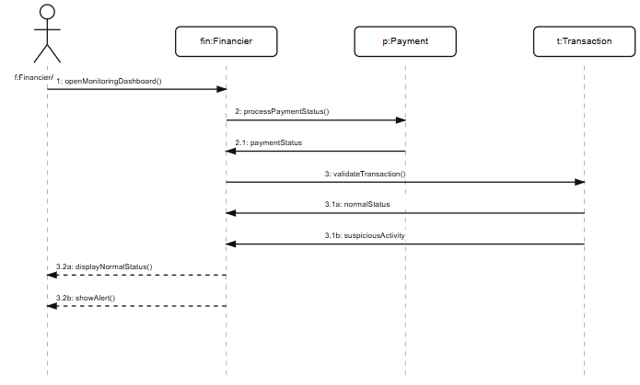

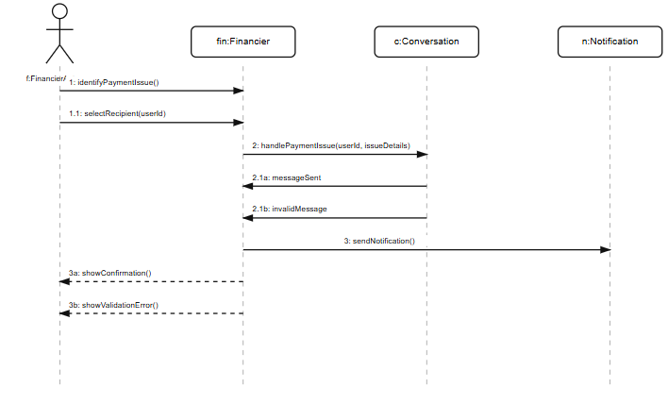

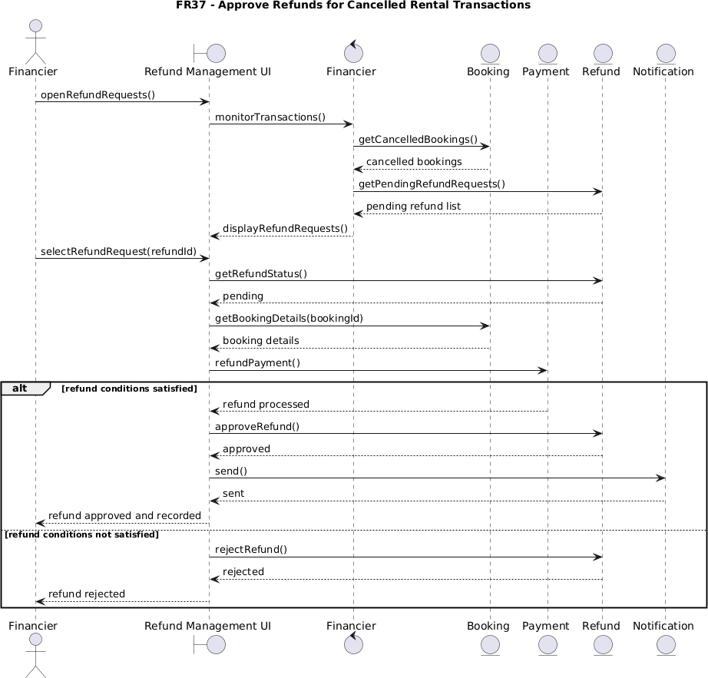

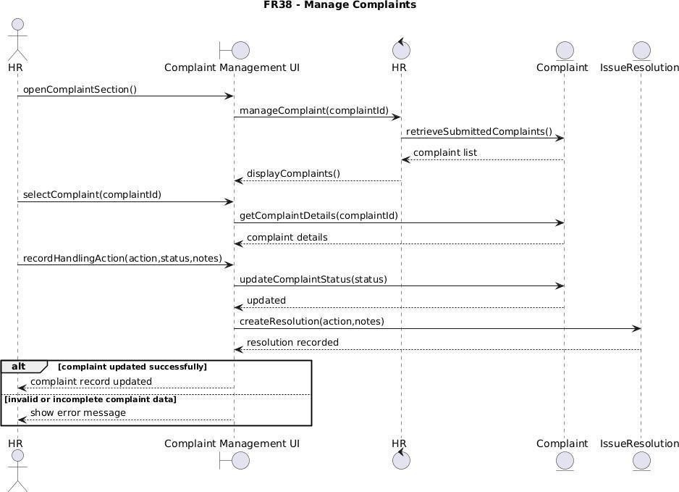

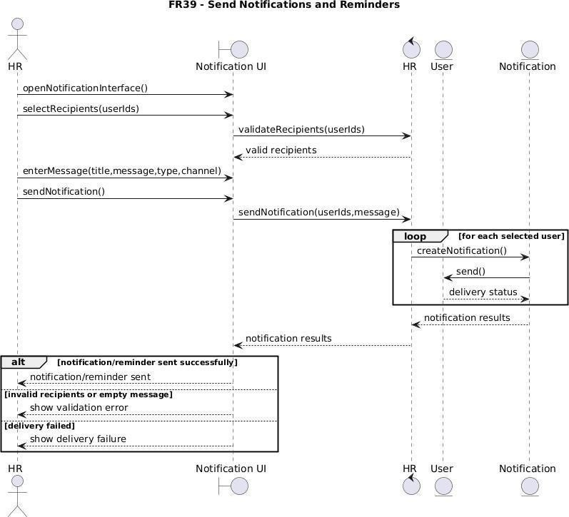

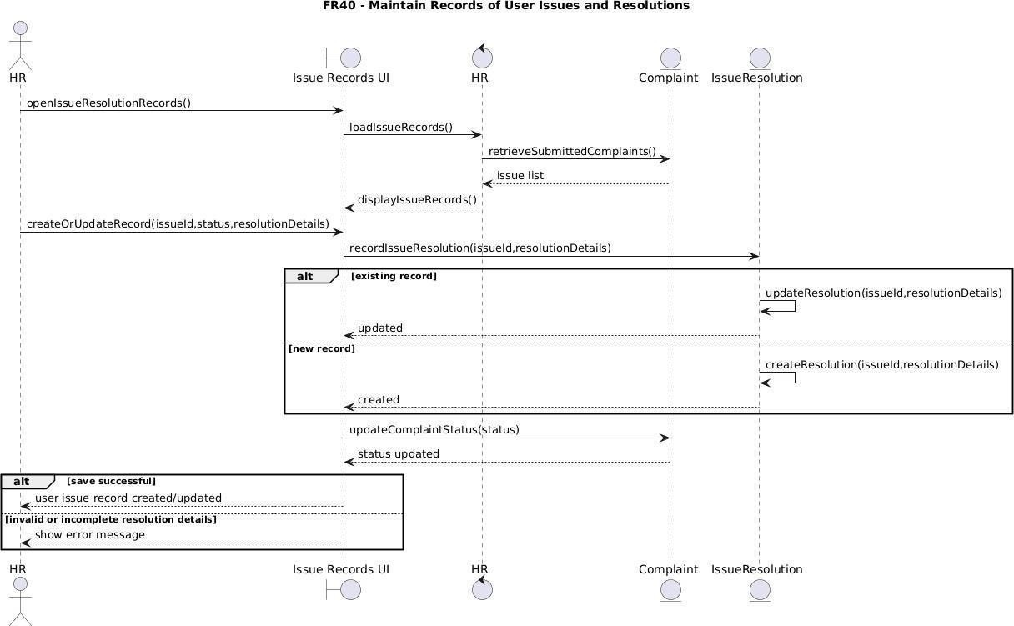

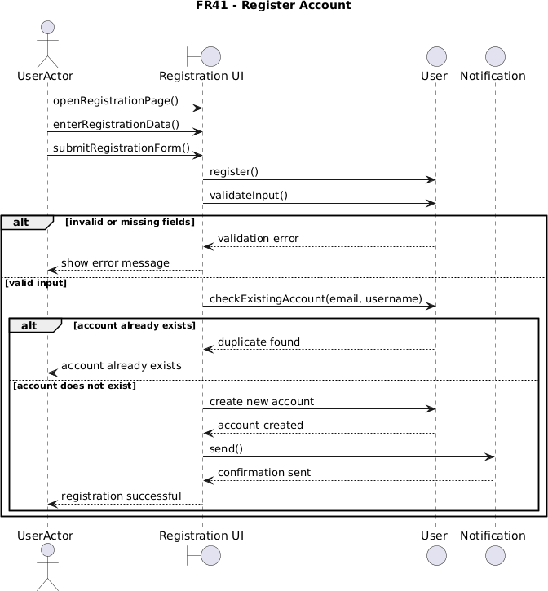

FR42 – Log In (Done by: Kevin Muho)

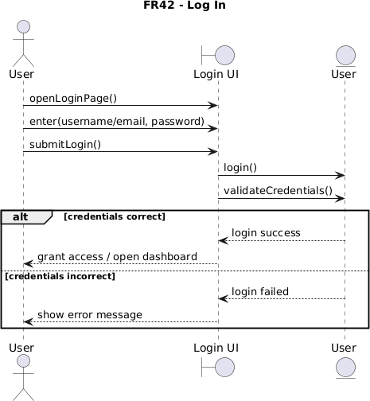

FR43 – Log Out (Done by: Kevin Muho)

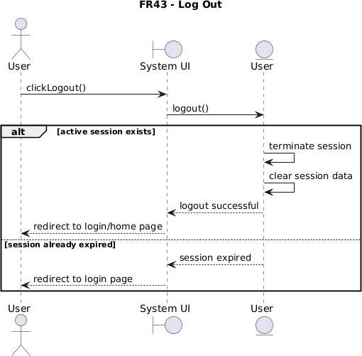

5.7. Collaboration diagram

Collaboration Diagrams

FR01 - Update personal information (Done by:Anisa Domi)
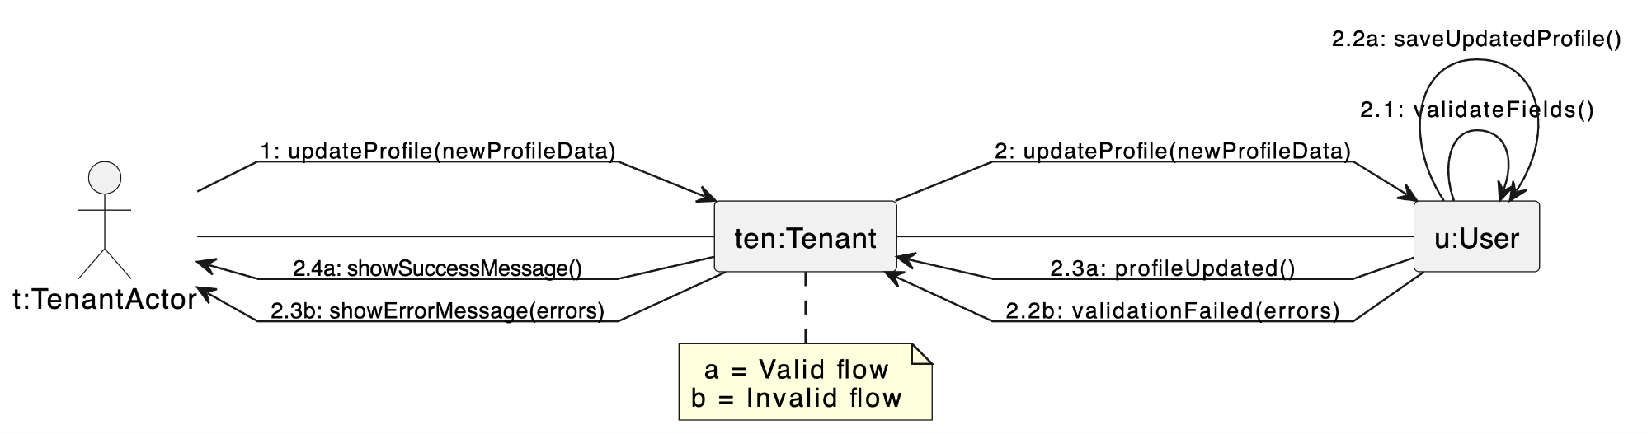

FR02 - Search properties (Done by:Anisa Domi)

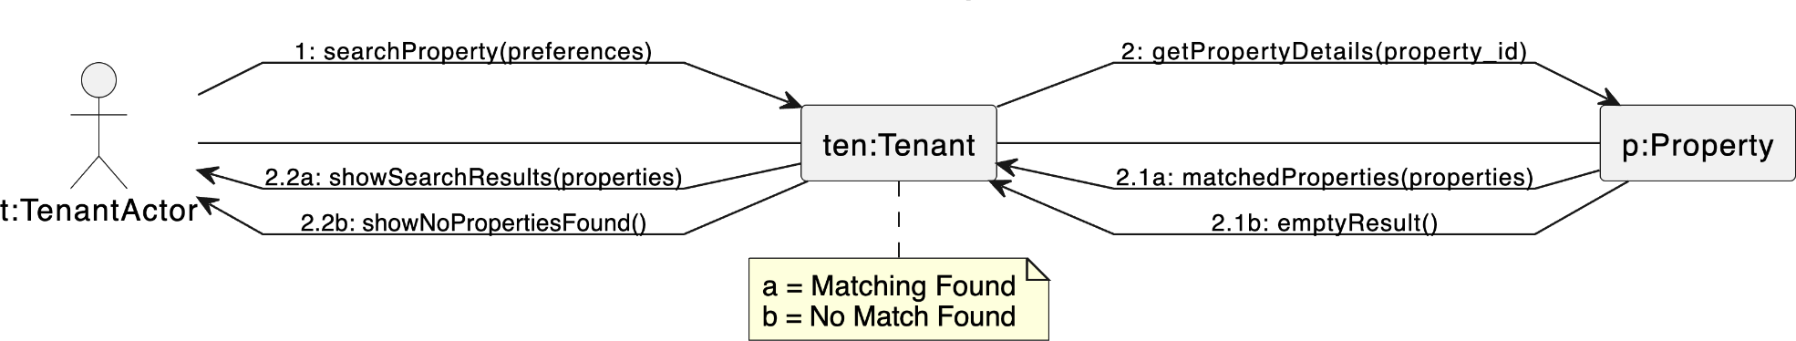

FR03 - Filter properties (Done by:Anisa Domi)

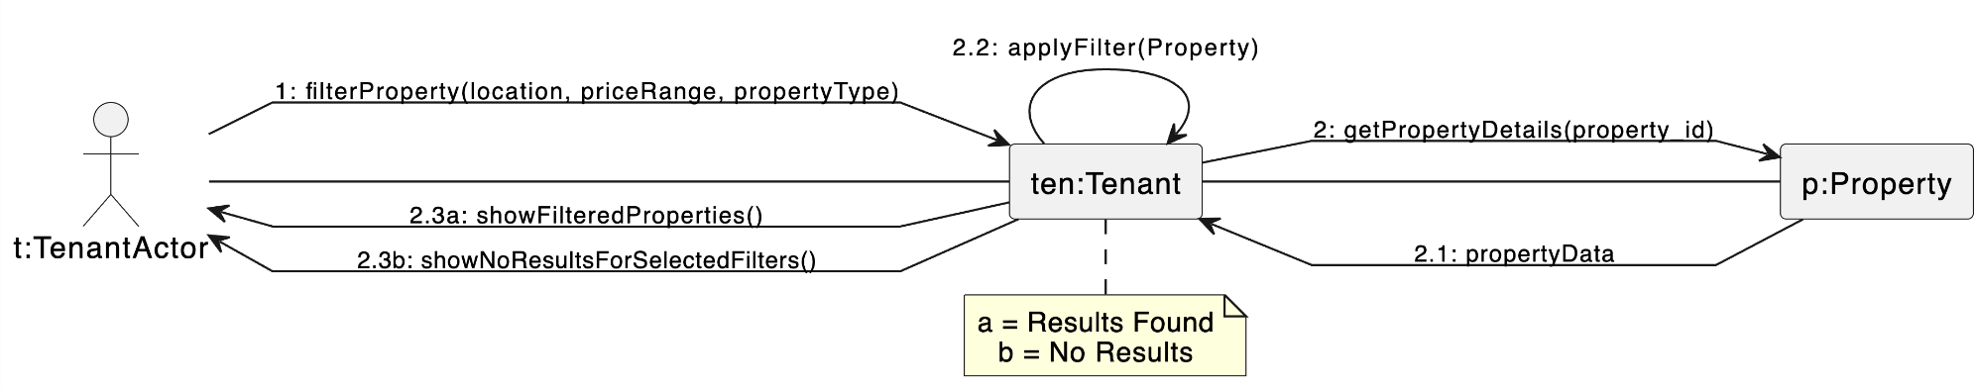

FR04 - View property details and booking history (Done by:Anisa Domi)
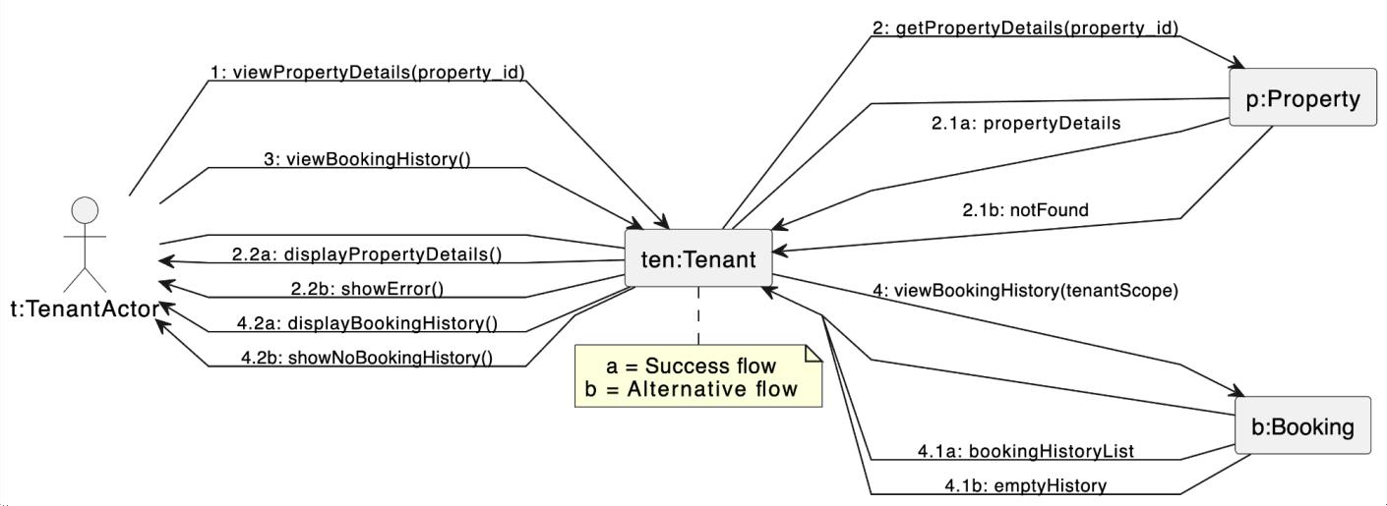

FR05 - Send rental requests and message to property owners (Done by:Anisa Domi)

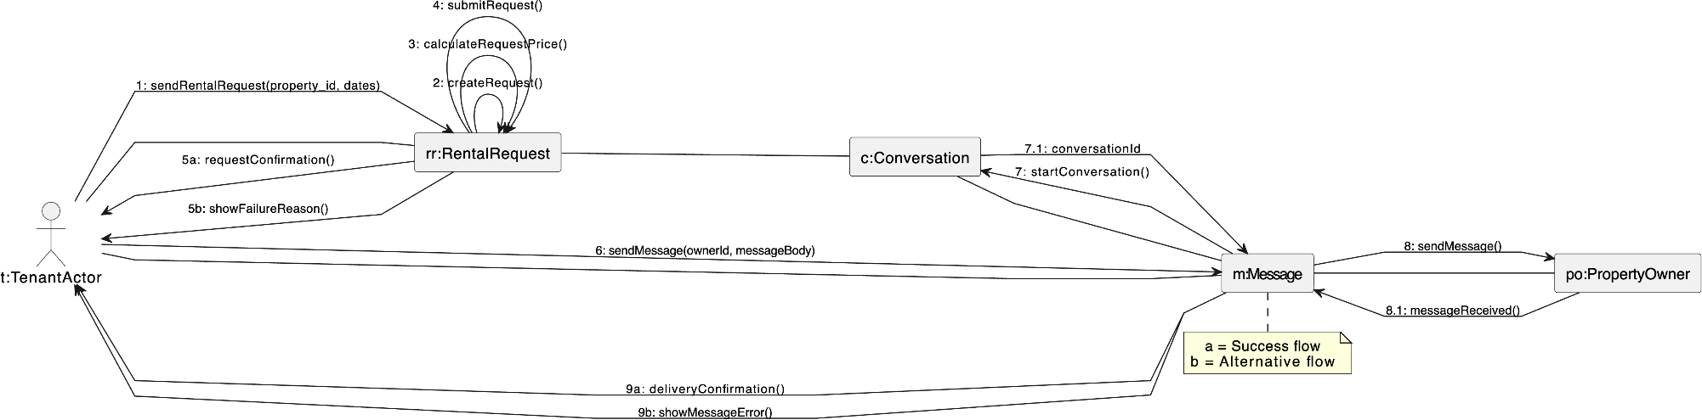

FR06 - Cancel rental request (Done by:Anisa Domi)

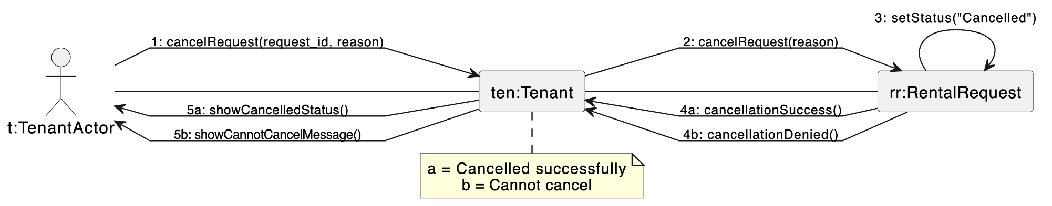

FR7-Receive Messages from property owners (Done by: Haidi Toto)
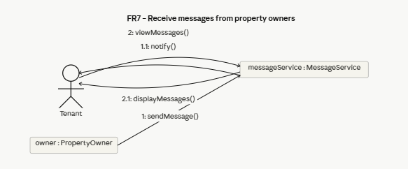

FR8 – Submit Rental Payment (Done by: Haidi Toto)
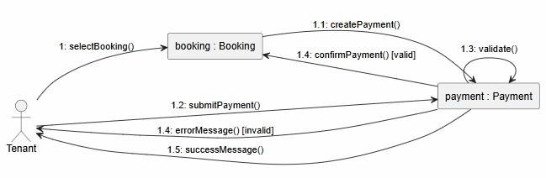
FR9 – Save Favourite Properties for later viewing (Done by: Haidi Toto)
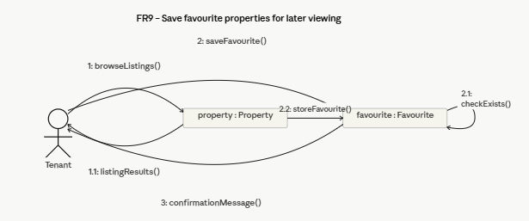

FR10 – Review and Rate Property (Done by: Haidi Toto)
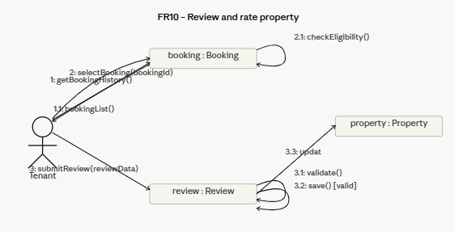
FR11 – Update Profile information and Availability of Rental Properties (Done by: Haidi Toto)
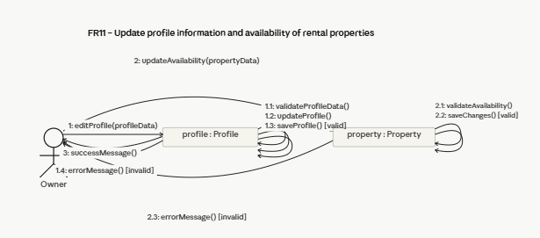
FR12 – Add Property Listing (Done by: Haidi Toto)
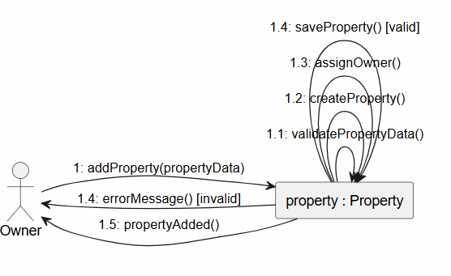

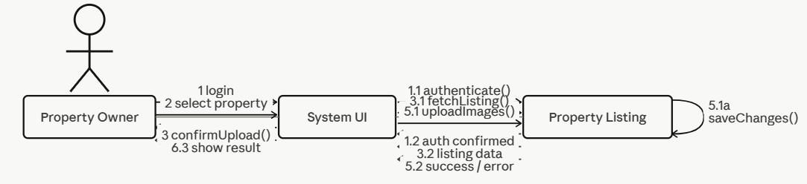
FR13-Upload Property Images (Done by: Ledio Tafciu)

FR14 - Edit Property Listing (Done by: Ledio Tafciu)
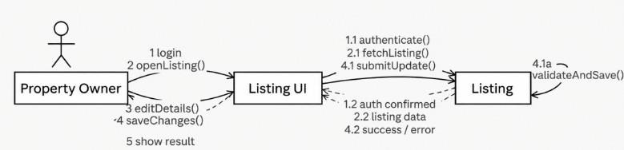
FR15 - Delete Property Listing (Done by: Ledio Tafciu)
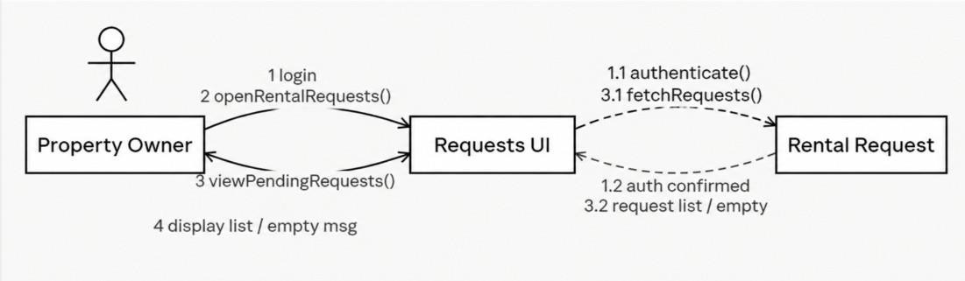
FR16 - View Rental Requests (Done by: Ledio Tafciu)
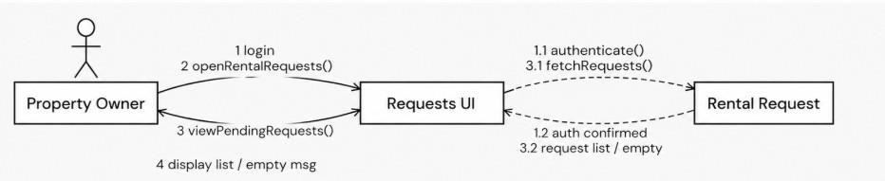

FR17 - Accept or Reject Rental Request (Done by: Ledio Tafciu)
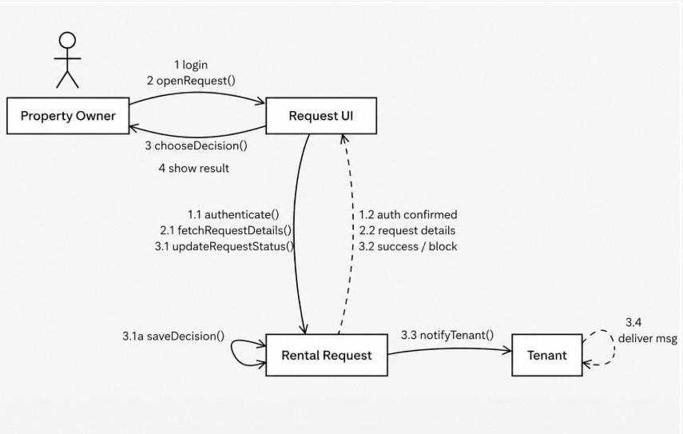
FR18 - Send Message To Tenant (Done by: Ledio Tafciu)
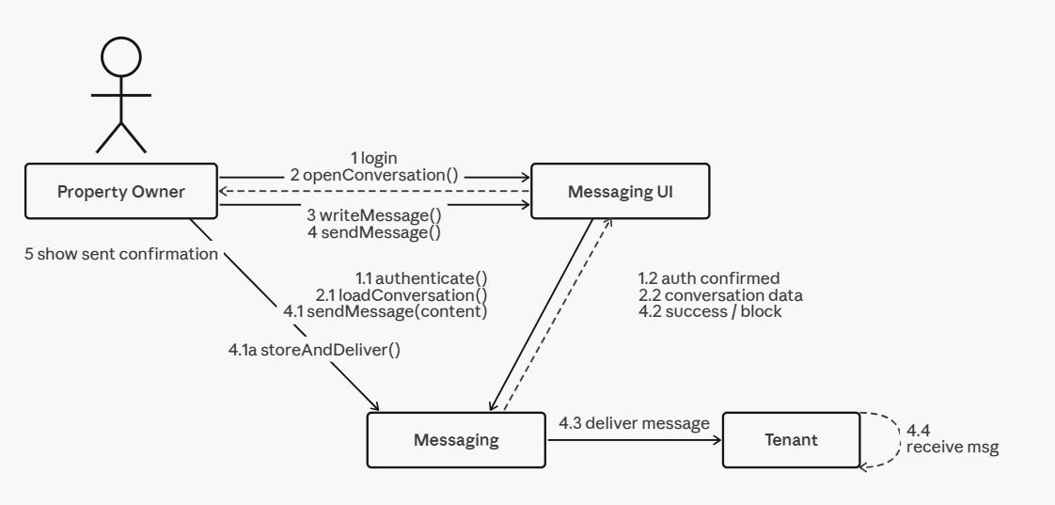

FR19 - View Booking History (Done by:Desard Lybeshari)
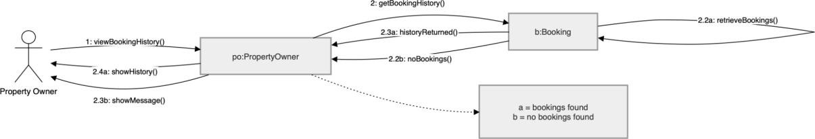

FR20 - Mark Property as Unavailable or Rented (Done by:Desard Lybeshari)

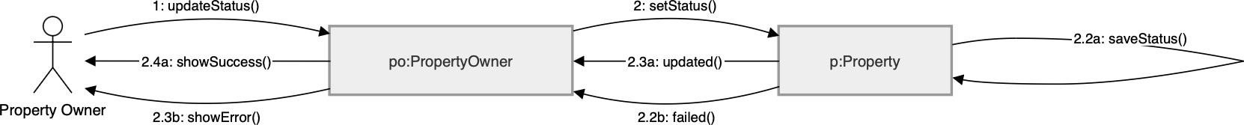

FR21 - Edit User Accounts (Done by:Desard Lybeshari)
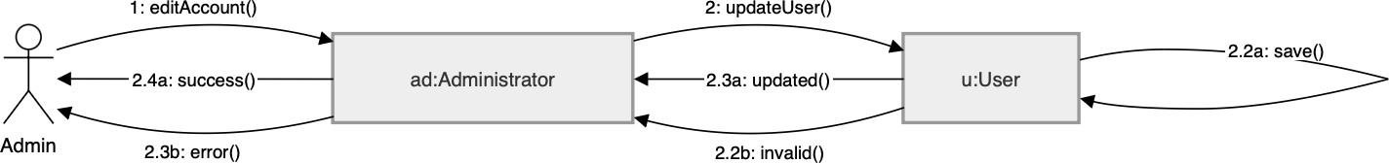

FR22 - Delete User Accounts (Done by:Desard Lybeshari)
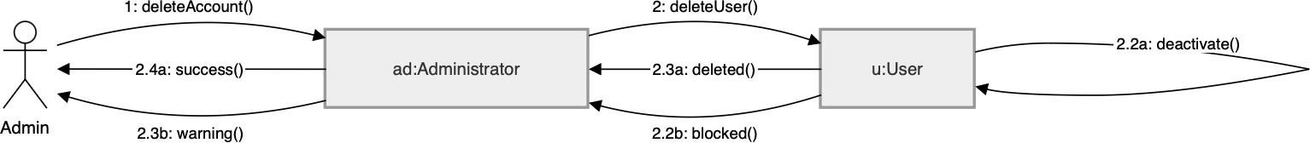

FR23 - Monitor Rental Transactions (Done by:Desard Lybeshari)

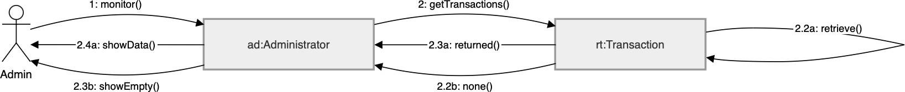

FR24 - View System Reports and Property Listings (Done by:Desard Lybeshari)

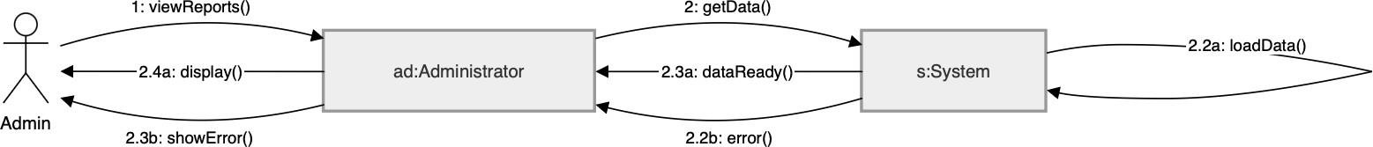

FR25- Remove inappropriate listings (Done by:Matias Bali)
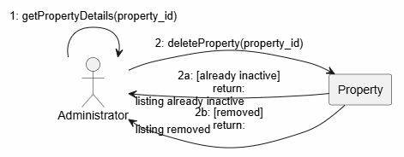

FR26- Manage disputes & system settings (Done by:Matias Bali)
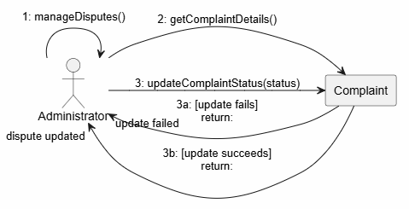

FR27- Restore user accounts (Done by:Matias Bali)
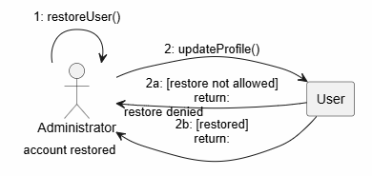

FR28- Suspend user accounts (Done by:Matias Bali)
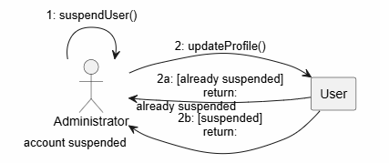

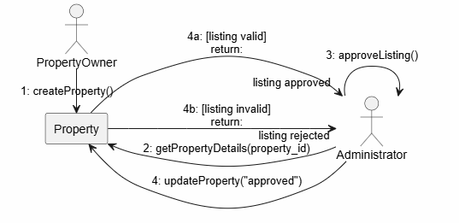
FR29- Verify and Approve property listings (Done by:Matias Bali)

FR30- Monitor rental requests (Done by:Matias Bali)
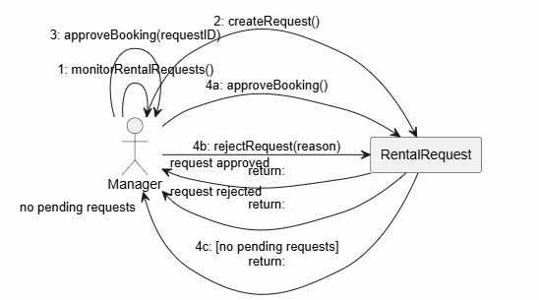

FR31 – Generate Management Reports (Done by: Ornelt Lemellari)
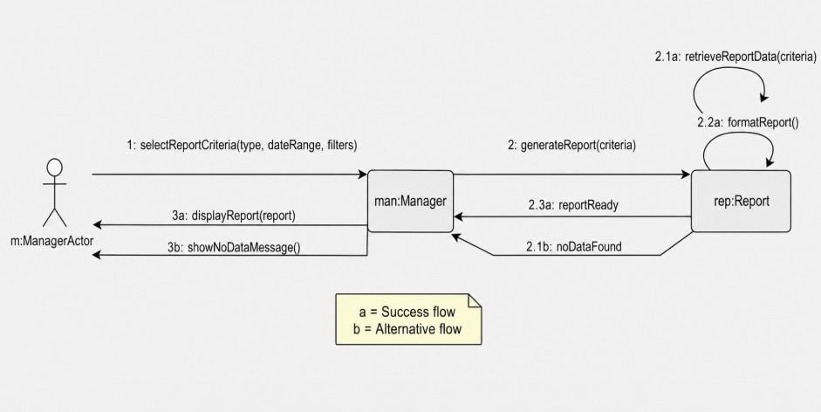

FR32 – Approve Large Discounts (Done by: Ornelt Lemellari)
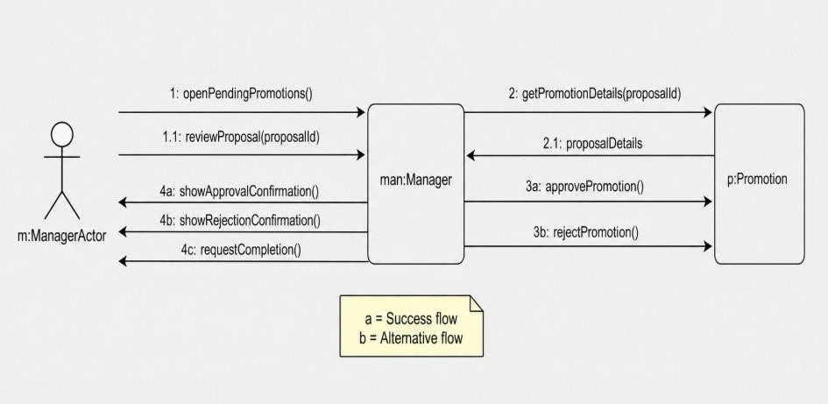
FR33 – Review Complaints and forward unresolved issues (Done by: Ornelt Lemellari)
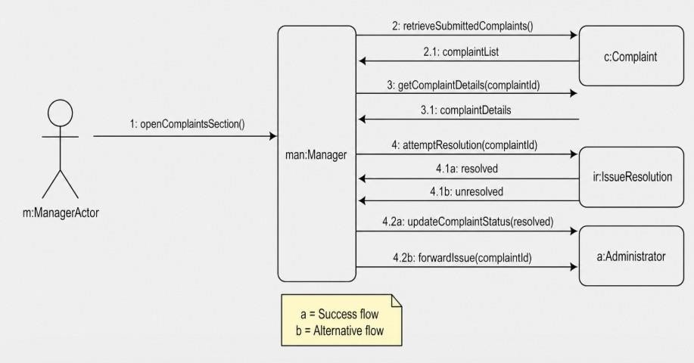
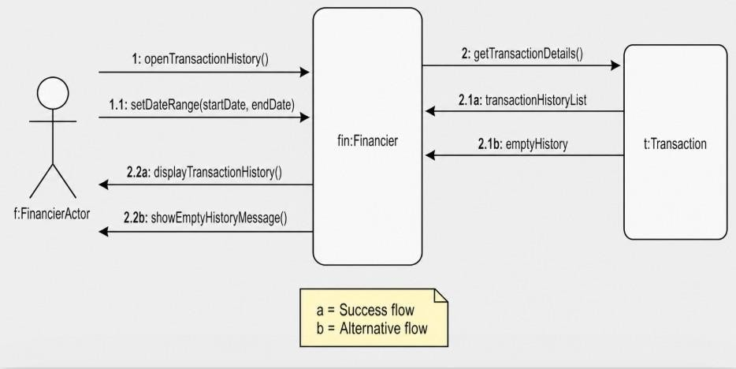
FR34 – View Transaction History (Done by: Ornelt Lemellari)

FR35 – Monitor Payment process and Security (Done by: Ornelt Lemellari)
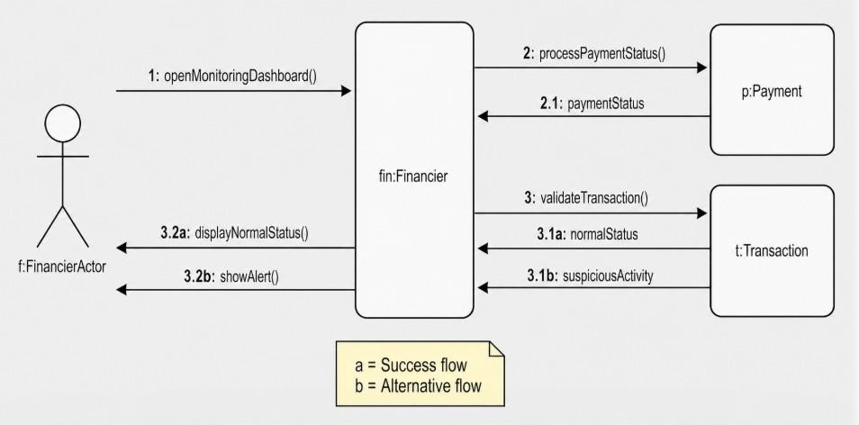

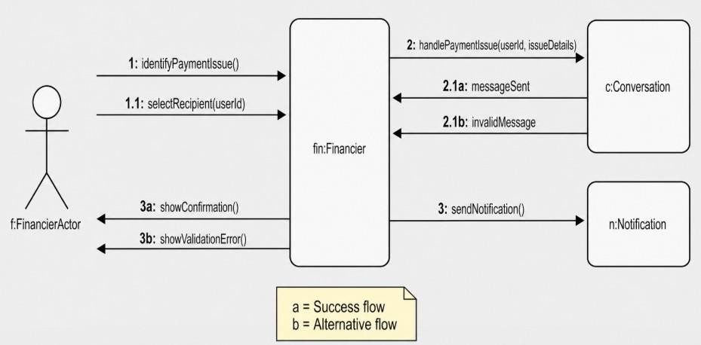
FR36 – Communicate Payment Issues with tenants and owners (Done by: Ornelt Lemellari)

FR37- Approve refunds for cancelled rental transactions (Done by:Kevin Muho)
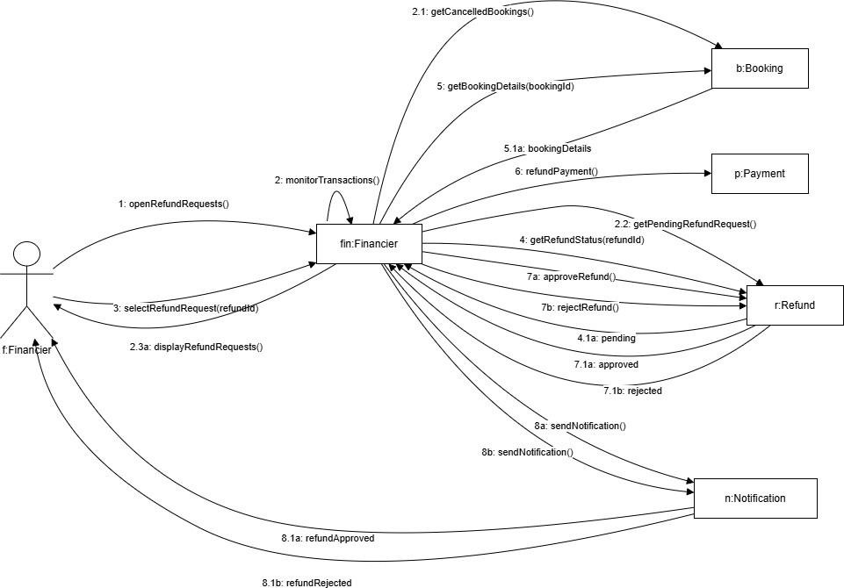

FR38- Manage Complaints (Done by: Kevin Muho)

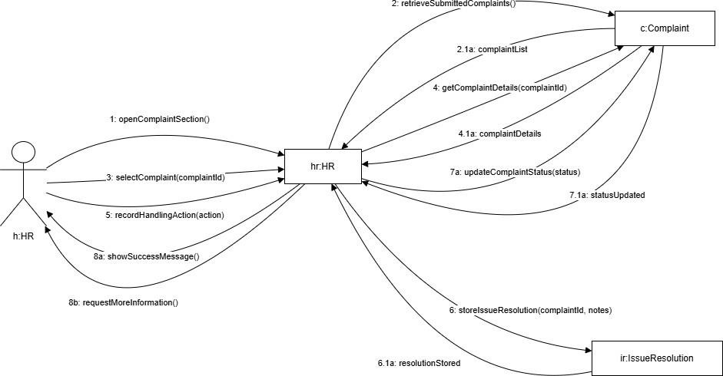

FR39- Send notifications and reminders (Done by:Kevin Muho)
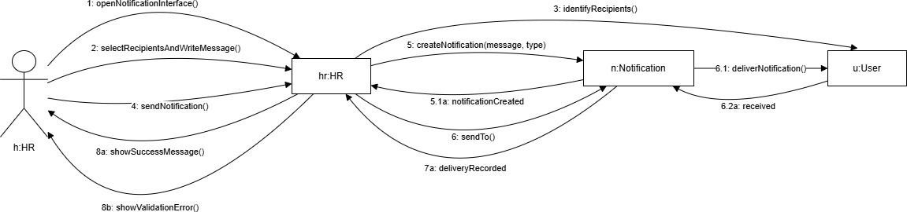

FR40- Maintain Record of User Issues and Resolutions (Done by:Kevin Muho)

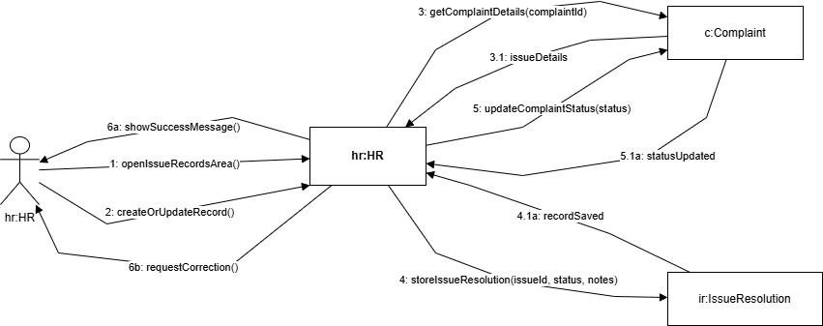

FR41- Register Account (Done by:Kevin Muho)

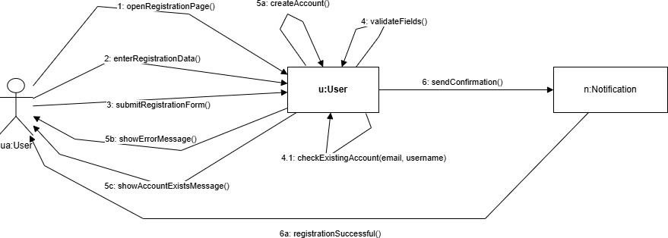

FR42 - Log In (Done by:Kevin Muho)
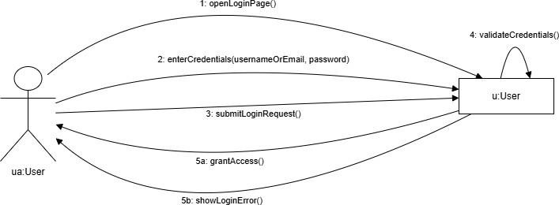

FR43 – Log Out (Done by:Kevin Muho)
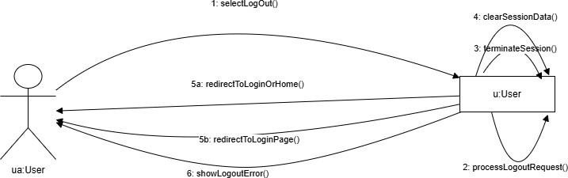

  - BPMN

Complaint & Issue Managment
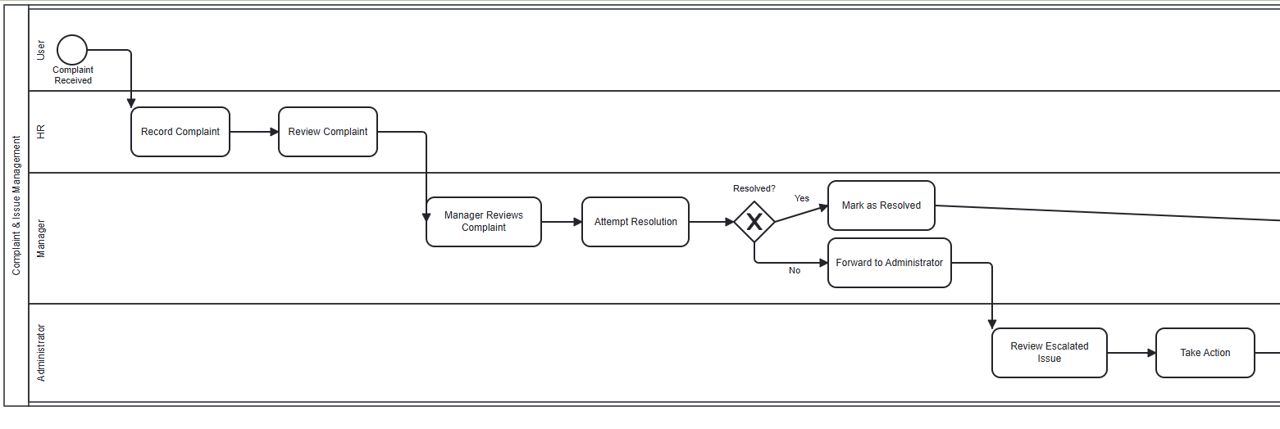

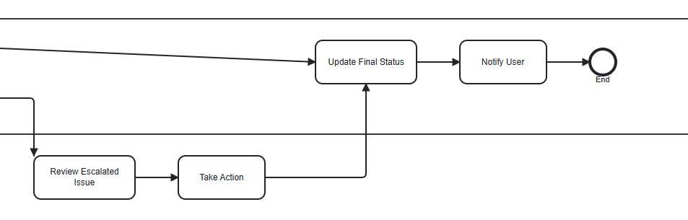

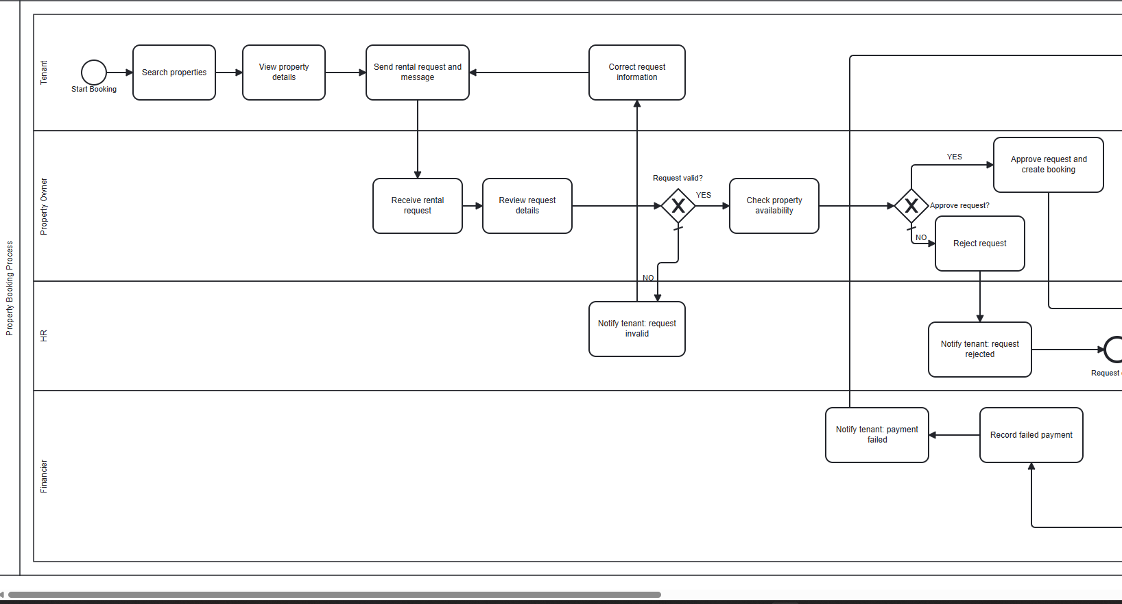
Property Booking
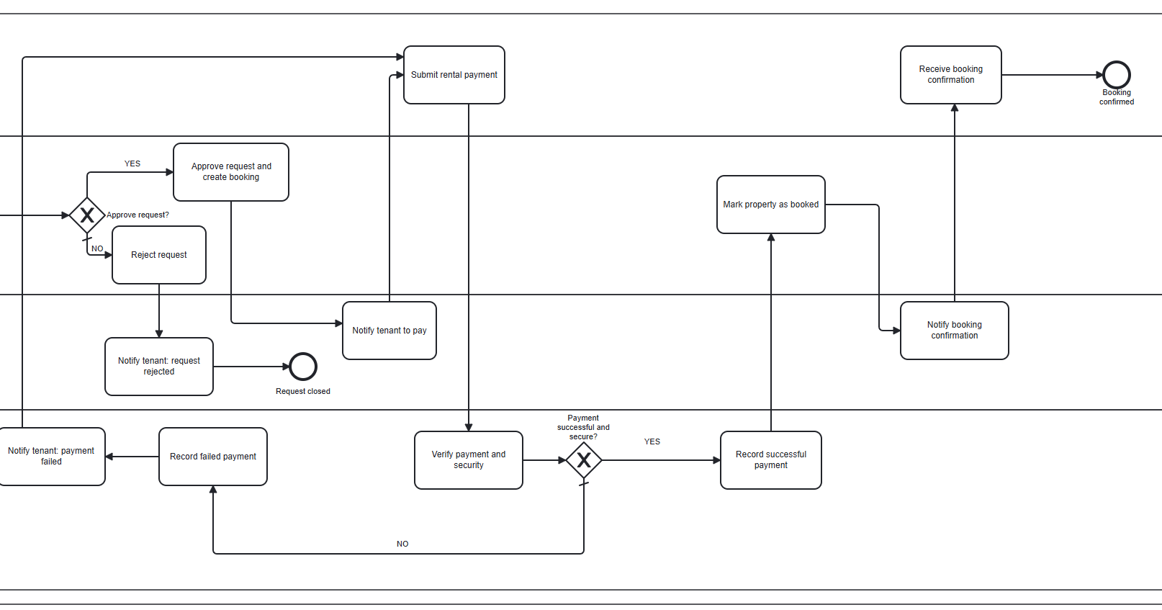

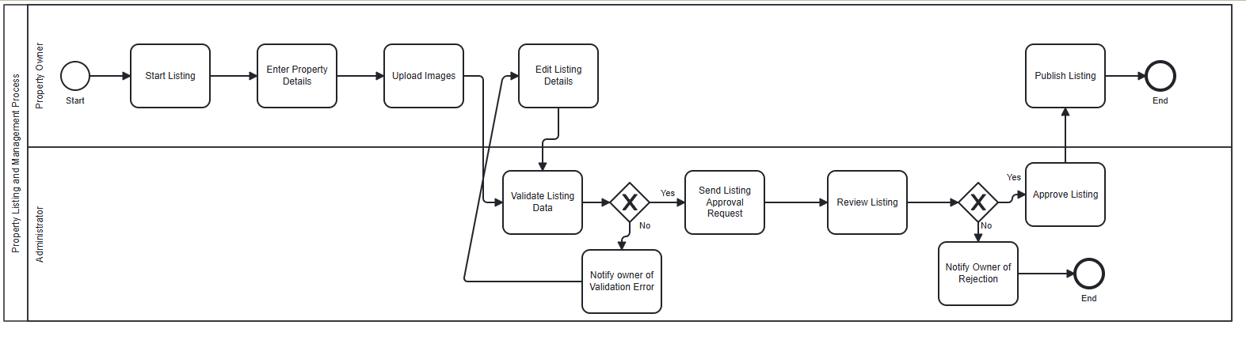
Property Listing and Managment

5.8 IOD
- Property Booking Process

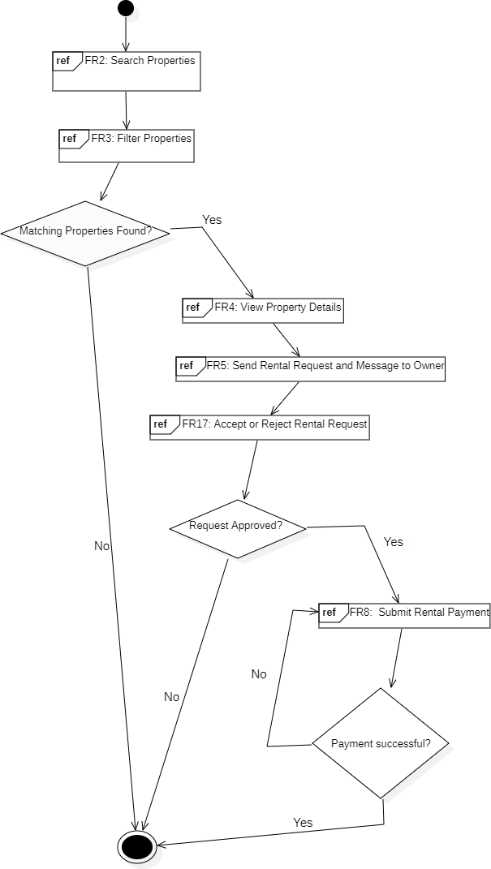

- Property Listing & Managment
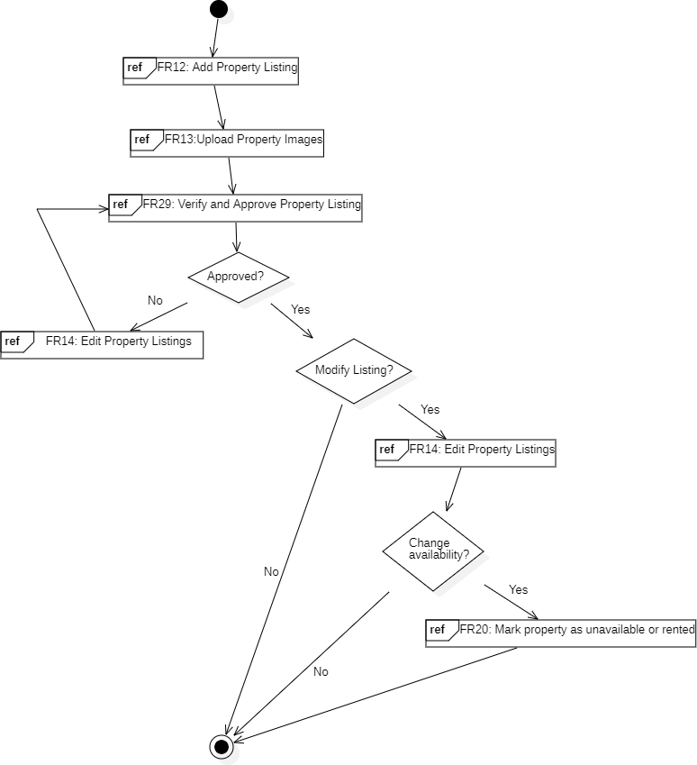

- Complaint & Issue Managment
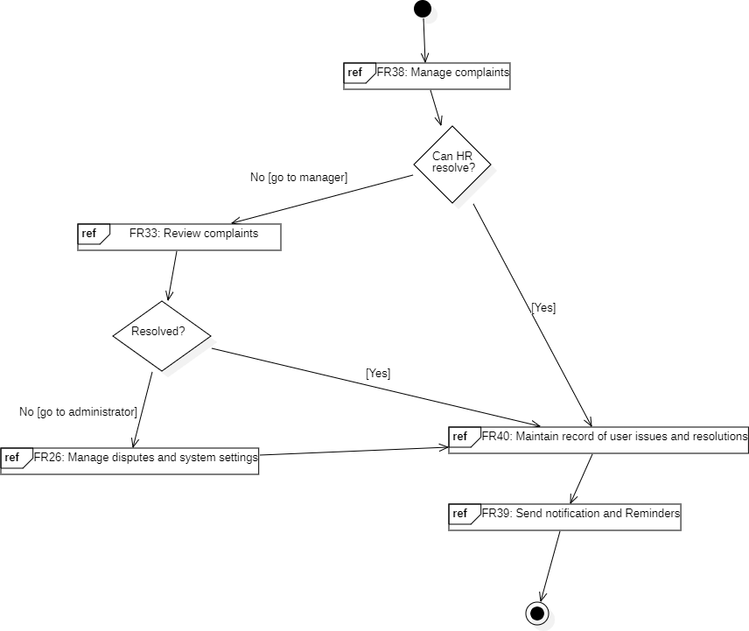

Design Patterns

Builder Pattern
Justifying the design pattern presence → The Builder Pattern is used in the system to automatically construct different User objects during registration based on the selected role.
In this design:
The RegistrationSystem acts as the Director controlling the build sequence UserBuilder ddefines the construction steps, each concrete builder assembles role-specific data, and the User product is returned fully built by the system.
For example:
In FR41 when a user registers an account and system selects the correct builder for the chosen role, builds profile data, credentials, and role-specific details step by step and returns a complete User object without changing the registration flow.
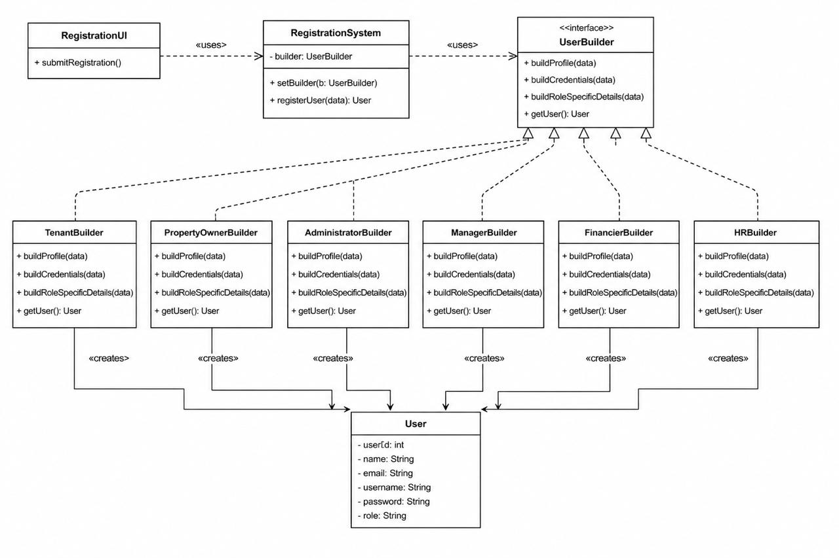

Chain of Responsibility Pattern
Justifying the design pattern presenceThe Chain of Responsibility Pattern is used in the system to automatically process complaints through multiple handling stages without placing all complaint logic in one class.
In this design:
ComplaintHandler acts as the abstract handler and stores nextHandler.
ValidationHandler, PriorityHandler, DuplicateComplaintHandler, AutoResolutionHandler, and EscalationHandler act as concrete handlers.Complaint is the request object passed through the chain.IssueResolution stores the final resolution details.
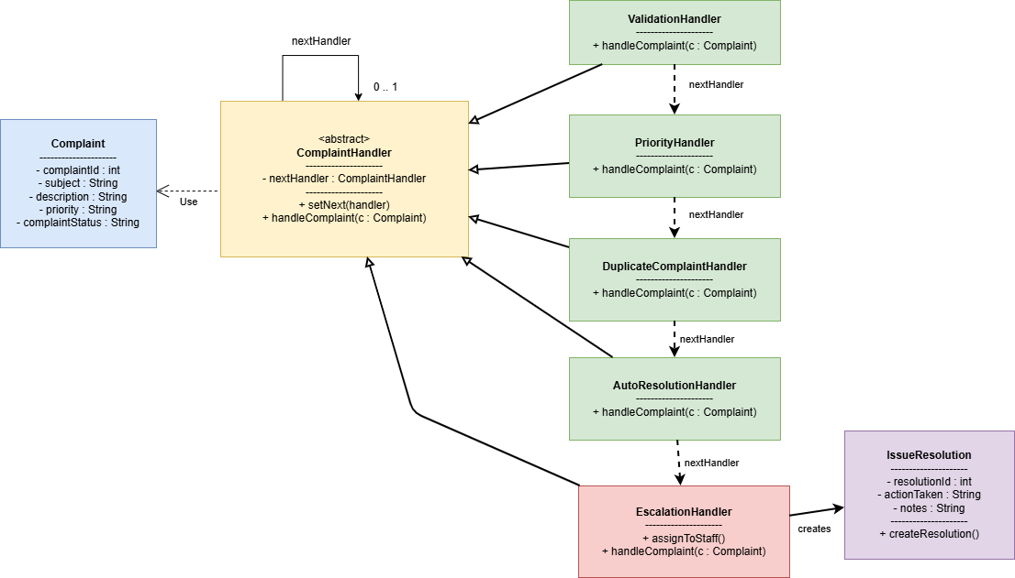
For example:
In FR38, when HR manages complaints, the system first validates and categorizes the complaint automatically.
In FR33, if the complaint cannot be resolved automatically, it is escalated for manager review.
In FR26, unresolved or serious complaints can be escalated to the administrator as a dispute/system issue.

Observer Pattern
Justifying the design pattern presenceThe Observer Pattern is used in the system to automatically notify users when important events occur, such as rental request updates or payment completion.
In this design:
RentalRequest and Payment act as Subjects because their status can
change.
NotificationSystem acts as the Observer, listening for these changes.
Tenant and PropertyOwner receive notifications about approvals, rejections, payments, and reminders.
For example:
-In FR17, when a property owner accepts or rejects a rental request, the tenant is notified.
-In FR8 and FR39, payment updates and reminders are also sent automatically.
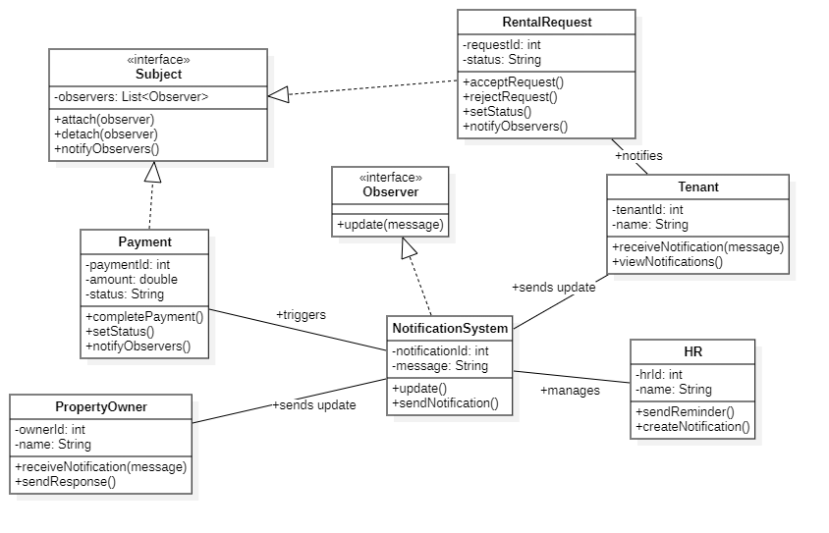

Facade Pattern
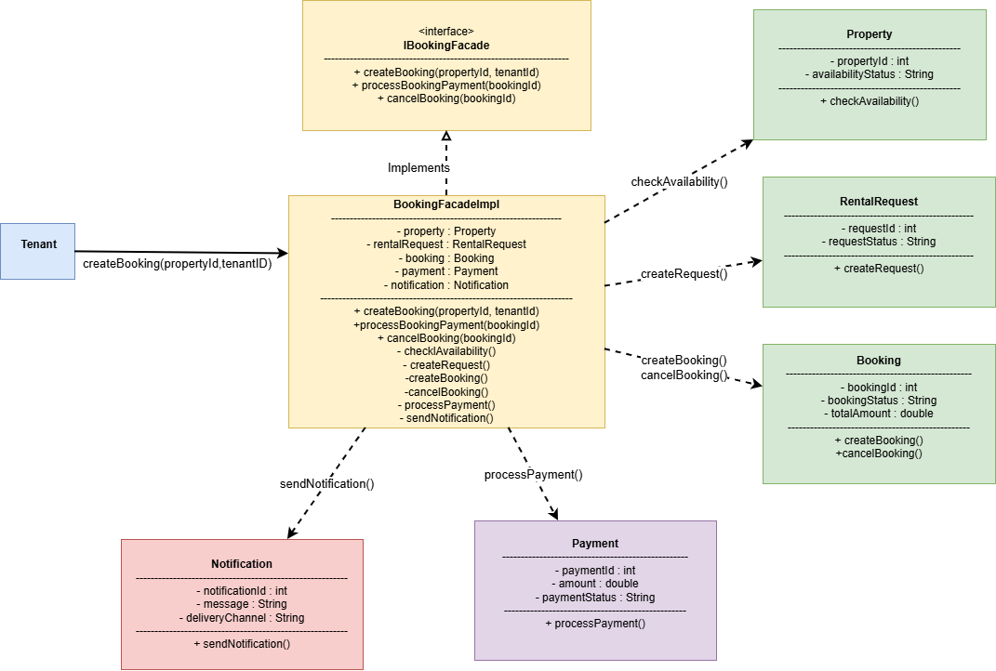
Justifying the design pattern presenceThe Facade Pattern is used in the system to simplify the property booking workflow by providing a unified interface for handling multiple booking-related operations through a single facade class.
In this design:
IBookingFacade acts as the facade interface that defines the booking operations.
BookingFacadeImpl acts as the concrete facade implementation that coordinates the subsystem classes.
Property, RentalRequest, Booking, Payment, and Notification act as subsystem classes responsible for specific booking operations.
Tenant acts as the client that interacts with the facade instead of directly communicating with all subsystem classes.
For example:
In FR2 and FR3, the system checks property availability before creating a booking request.
In FR5, the system automatically creates a rental request through the facade.
In FR17, the system manages booking creation and status updates after request approval.
The facade also sends notifications automatically after important booking and payment events occur.

Adapter Pattern
Justifying the design pattern presenceThe Adapter Pattern is used to connect the rental system with an external payment service without changing the internal system structure.
In this design:
PaymentServiceAdapter acts as a bridge between the system and ExternalPaymentService. The system sends payment data using the PaymentProcessor interface, while the adapter converts the request and response formats required by the external service.
This pattern focuses on *software structure and object collaboration*, since it shows how objects inside the system communicate during payment processing.
For example:
On FR8 – Submit Rental Payment, the system sends the payment request to the payment service.Also, the system receives the payment result and displays confirmation.
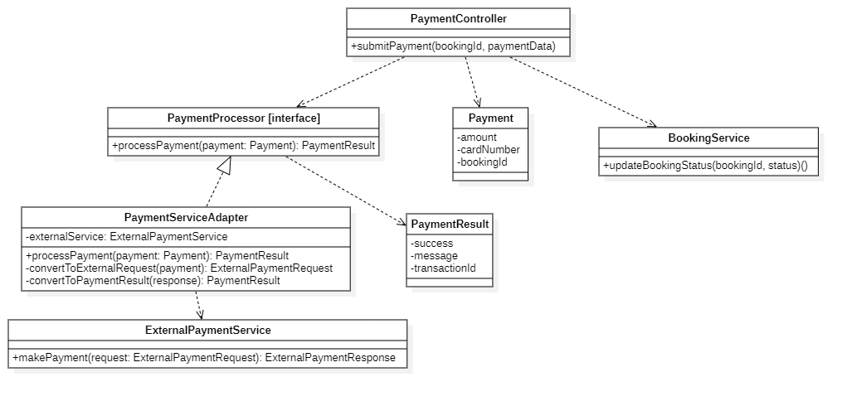

Appendix.
This section is for information only as an aid in preparing the requirements document.
Detailed tend to be extensive. Give careful consideration to your organization scheme. Some examples of organization schemes are described below:

